

HIGH JUDICIAL & PROSECUTORIAL COUNCIL
OF BOSNIA AND HERZEGOVINA

2021 ANNUAL REPORT

The Council prints its annual reports in one of the official languages of Bosnia and Herzegovina, alternating the order as follows – Bosnian, Serbian and Croatian.

CONTENTS

FOREWORD FROM THE HJPC PRESIDENT 7
MEMBERS OF THE HJPC BiH 11
HJPC BiH Organisational Chart 14
HJPC BiH FINANCIAL OPERATIONS 15
Funding HJPC BiH activities 15
Financing project activities focused on judicial reform with donor funds 15
Investments in the Judiciary of Bosnia and Herzegovina 17
Audits 17
APPOINTMENT TO JUDICIAL OFFICE 18
The database with questions for entrance exams has been expanded to include 600 new exam questions 21
DISCIPLINARY LIABILITY OF JUDICIAL OFFICE HOLDERS 22
Improving disciplinary procedures 22
Disciplinary proceedings 22
Complaints against judicial office holders alleging breach of duty 22
Initiated disciplinary proceedings 23
Completed disciplinary proceedings 25
Suspension from office 27
Enforcement of disciplinary measures 28
Disclosure of disciplinary decisions 28
SIGNIFICANT ACHIEVEMENTS OF THE HJPC BiH DURING 2021 29
Efficiency, quality and quantity of court performance 29
Strategic planning system introduced in all BiH courts 29
Introduction of the efficiency indicators 30
Backlog reduced with the backlog reduction plans in courts 31
More efficient processing of corruption and organised crime cases 32
Improving enforcement procedures in BiH 33
Activities of the HJPC BiH with the aim of improving the enforcement procedure in BiH 33
Application of the SOKOP-Mal system for more efficient processing of utility cases 34
Improving business processes in courts, through reorganisation of work and human resources in courts 35
Improving the efficiency of bankruptcy proceedings 36
Draft Strategy for Alternative Dispute Resolution developed - faster and more economic dispute resolution 37
Improving efficiency and quality of civil procedure 39
Introducing quality standards in target courts and strengthening the capacity of civil / litigation departments 39
Implementation of the Strategy for Improving Gender Equality in the Judiciary in BiH 40
The judiciary and vulnerable groups 42
Improving the quality of judgement in civil proceedings 43
Initiating civil legislation reform 45
Assessment of independence, accountability and quality of justice according to the ENCJ Indicators 45
Reconstruction and modernisation of selected judicial buildings 46
Conversion of the Miljacka Prison premises 48
More proactive communication by the courts leads to greater transparency 49
New communication practices in judicial institutions in Bosnia and Herzegovina 49
Performance, quality and transparency of prosecutor’s offices 51
Prosecution of corruption 52
Prosecution of organised crime 52
Supporting POs in processing cases involving economic crime, organised crime and corruption 53
Situation analysis and backlog reduction measures for the prosecutor's offices 53
Activities of the Standing Committee on the Efficiency and Quality of Prosecutor's Offices 54
Improving cooperation between prosecutor’s offices and law enforcement agencies 55
Improving specialisation of prosecutors and expanded categories of participants 55
Supporting the Coordinating Body of the chief prosecutors of the Prosecutor's Office of BiH, entity prosecutor’s offices and the Prosecutor’s Office of the Brcko District of BiH 56
Strategic planning in prosecutor’s office 56
Support of the prosecutor’s offices in implementing the digitisation of archives 57
Transparency, public relations in the prosecutors offices and cooperation with the NGO sector 57
Performance evaluations for judicial office holders 57
Education of judicial office holders 59
Coordination of the case law harmonisation process 61
The increased transparency of the judicial system 63
The implementation of the Revised National War Crime Strategy and monitoring the work of courts and prosecutor’s office on war crimes cases 64
Integrity 66
Asset declarations of judges and prosecutors 66
Ethics, integrity and conflict of interest 67
ANNEX 1: RECOMMENDATIONS 68
Judicial efficiency 68
Recommendations pertaining to court efficiency 68
Recommendations pertaining to efficiency of prosecutor's offices 69
Recommendations for courts and prosecutor's offices in processing war crimes cases 69
Recommendations pertaining to performance evaluation 70
Recommendations pertaining to training and case law 70
Integrity and accountability 70
ANNEX 2: COURT PERFORMANCE STATISTICS 71
Analysis of court performance 71
Case flow – per court instance 71
Pending court cases 71
Courts' influx 72
Change in the number of pending cases and change in influx 73
Completed cases in courts 73
Flow of cases – per case type 74
Pending cases by type 74
Influx by case type 75
Completed cases by type 75
Quality and quantity of justice 76
Statute of limitations 77
ANNEX 3: PROSECUTOR'S OFFICES PERFORMANCE STATISTICS 78
Analysis of performance of prosecutor’s offices 78
Crime reports 78
Investigations 79
Indictments 79
Judgments 80
Backlog 81
The statute of limitations on criminal prosecution 82
Breakdown of crimes 82
Quality and quantity of justice 84

FOREWORD FROM THE HJPC PRESIDENT
Dear friends and colleagues,
I am pleased to present the 2021 Annual Report of the High Judicial and Prosecutorial Council, which provides an overview of major activities and the results achieved by the HJPC and the judiciary of Bosnia and Herzegovina during the past year.
Even though it was another year of working under the pandemic, as opposed to 2020 - when we saw major delays in the operations of judicial institutions due to the coronavirus - in 2021, judicial institutions looked to deal with the backlogs from the past year and get the judiciary back on track and operating as normal, while at the same time following the recommended epidemiological measures. As for the HJPC BiH, I can safely say that, despite the fact that the majority of our staff had caught the coronavirus and, accordingly, were temporarily absent from work, we continued to operate at full capacity.
Furthermore, considering that the institution was faced with threats from politicians to terminate its competences which was pushed forward in 2022, with the adoption of a Draft Law on the High Judicial and Prosecutorial Council of Republika Srpska, by acting together, the members of the HJPC BiH i.e. representatives from Republika Srpska, the Federation of Bosnia and Herzegovina, the level of Bosnia and Herzegovina and the Brcko District BiH, remained consistent with their mission to ensure an independent, impartial and professional judiciary.
I would also emphasise the fact that in 2021, we did not see the anticipated amendments to the Law on the HJPC BiH which would allow for significantly improvements to judicial office holder integrity issues through the detailed processing of personal financial statements of judges and prosecutors as well as issues concerning the evaluation of judicial office holders by providing specific provisions in the law.
However, this did not stop us from providing important contributions in numerous areas vital for the effective functioning of the judicial system, such as the appointment of judicial office holders, the efficiency of courts and prosecutors offices, performance quality, the integrity of judicial office holders, improving war crimes case processing, as well as for measures that were taken towards improving the preconditions for fighting organised crime and corruption along with activities in numerous other areas.
In that respect, I would add that the procedure for judicial office appointments and promotions continues to be improved through targeted amendments to the HJPC BiH Rules of Procedure, where we have improved candidate interview scoring issues, introduced the option for candidates to apply for judicial office positions electronically, banned candidates from applying to competitions if they have been suspended through a final Council disciplinary panel decision pursuant to articles 76 and 77 of the Law on the HJPC BiH, while also elaborating the rights candidates have to listen to audio recordings and receive copies of audio recordings.
Furthermore, we have set clearer actions to be taken on candidates objections concerning entrance exams and written tests while also improving the calculation of the overall points score for the performance evaluation to provide clearer success level distinctions among the candidates and their written test scores.
Based on the recommendations from the EC Peer Review Assessment expert mission to Bosnia and Herzegovina on procedures and criteria for the appointment of judges and prosecutors, that refer to planning, reviewing, updating and the ongoing use of the test database, 600 new test questions were developed covering the civil, criminal and commercial areas for candidates applying for judicial office. This means that the database with test questions has increased by 21.5%.
We also organised entrance exams for 307 candidates and written tests for 342 candidates, while 454 interviews were carried out with candidates, all covering six competitions that were announced last year.
Two competitions were announced in 2021, with 821 candidates applying for judge & prosecutor positions in the first competition and 92 candidates for management-level positions, with 87 candidates applying for legal associate positions. More detailed information on the number of candidates who have taken entrance exams, written tests and interviews can be found in the Report by referencing the contents.
The next competition will close at the beginning of 2022, meaning that relevant data will be presented in the next report.
Disciplinary liability of judicial office holders is another important area for establishing the rule of law which the Office of the Disciplinary Counsel and the HJPC BiH continued to focus on in line with their competences. Accordingly, the Office of the Disciplinary Counsel registered 925 complaints against judicial office holders, which is 28.1% more than for the preceding year. The ODC resolved 939 complaints, which is 6% more than in 2020. In 2021, 35 disciplinary procedures were initiated against 25 judicial office holders, of which 17 against judges, 8 against prosecutors, 5 against court presidents and 4 against chief prosecutors.
In 2021, 31 disciplinary procedures were completed, with disciplinary liability established in 25 procedures for 25 judicial office holders, while disciplinary complaints were denied in four procedures against judicial office holders with two procedures discontinued due to the resignation of the judge against whom proceedings were held.
It is important to emphasise that the average processing time for complaints in 2021, was 190 days which is far less than the two year deadline from the filing of the complaint which the ODC is required to follow.
At the same time, the bulk of the complaints referred to case duration meaning that 26% of the complaints refer to the length of proceedings before the courts and 11% refer to the length of procedures before the prosecutors offices. Also, 12% of the complaints referred to neglect or careless exercise of official duties by a judge and 9% neglect or careless exercise of official duties by a prosecutor.
More detailed information on disciplinary liability, together with corresponding graphs can be found in the Report by referencing the contents.
As regards the efficiency of the judiciary, we must stress that, regardless of the conditions created with the pandemic, throughout 2020 & 2021, the courts managed to maintain above-average performance results. Accordingly, as part of their backlog reduction plans the courts completed 163,025 of the oldest cases. Expressed as a percentage of backlog plan completion, the courts were at 87%.
The activities undertaken by the HJPC in partnership with the courts also contributed towards achieving the maximum effect. The introduction of a strategic planning system for all courts in BiH represents one of the more significant activities that will contribute to the optimal engagement of human resources as well as allow for accurately planning activities and securing funds for work.
So called efficiency indicators have also been introduced for the easier identification of concrete problems with court operations, such as increased duration of pending cases, reduced quota achievement together with other useful tools based on eight indicators used to generate reports in order to monitor the situation and pass decisions to resolve potential work-related problems.
Other systemic activities and measures have also been taken to improve court performance efficiency as well as to implement the recommendations of the Subcommittee for Justice, Freedom and Security and the Expert Report on Rule of Law issues in BiH, specifically focused on improving enforcement procedures in BiH.
Furthermore, improvements were made regarding the application of the system for the electronic processing of utility cases and small claims which has stopped the rise in the number of such pending cases and facilitated more effective actions by judges and legal associates. By reorganising court operations and human resources, business processes have also been improved which has resulted in shorter court procedures.
The efficiency of bankruptcy procedures with regards to a better understanding of economic context was a focus of improvements during the past year as was the quality of civil litigation procedures by strengthening the capacities of the civil and litigation departments of the courts and improving the quality of civil judgments.
We have not forgotten vulnerable groups in contacts with the judiciary and have taken concrete steps accordingly, while also participating in an international campaign on activism against gender-based violence, and at the same time monitoring the implementation of the Strategy for improving gender equality in the BiH judiciary.
As regards the performance efficiency of prosecutors offices in 2021 - prosecutors offices issued 11,041 indictments, which is 14% more than in 2020. We can also see that the prosecutors offices received 21,683 cases involving known perpetrators while there were 15,213 pending cases as at 31 December 2021, which is 3% fewer than compared to last year.
As for processing corruption, in 2021, prosecutors issued 235 indictments involving corruption-related crimes, which is 87% more than the number of like indictments for the previous year. They also issued 555 orders not to pursue an investigation and 119 orders to discontinue investigations involving the aforesaid crimes.
As regards high-profile corruption, of the 328 investigations that were ordered in 2021 that focused on corruption cases, 11 investigations or 3% involved high-profile corruption.
Of all (235) indictments that were filed against corruption-related crimes in 2021, prosecutors filed 8 indictments involving high-profile corruption i.e. 3% of the total number of corruption-related indictments filed.
As for processing organised crime, in 2021, prosecutors issued 32 indictments involving organised crime, which is 23% more than for the previous year. They also issued 25 orders not to pursue an investigation and 13 orders to discontinue investigations involving the aforesaid crimes.
Of the 55 investigations that were ordered in 2021, 2 investigations or 4% involved high-level organised crime.
Of the total number of indictments (32) filed against organised crime in 2021, prosecutors filed 2 indictments involving high-level organised crime i.e. 6% of the total number of indictments against organised crime for 2021.
As for the performance quality of prosecutors offices, allow me to provide a number of concrete activities focused on improving their performance.
One being support to prosecutors offices in processing commercial crimes, organised crime and corruption through the engagement of 11 financial advisors for 10 prosecutors offices with IPA 2017 funds. The experts are involved at the earliest phase of criminal procedure, while their results are visible through quicker documentation collection, avoiding unnecessary documents, faster handling of incoming cases, better communication with expert witnesses and law enforcement agencies, assistance in drafting orders for expert witnessing, as well as in the examination of witnesses and defendants. The significance of their contribution was visible in recognising the need for financial investigations, providing expert assistance in analysing cash flows and identifying illegal income.
To date, most of the cases they worked on involved complex economic and organised crime, corruption, tax evasion, abuse of position, loan fraud, concluding prejudicial contracts, compiling false balance sheets, privatisation, market abuse, money laundering and other crimes.
An analysis was also carried out on the situation and measures for backlog reduction at the prosecutors offices, while the Standing Committee for the Efficiency and Quality of Prosecutors Offices held a number of meetings with particular focus on improving the organisation of operations at prosecutors offices in order to process high profile corruption and organised crime cases more effectively. Furthermore, activities continued on improving cooperation between prosecutors offices and law enforcement agencies as well as with the NGO sector, while special attention was devoted to the performance transparency of prosecutors offices.
It must be said that the HJPC BiH and its international partners are currently working on the construction of five new judicial institution buildings i.e. District Public Prosecutors Office in Bijeljina and the courts in Zepce, Zenica, Mrkonjic-Grad and Prnjavor. Also, the Sarajevo Palace of Justice is at the top of our priorities considering the long-standing problem with accommodation, and we trust that we are close to resolving the matter and that it will be resolved in 2022.
I would finish my introduction by listing the major achievements of the HJPC BiH regarding the transparency of the judiciary which has been subject to criticism in the past.
Specifically, in 2021, we adopted the HJPC BiH Communication Strategy which incorporates strategic objectives that go beyond the HJPC institutional framework, covering all of the judiciary. We trust that this strategic document will contribute to harmonising communication practices and, ultimately, directly lead to judicial institutions being more open to the public and the media while also reinforcing the transparency of the performance of courts and prosecutors offices.
Furthermore, we have opened a HJPC BiH court decision database with free access for the public - compared to the past when a fee was required - and added 2,913 new decisions to it, meaning that as at 31/12/2021, there are 14,972 open and searchable decisions available in the database. Focus was also placed on legally final decisions in cases of particular interest such as war crimes, discrimination and human trafficking, while the database is currently being updated with decisions involving organised crime and corruption.
Parallel to 13 summaries of legally final war crime case decision, we have also updated the interactive war crimes map which is available to the public.
Considering the importance of processing war crimes, I would take this opportunity to invite you to search the Report and look into information on the activities taken by the HJPC BiH in this field, especially regarding the implementation of the Revised National War Crime Strategy and overseeing the efforts of the courts and prosecutors in processing war crimes.
At the same time, attached to the Report you can find detailed statistical data on the performance of the courts and prosecutors offices with information on caseflow, incoming cases, completed cases, quality and quantity of performance of the courts as well as information on reports, investigations, indictments and judgments rendered for prosecutors offices, including data on pending cases, statute of limitations against prosecution and the breakdown of crimes.
It seems that we are moving towards the end of the pandemic, even though I do not doubt that there will still be challenges both, internally and externally, however I am sure that the BiH judiciary will effectively respond to any challenges and safeguard the principles on which it lays.
Ultimately, I want to emphasise that the results presented in the Report were achieved through the joint efforts of the judges, prosecutors and our partners within the state and the international community.
Therefore, I take this opportunity to thank our numerous international friends who continue to support the HJPC BiH and the judiciary of Bosnia and Herzegovina - as clearly demonstrated when HJPC competences for the whole of Bosnia and Herzegovina were being disputed - and without their selfless support we quite definitely would not have been able to address issues vital for the establishment of the rule of law in our country. The financial support from our major donors in 2021 - the European Union, Sweden, Norway, Switzerland - is not only support for the HJPC BiH and the BiH judiciary, rather is primarily focused on the citizens of this country who deserve to be equal members of the European family.
We also owe our gratitude to the BiH authorities for their ongoing support, and trust that our cooperation on vital issues for judicial reform will continue in future.
And ultimately, I would especially like to thank our colleagues, the judges and prosecutors, as well as all other employees within the judicial community, without whose commitment and professionalism the HJPC would not have been able to respond to all of the challenges placed before the judiciary.

Halil Lagumdzija
President of the HJPC BiH
MEMBERS OF THE HJPC BiH
The High Judicial and Prosecutorial Council of BiH has 15 domestic members who are elected in accordance with Article 4 of the Law on the HJPC BiH. The Council has six judges, five prosecutors, two representatives of the executive and legislative branches as well as two representatives of the entity bar associations.

Halil Lagumdžija, President of the HJPC BiH
Mandate: February 2021 - February 2025
The judges of the Court of BiH elected judge Halil Lagumdžija to the HJPC BiH in December 2020. He was elected President of the HJPC BiH at the HJPC BiH session on 10 February, 2021.
He holds the office of judge of the Court of Bosnia and Herzegovina.
He was elected after judge Dragomir Vukoja’s, mandate as member of the HJPC BiH ended
Mandate: February 2017 - February 2021
The judges of the Court of BiH elected judge Dragomir Vukoja to the HJPC BiH in January 2017.
He held the office of judge of the Court of Bosnia and Herzegovina.

Biljana Simeunović, Vice-President of the HJPC BiH
Mandate: November 2020 – November 2024
The prosecutors of the Prosecutors Office of Bosnia and Herzegovina elected prosecutor Biljana Simeunović to the HJPC BiH in October 2020. She was elected Vice-President of the HJPC BiH at the HJPC BiH session on 10 February, 2021.
She holds the office of prosecutor of the Prosecutors Office of Bosnia and Herzegovina.

Sanela Gorušanović Butigan, Vice-President of the HJPC BiH
Mandate: June 2020 - June 2024
The judges of the cantonal and municipal courts in the Federation of BiH elected judge Sanela Gorušanović Butigan to the HJPC BiH in June 2020. She was elected Vice-President of the HJPC BiH at the HJPC BiH session on 6 June 2020 and held the office until the termination of the mandate of the President of the HJPC BiH on 16 December 2020. She was re-elected for a second term as Vice-President of the HJPC BiH at the HJPC BiH session on 10 February, 2021.
She holds the office of judge of the Municipal Court in Sarajevo.

Srđan Forca, member of the HJPC BiH
Mandate: February 2021 - February 2025
The judges of the district, basic, district commercial courts of Republika Srpska and the High Commercial Court in Banja Luka elected judge Srđan Forca as a member of the HJPC BiH in June, 2021.
He holds the office of judge of the District Court in Banja Luka.
He was elected after Milan Tegeltija’s mandate to the HJPC BiH ended
Mandate: July 2018 - July 2022 His mandate ended in December 2020 subsequent to his resignation.
The judges of the district, basic, district commercial courts of Republika Srpska and the High Commercial Court in Banja Luka elected judge Milan Tegeltija as a member of the HJPC in June, 2018.
Aleksandra Obradović, member of the HJPC BiH
Mandate: June 2021 - June 2025
The Judicial Commission of the Brcko District BiH elected judge Aleksandra Obradović to the HJPC BiH in April 2021.
She holds the office of judge of the Basic Court of the Brcko District BiH.
She was elected after Selim Karamehić’s mandate to the HJPC BiH ended
Mandate: June 2017 - June 2021
The Judicial Commission of the Brcko District elected judge Selim Karamehic to the HJPC BiH in June 2017. He was elected to the position of HJPC BiH member to work full-time at the Council at the session on 25 October 2017 and he retained such status through to the end of the mandate of the HJPC BiH President on 16 December 2020.
He holds the office of judge of the Basic Court of the Brcko District BiH.

Mustafa Šabić, member of the HJPC BiH
Mandate: February 2021 - February 2025
The judges of the Supreme Court of the Federation of BiH elected judge Mustafa Šabić to the HJPC BiH in February 2020.
He holds the office of judge of the Supreme Court of FBiH.
He was elected after Goran Nezirović’s, mandate as member of the HJPC BiH ended.
Mandate: February 2017 - February 2021 (2nd mandate)
The judges of the Supreme Court of the Federation of BiH re-elected judge Goran Nezirovic to the HJPC BiH for a second term in February 2016.
He holds the office of judge of the Supreme Court of FBiH.

Jadranka Stanišić, member of the HJPC BiH
Mandate: September 2019 - September 2023
The judges of the Supreme Court of Republika Srpska elected judge Jadranka Stanišić to the HJPC BiH in September 2019.
She holds the office of judge of the Supreme Court of Republika Srpska.

Slavo Lakic, member of the HJPC BiH
Mandate: July 2018 - July 2022 (2nd mandate)
The prosecutors of the Federal Prosecutors Office of FBiH re-elected prosecutor Slavo Lakic to the HJPC BiH for a second term in May, 2018.
He holds the office of prosecutor of the Federal Prosecutors Office of FBiH.

Snježana Petković, member of the HJPC BiH
Mandate: September 2021 - September 2025
The prosecutors of the Republic Prosecutors Office of Republika Srpska elected prosecutor Snježana Petković to the HJPC BiH in August 2021.
She holds the office of prosecutor of the Republic Prosecutors Office of Republika Srpska.
She was elected after Mahmut Švraka’s mandate as member of the HJPC BiH ended.
Mandate: September 2017 - September 2021 (2nd mandate)
The prosecutors of the Republic Prosecutors Office of Republika Srpska re-elected prosecutor Mahmut Svraka to the HJPC BiH for a second term in September 2017.

He holds the office of chief prosecutor of the Republic Prosecutors Office of Republika Srpska.

Sanin Bogunić, member of the HJPC BiH
Mandate: September 2021 - September 2025
The prosecutors of the cantonal prosecutors offices in the Federation of BiH elected prosecutor Sanin Bogunić to the HJPC BiH in July 2021. He was elected to the position of HJPC BiH member to work full-time at the HJPC BiH at the session on 8 September, 2021.
He holds the office of prosecutor of the Cantonal Prosecutors Office of the Sarajevo Canton.
He was elected after Berina Alihodžić’s mandate to the HJPC BiH ended
Mandate: September 2017 - September 2021
The prosecutors of the cantonal prosecutors offices in the Federation of BiH elected prosecutor Berina Alihodzic to the HJPC BiH in June 2017.
She holds the office of Deputy Chief Prosecutor of the Cantonal Prosecutors Office of the Sarajevo Canton.

Zeljka Radović, member of the HJPC BiH
Mandate: April 2019 - April 2023 (2nd mandate)
The prosecutors of the district public prosecutors offices in Republika Srpska re-elected prosecutor Zeljka Radovic to the HJPC BiH for a second term in April 2019.
She holds the office of chief prosecutor of the District Public Prosecutors Office in Doboj.

Duška Bogojević, member of the HJPC BiH
Mandate: July 2019 - July 2023
The Bar Association of Republika Srpska elected attorney Duška Bogojević to the HJPC in July 2019.
She works as an attorney at a law practice in Banja Luka.

Amila Kunosic, member of the HJPC BiH
Mandate: January 2017 - January 2021 (1st mandate) & January 2021 - January 2025 (2nd mandate)
The Assembly of the Bar Association of the Federation of BiH elected attorney Amila Kunosic to the HJPC in December 2016 and to a 2nd mandate in December 2020.
She works as an attorney at a law practice in Tuzla.

Davor Martinović, member of the HJPC BiH
Mandate: February 2021 - February 2025
The Council of Ministers of BiH elected Davor Martinović to the HJPC BiH in January 2021.
He works as an attorney at a law practice in Mostar.
He was elected after Monike Mijić’s mandate to the HJPC BiH ended
Mandate: December 2016 - December 2020
The Council of Ministers of BiH elected Monika Mijic to the HJPC BiH in December 2016.

Lejla Hadžić, member of the HJPC BiH
Mandate: October 2020 - October 2024
The House of Representatives of the Parliamentary Assembly of BiH elected Lejla Hadžić to the HJPC BiH in July 2020.
She is the Chief of Cabinet of the Deputy Minister of Justice for the House of Representatives of the Parliamentary Assembly of BiH.
HJPC BiH Organisational Chart

Judicial Integrity Department
(Judicial Analytics and Reporting Department)
Improving Court Efficiency and Quality Department
Department for Improving the Efficiency and Quality of Prosecutors Offices
Appointments and Promotions Department
Judicial Documentation and Training Department
European Integrations and Strategic Planning Department
Information & Communication Technology Department
Legal Affairs Department
Finance & Accounting Department
Human Resources and Administration Department
The Council
Presidency
Office of the Disciplinary Counsel
Secretariat Director and Deputy Director

Cabinet of the Presidency
Projects
Secretariat

On 31 December, 2021, the HJPC had 147 employees, with 75 financed from the HJPC BiH budget and 72 hired for the implementation of project activities by the HJPC BiH and financed by donors. As at 31 December 2018, there were sixteen (16) competitions under way to fill vacancies (8 for budget-funded positions & 8 for projects), eight initiated through public vacancy announcements for civil service positions (7) one vacancy announcement for a permanent employee position - of the limited 84 positions for the HJPC BiH, as well as eight competitions for fixed-term project positions as funded by donors. The Book of Rules on Internal Organisation and the Systematisation of Posts of the HJPC BiH provides for 142 posts with indefinite durations. In line with budget-related savings measures for BiH institutions as elaborated in the Letter of Intent for a ”stand-by“ arrangement sent to the International Monetary Fund (IMF) and which limits employments in BiH institutions to 2009 levels, the maximum number of employees for the HJPC BiH stands at 84.
HJPC BiH FINANCIAL OPERATIONS
The HJPC BiH finances part of its activities with funds from the approved budgets for BiH institutions, while project activities are directed at judicial reform and are funded by donors.
Funding HJPC BiH activities
In accordance with the Law on the Budget for Institutions of BiH and International Obligations of BiH, the approved 2021 budget for HJPC BiH expenditures is 5,094,000 KM. Budget expenditure in 2021 amounted to 4,928,563 KM or 97%. Additional approved funds under the current budgetary reserve amounting to 156,000 KM were also fully expended.

Table 1: Budget expenditure per item
EXPENDITURES | Approved budget | Budget execution | Index
I CURRENT EXPENDITURES | 5,094,000 | 4,928,563 | 97%
Gross salaries and other payments | 3,577,000 | 3,524,427 | 99%
Employee reimbursements | 146,000 | 135,619 | 93%
Travel expenses | 126,000 | 116,875 | 93%
Telephone and postal services | 48,000 | 43,486 | 91%
Power and utilities | 75,000 | 63,476 | 85%
Supplies | 9,000 | 8,978 | 100%
Transportation and fuel | 41,000 | 35,786 | 87%
Lease and rent | 1,000 | 49 | 5%
General maintenance | 616,000 | 593,100 | 96%
Insurance and payment operations | 6,000 | 3,112 | 52%
Contracted services | 449,000 | 403,656 | 90%
II CURRENT BUDGETARY RESERVE | 156,000 | 156,000 | 100%
TOTAL | 5,250,000 | 5,084,563 | 97%

Financing project activities focused on judicial reform with donor funds
Article 15, paragraph 9 of the Law on the HJPC BiH stipulates that: “The Council may receive donations from international donors to its operational budget and for special judicial reform projects outside the operational budget of the Council. Such funds shall be transferred to a special purpose account with the Central Bank of Bosnia and Herzegovina. The funds shall be spent upon the order of the Director of the Secretariat in accordance with regulations for the execution of donor funds issued by the Council and in accordance with the conditions of the grant agreement with the donor.”
In 2021, donor funds were used to finance five projects dealing with judicial reform and aimed at strengthening the capacities of the judiciary.

Table 2: Overview of donors and the total available funds for each project in 2021
Total funds available in 2021 (KM) | Total expended in 2021 (KM) | Project implementation period
EU donation (IPA 2017) for the Project - Building an Effective and Citizen-friendly Judiciary
4,845,142 | 4,028,339 | September 2018 – January 2022
Donation from the Kingdom of Norway for the Project - Improving Judicial Quality
2,225,674 | 1,642,580 | January 2019 - February 2022
Donation from the Swiss Government for the Project - Support for the Judiciary of Bosnia and Herzegovina - Strengthening the Capacity of Prosecutors in the Criminal Justice System, phase III
1,937,830 | 1,084,342 | January 2020 - December 2023
Donation from the Kingdom of Sweden for the Project - Improving the Efficiency of Courts and Accountability of Judges and Prosecutors in BiH, phase III
856,968 | 319,283 | December 2020 – March 2024
EU donation (IPA 2019) for the Enhancing War Crimes Case Processing Project
476,897 | 385,194 | January 2021 - December 2022

The major donor in 2021 was the European Union with 59% of the total donor funds expended. Significant funds for projects were also contributed by the Kingdom of Norway, the Kingdom of Sweden and the Swiss Agency for Development and Cooperation.
Graph 1: Donors

Investments in the Judiciary of Bosnia and Herzegovina
Between 2004 and 2021, the HJPC BiH secured 117 million KM for project activities involving judicial institutions at all government levels. The figure includes projects that the HJPC BiH directly carried out as well as projects carried out by the EU Delegation to BiH with the HJPC BiH as a partner.
The European Union is the largest single donor with 64 million KM, which was used to procure computer equipment, software and other equipment for the informatisation of the judiciary on all government levels as well as for renovating and furnishing judicial buildings. The EU is followed by the Kingdom of Norway with 15.3 million KM and the Kingdom of Sweden with 10.2 million KM.
As for the breakdown of funds, 60.3 million KM was used for the procurement of equipment, 36.4 million KM for building renovation efforts and 5.9 million KM for the maintenance of the judicial information system.
During this period, 19.9 million KM were allocated to the HJPC from the budget of BiH institutions for purchasing computer equipment, software and other equipment within the Project for the Informatisation and Strengthening the Capacity of Judicial Institutions in BiH, as well as for the maintenance of the judicial information system and other current expenditures for the judiciary.
Audits
In 2021, the Audit Office for BiH Institutions (hereinafter: AO) carried out the final audit for 2020, based on samplings of major items from current and capital expenditures, donations received and public procurements completed thus far.
In its 2020 Report, while stating an emphasis of matter, the AO gave the following positive opinion:
“It is our opinion that the financial statements of the Council present fairly and accurately, for all material aspects, the financial state of assets, liabilities and revenue sources as at 31/12/2020 and the expenditure of the budget for the year ending at the aforesaid date, in accordance with the accepted financial reporting framework.”
“In our opinion, activities, financial transactions and information of the Council for 2020, concerning all material aspects, are in accordance with the law and other relevant regulations that serve as criteria for this audit.”
Relevant activities were initiated and appropriate measures taken based on the recommendations of the AO. The Financial Audit Report for the High Judicial and Prosecutorial Council of Bosnia and Herzegovina for 2020 is available on the website of the Office for the Audit of BiH Institutions.
In 2021, independent auditors performed audits of the following grants:
- An audit of the financial statement of the Improving Judicial Quality Project,
- An audit of the financial statement of the Support for the Judiciary of BiH – Strengthening the capacity of prosecutors in the criminal justice system, Phase III,
- An audit of the financial statement of the Project - Building an Effective and Citizen-friendly Judiciary.
During the aforesaid audits, checks were made to financial regularity, consistency with project goals, economy and efficiency in managing the projects as well as the suitability, relevance and functioning of internal controls. A qualified opinion was given in the audit reports.

APPOINTMENT TO JUDICIAL OFFICE
A fundamental competence of the High Judicial and Prosecutorial Council in ensuring the independence and impartiality of the courts and prosecutors offices in Bosnia and Herzegovina is to establish transparent and objective appointment procedures for judicial office.
Article 43 of the Law on the High Judicial and Prosecutorial Council of Bosnia and Herzegovina (Official Gazette of BiH, 25/04, 93/05, 48/07 &15/08) prescribes the appointment criteria and serves as general guidance for the HJPC when determining competences required for judicial office.
The procedure for the appointment of judges and prosecutors is covered in detail with the Rules of Procedure of the High Judicial and Prosecutorial Council of Bosnia and Herzegovina (Official Gazette of BiH, no. 55/13, 96/13, 46/14, 61/14, 78/14, 27/15, 46/15, 93/16, 48/17, 88/17, 41/18, 64/18, 12/21, 26/21, 35/21, 68/21 & 1/22) (hereinafter: HJPC BiH Rules of Procedure) and in the Book of Rules on Entrance Exams and Written Tests for Candidates for Judicial Office in the Judiciary of Bosnia and Herzegovina (Official Gazette of BiH, no. 78/14, 45/15, 48/16, 12/18 & 51/18, 12/21, 64/21) (hereinafter: the Book of Rules on Entrance Exam and Written Tests). In accordance with Article 37 of the Rules of Procedure of the HJPC of BiH, the competition procedure includes:
- entrance exams and written tests for candidates who are required to take entrance exams and written tests;
- candidate interviews;
- candidate ranking and proposal.
After an analysis of the effects of the amendments to the Rules of Procedure of the HJPC BiH and the Book of Rules on Entrance Exams and Written Tests, the HJPC BiH Standing Committee in charge of conducting test procedures, structured interviews and improving appointment procedures proposed to the Council further improvements to the said regulations for 2021.
Accordingly, at the session on 21/1/2021, the Council adopted Rules of Procedure on Amendments to the Rules of Procedure of the HJPC BiH which improve the elements for candidate scoring at interviews, introduce the option for candidates to apply electronically to judicial office positions, prescribe a ban prohibiting candidates with legally final disciplinary panel decisions on temporary suspension from office for reasons pursuant to articles 76 & 77 of the Law on the HJPC BiH from participating in competitions, while also detailing the rights of candidates to listen to audio recordings and to receive copies of audio recordings.
Furthermore, at the session held on 21/1/2021, and the session on 29 & 30/9/2021, the Council adopted the books of rules on amendments to the books of rules on entrance exams and written tests with accompanying forms. Amendments were made to establish clearer actions for the Standing Committee with regards to candidate objections involving entrance exams and written tests, also introducing time limits for the overall assessment of competence and the right to retake a test after the elapsing of one year, and also aimed at improving the candidate interview forms and the calculation of total performance scores in order to have a clearer distinction of success among the candidates regarding the score for written tests.
As for statistical data for 2021, we must stress that regarding the six competitions that were previously announced, in 2021, entrance exams were organised for 307 candidates, written tests for 342 candidates and interviews were conducted with 454 candidates.
Two competitions were announced in 2021:
- Competition no. 04-07-3-2543-1/2021, which closed on 22/7/2021, announced 119 positions, of which 27 management-level positions, 84 regular positions and 8 legal associate positions.
There were 821 candidates who applied for the competition with a number of candidates applying for multiple positions, meaning that there were, in all, 2,251 applications submitted for positions with the courts and prosecutors offices.
There were 92 applicants for management-level positions, while 87 candidates applied for 171 legal associate positions.
There were 497 candidates who were called to take an entrance exam (370 candidates for judge positions and 127 for prosecutor positions), however 229 did not show up, while 268 candidates did take the exam (209 candidates for judge positions and 59 candidates for prosecutor positions). Of the candidates who took the test, 42 did not pass. The turnout for the test was 53.92%. The overall passing rate on the tests was 83.58%.
There were 225 candidates who passed the entrance exam (172 for judges and 53 for prosecutors) who were then all called to take the written test. The test was taken by 195 candidates (150 candidates for judge positions and 45 candidates for prosecutor positions). The turnout for the test was 86.66%. The pass rate for the written tests was 81.02% i.e. out of 195 candidates who took the test, 159 achieved 70 or more points.
There were 778 candidates who were called for an interview.
- Competition no. 04-07-3-4416-1/2021, that closed on 7/1/2022, announced 12 positions with 6 management level positions and 6 regular judge positions. In accordance with its competences pursuant to Article 17, paragraph (1), item 3), the Council also announced 1 judge position with the Constitutional Court of RS in the said competition announcement.

Table 3: Ethnic and gender breakdown of judicial office holders
Level | Institution | Systematised number | No. of positions filled | Ethnic breakdown |  |  |  |  |  | Gender breakdown
 |  |  |  | B | C | S | O |  | M |  | F
State | Court | 56 | 49 | 23 | 8 | 15 | 3 |  | 24 |  | 25
 | Prosecutor’s Office | 63 | 58 | 26 | 9 | 18 |  | 5 | 31 |  | 27
The Supreme Court of FBIH |  | 58 | 46 | 28 | 7 | 9 |  | 2 | 13 |  | 33
Prosecutors Office FBiH |  | 23 | 11 | 5 | 3 | 2 |  | 1 | 5 |  | 6
High Commercial Court |  | 8 | 7 | 1 | 1 | 5 |  | 0 | 3 |  | 4
Supreme Court RS |  | 23 | 21 | 3 | 3 | 12 |  | 3 | 5 |  | 16
Republic Prosecutors Office of RS |  | 14 | 12 | 2 | 1 | 8 |  | 1 | 6 |  | 6
Cantonal | Courts | 177 | 140 | 76 | 35 | 23 |  | 6 | 36 |  | 104
 | Prosecutor's offices | 210 | 193 | 112 | 37 | 30 |  | 14 | 92 |  | 101
District courts |  | 77 | 70 | 16 | 3 | 47 |  | 4 | 22 |  | 48
District commercial courts |  | 45 | 35 | 8 | 3 | 23 |  | 1 | 11 |  | 24
District Prosecutor's Offices |  | 106 | 79 | 11 | 6 | 58 |  | 4 | 36 |  | 43
Municipal Courts |  | 452 | 413 | 219 | 93 | 69 |  | 32 | 158 |  | 255
Basic courts |  | 217 | 191 | 42 | 13 | 124 |  | 12 | 70 |  | 121
Basic Court of the Brcko District |  | 20 | 20 | 8 | 3 | 7 |  | 2 | 11 |  | 9
The Prosecutors Office of the Brcko District BiH |  | 9 | 8 | 3 | 2 | 3 |  | 0 | 4 |  | 4
Appellate Court |  | 8 | 6 | 2 | 1 | 3 |  | 0 | 4 |  | 2
TOTAL |  | 1566 | 1359 | 585 | 228 | 456 |  | 87 | 531 |  | 828

Table 4: Ethnic and gender breakdown of the managers of judicial institutions (prosecutor’s offices include chief prosecutors and deputy chief prosecutors)
Level | Institution | Bosniac | Croat | Serb | Other | Male | Female
The Court of BiH |  |  |  |  | 1 | 1
The Prosecutor's Office of BiH |  | 2 |  | 2 |  | 2 | 2
The Supreme Court of FBIH |  |  |  | 1 |  |  | 1
Prosecutors Office FBiH |  | 2 | 1 |  |  | 2 | 1
High Commercial Court |  |  | 1 |  |  | 1
Supreme Court RS |  |  |  |  | 1 |  | 1
Republic Prosecutors Office of RS |  | 1 | 1 | 1 |  | 2 | 1
Cantonal | Court | 3 | 5 | 2 | 0 | 3 | 7
 | Prosecutors Office | 10 | 7 | 3 | 3 | 13 | 10
District courts |  | 1 | 0 | 5 | 0 | 4 | 2
District commercial courts |  | 2 | 0 | 3 | 0 | 2 | 3
District Prosecutor's Offices | prosecutors office | 4 | 1 | 7 | 2 | 7 | 7
Municipal | Courts | 17 | 10 | 4 | 1 | 15 | 17
Basic | Courts | 4 | 1 | 15 | 1 | 9 | 12
The Appellate Court of the Brcko District BiH | Appellate Court |  |  | 1 |  | 1
The Basic Court of the Brcko District BiH | Basic Court |  | 1 |  |  | 1
Brcko District BiH | prosecutors office | 1 | 1 |  |  | 2
TOTAL |  | 47 | 29 | 44 | 9 | 65 | 64
The database with questions for entrance exams has been expanded to include 600 new exam questions
The Standing Committee for Test Procedures, Structured Interviews and Improving the Appointment Procedure adopted, among others, the recommendations from the Analysis of test procedures and structured interviews for entry-level candidates with reference to expanding the entrance exams questions database.
Eight experts (judges and prosecutors from the entity supreme courts and entity prosecutors offices as well as judges from the High Commercial Court in Banja Luka) were selected to develop questions for the civil, criminal and commercial fields.
The experts developed 600 additional questions. The new test questions will be entered in the database, publicly disclosed and used for organising entrance exams in 2022.
This means that the database has been increased by some 21.5%, while at the same time implementing one of the TAIEX recommendations (Technical Assistance and Information Exchange Instrument of the European Commission) expert Peer review mission in Bosnia and Herzegovina regarding the procedures and criteria used for the appointment of judges and prosecutors with reference to planning reviews, updating and the ongoing implementation of the test database. The activity was carried out with funds from the Improving Judicial Quality Project (IJQ) financed by the Norwegian government.

DISCIPLINARY LIABILITY OF JUDICIAL OFFICE HOLDERS
Improving disciplinary procedures
Various activities were carried out in 2021 - on analysing procedures and current practices of the HJPC BiH disciplinary panels - aimed at further improving disciplinary procedures, primarily with reference to efficiency and transparency as well as providing information on disciplinary procedures.
To that end, an analysis was carried out and disclosed of disciplinary decisions based on disciplinary offence for the past three years, which contains summaries of final disciplinary decisions and is used to further improve disciplinary procedures as well as to prepare and implement training programs for the members of the disciplinary panels.
Based on the findings on the analysis as well as the conclusions and recommendations on regular training for the members of the disciplinary panels, activities were initiated to improve this area by further expanding the provisions of the HJPC BiH Rules of Procedure - until such time when the most recent amendments to the Law on the HJPC BiH are adopted.
All final disciplinary decisions that were rendered in 2021, have been anonymised and placed on the HJPC BiH website and made available for the judicial community and general public, while for disciplinary procedures of greater interest to the public, the HJPC BiH provided separate press releases.
Disciplinary proceedings
Complaints against judicial office holders alleging breach of duty
In 2021, the Office of the Disciplinary Counsel (ODC) received 925 complaints, or 28.1% more than in 2020. In 2021, the ODC processed 939 complaints, which is 6% more than the number of complaints processed in 2020 (886 complaints).
The most common reasons for filing complaints were the length of proceedings before courts and prosecutor's offices and dissatisfaction with court decisions.
The majority of complaints relate to the length of the proceedings: 26% of complaints referred to the length of the proceedings before the court, and 11% referred to the length of proceedings before the prosecutor's office. Also, 12% of the complaints referred to neglect or careless exercise of official duties by a judge and 9% neglect or careless exercise of official duties by a prosecutor.
When considering complaints concerning the duration of proceedings, apart from the objective length of the proceedings, the ODC must prove the subjective failures of a judge or prosecutor that caused delays in the proceedings. Taking into consideration performance indicators for judges and prosecutors, which, among others, refer to the number of pending cases, performance quotas, backlog reduction plans, chronological case processing, etc., in many cases the ODC found that, despite the objective length of proceedings, there was not enough evidence of a breach of duty by the relevant judge/prosecutor.
Article 87 of the Law on the HJPC BiH stipulates that a judge or prosecutor may not be subject to civil liability for opinions expressed or decisions taken within the scope of official duties. However, this immunity does not refer to disciplinary liability for judges (and legal associates with adjudicative powers) for disciplinary offences pursuant to Article 56, paragraph 9) of the Law on the HJPC BiH: “issuing decisions in patent violation of the law or persistent and unjustified violation of procedural rules“.
It should also be noted that 24% of the complaints were filed against judges for disciplinary offences pursuant to Article 56, paragraph 9) of the Law on the HJPC BiH: “issuing decisions in patent violation of the law or persistent and unjustified violation of procedural rules“, where the allegations in the complaints are to a certain extent related to the outcome of the case, meaning that a number of these complaints should be viewed in the wider context of dissatisfaction with the decisions rendered.
In 2021, the average disposition time was 190 days, which is considerably less compared to the statutory deadline under which the ODC is required to resolve a complaint within two years of its filing.
Initiated disciplinary proceedings
The ODC initiated 35 cases in 2021, four more than the year before.
In two disciplinary cases, the ODC motioned that disciplinary panels impose the measure of dismissal.
Most of the proceedings were instituted against judges (17). Eight proceedings were initiated against prosecutors. Proceedings were also initiated against 5 court presidents (2 municipal court presidents, 1 basic court president, the president of the Basic Court of the Brcko District BiH and the president of the Court of BiH), as well as against 4 chief prosecutors in that one chief prosecutor had two disciplinary proceedings initiated against them in one year (Republic Public Prosecutors Office of RS), and 1 chief cantonal prosecutor, 1 chief district public prosecutor and the chief prosecutor of the Prosecutors Office of BiH.
Graph 2: Disciplinary complaints and judicial office holders

The majority of disciplinary proceedings against judges were initiated for disciplinary offences pursuant to Article 56, item 10): “unjustified delays in issuing decisions or any other act related to the exercise of judicial functions, or any other repeated disregard of the duties of the judicial function”(8 complaints). Then, offences pursuant to Article 56, item 8) of the Law on the HJPC BiH: “neglect or careless exercise of official duties” (7 complaints) and item 22)” behaviour inside or outside the court that demeans the dignity of judge” (5 complaint).
Four disciplinary proceedings were initiated for offences pursuant to item 9): “issuing decisions in patent violation of the law or persistent and unjustified violation of procedural rules”, with one complaint for each of the following offences pursuant to Article 56, item 6: (exploiting his or her position as a judge in order to obtain unjustified advantages for himself or herself or for other persons), item 7: (not disqualifying himself or herself from hearing a case...), item 19: (if he or she intentionally provides false, misleading or insufficient information...) and item 23: (any other behaviour that represents a serious breach of official duties or that compromises the public confidence...).

Graph 3: Disciplinary offences committed by judges as cited in disciplinary complaints

As for disciplinary proceedings initiated against prosecutors, the majority of complaints referred to disciplinary offences from Article 57, item 8) of the Law on the HJPC BiH: “neglect or careless exercise of official duties” (7 complaints) and item 22 “behaviour inside or outside the court or office that demeans the dignity of the prosecutor” (5 complaints).
Four disciplinary proceedings were initiated due to the violation of item 17) “failure, for an unjustified reason, to comply with the decisions, orders or requests of the Council”, while one complaint was filed due to the violation of Article 57, item 7) (not disqualifying himself or herself from prosecuting a case...), one pursuant to item 9) (unjustified delays in performing any acts related to the exercise of prosecutorial functions...) and one pursuant to item 23) (any other behaviour that represents a serious breach of official duties or that compromises the public confidence...).
Graph 4: Disciplinary offences committed by prosecutors as cited in disciplinary complaints

The majority of disciplinary proceedings were initiated based on complaints that were filed by parties to proceedings (9) and anonymous complainants (8). Then, proceedings that were initiated based on complaints filed by attorneys (7) and third parties (6 complaints).
It should be noted that the sum does not correspond to the total number of disciplinary complaints filed (35), since a number of disciplinary complaints were filed on the basis of multiple complaints filed by different categories of complainants.

Graph 5: Disciplinary complaints by complainants

Completed disciplinary proceedings
Thirty-one (31) disciplinary proceedings were completed in 2021. The breakdown of completed proceedings by year of initiation is as follows: 3 proceedings were initiated in 2019, 16 in 2020 and 12 were initiated in 2021.
Disciplinary liability was established in 25 proceedings, the disciplinary complaint was rejected in four proceedings, while two proceedings were discontinued due to the resignation of a district court judge. The resignation was submitted during the course of the disciplinary proceedings.
Disciplinary liability was found against 25 judicial office holders. Disciplinary measures were pronounced against one municipal court president, 15 judges (8 municipal court judges, 3 basic court judges, one cantonal court judge and two supreme court judges of the FBiH Supreme Court), against 6 prosecutors (one district public prosecutor, 4 cantonal prosecutors and one federal prosecutor of the Federal Prosecutors Office FBiH), as well as the Chief Prosecutor of the Republic Prosecutors Office of RS and the Chief Prosecutor of the Prosecutors Office of Bosnia and Herzegovina. Disciplinary liability was also found against one legal associate of a municipal court.

Graph 6: Measures imposed and judicial office holders

Judges were found to have most frequently committed disciplinary offences under Article 56 of the Law on the HJPC BiH - item 8) “neglect or careless exercise of official duties” (11 judges) and item 10 “unjustified delays in issuing decisions or any other act...” (5 judges).
Prosecutors were found to have most frequently committed disciplinary offences under Article 57 of the Law on the HJPC BiH - item 8) “neglect or careless exercise of official duties” (4 prosecutors), two prosecutors for item 9 “unjustified delays in performing any acts related to the exercise of prosecutorial functions...” and two prosecutors for item 17) “failure, for an unjustified reason, to comply with the decisions, orders or requests of the Council”.
There were 25 disciplinary measures pronounced in 25 disciplinary proceedings.
The breakdown of all final disciplinary measures pronounced is as follows: a written warning which shall not be made public (4), a public reprimand (3), a reduction in salary (14); a reduction in salary together with another measure (1), demotion of a Chief Prosecutor to an ordinary prosecutor (1), demotion of a Deputy Chief Prosecutor to an ordinary prosecutor (1) and removal from office (1).

Graph 7: Final disciplinary measures pronounced

The disciplinary measure removal from office was pronounced against one municipal court judge.
The judge was dismissed for committing the disciplinary offences from Article 56 of the Law on the HJPC BiH: item 8) (neglect or careless exercise of official duties) and item 10 (unjustified delays in issuing decisions or any other act related to the exercise of judicial functions, or any other repeated disregard of the duties of the judicial function).
The ODC filed ten appeals against first instance disciplinary decisions and three appeals against first instance decisions dismissing a complaint. The ODC filed one appeal in second instance proceedings and submitted three responses to appeals filed by defendants against second instance panel decisions.
ODC appeals were upheld in two cases leading to stricter disciplinary measures.
Suspension from office
In 2021, the ODC filed 4 motions for temporary suspension from office. Six motions were granted while four motions for suspension were denied. The grounds for initiating a procedure for suspension were: detention (3), indictment issued (4) and criminal investigation initiated (3).
Three motions were also filed and granted to extend suspension seeing as indictments were issued after detention.
Throughout 2021, five suspensions were finalised, while at year-end 2021, there were 10 judicial office holders under suspension. One court president (district commercial court), 6 judges (3 municipal court judges, 1 basic court judge, 1 cantonal court judge, 1 district court judge), and three prosecutors (1 cantonal prosecutor and 2 prosecutors of the Prosecutors Office of BiH).
Enforcement of disciplinary measures
Throughout 2021, 19 disciplinary measures were pronounced, the enforcement of two disciplinary measures is expected, while four measures involving salary reductions are temporarily on hold until conditions for enforcement are met.
Disclosure of disciplinary decisions
Final disciplinary decisions rendered in 2021, except for decisions establishing disciplinary liability and the measure - a written warning which shall not be made public, are anonymised and placed on the HJPC BiH website, as well as decisions rejecting a disciplinary complaint.

SIGNIFICANT ACHIEVEMENTS OF THE HJPC BiH DURING 2021
Efficiency, quality and quantity of court performance
Strategic planning system introduced in all BiH courts
For the first time, a strategic planning system has been introduced in BiH courts. Unlike previous work, which was mainly based on annual plans, the courts will base their work on strategic plans that will allow them to work more efficiently and achieve maximum performance.
So far, the annual plans mainly served to distribute the work among judges by case type, while the new method will allow maximum use of all human and material resources, but also timely planning of activities and funding.
As this is a new process in the judiciary, in 2021 the HJPC BiH provided full support to the courts in the implementation of the strategic planning process through the adoption of the Guidelines for Strategic Planning and Reporting in the BiH courts and organising workshops during which the entire process of strategic planning was presented in a practical way, as well as the method of developing strategic plans.
Strategic plans have been developed by all courts in BiH, and they are available on the courts' websites, which allows the public not only to see the plans, but also to follow up on their implementation.
Image 1: Regional workshop on the introduction of the strategic planning system
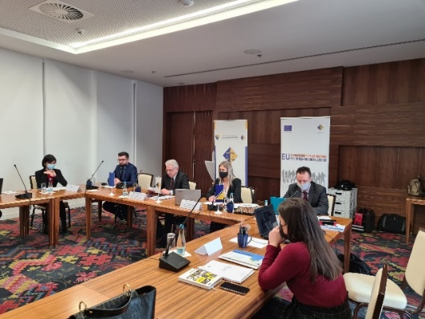

Image 2: Infographic on the process of introducing strategic planning in the BiH courts
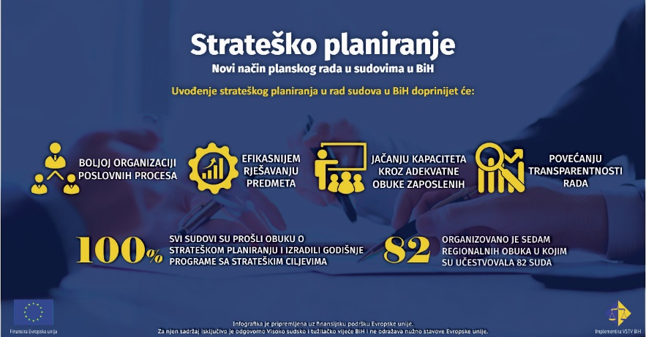

Introduction of the efficiency indicators
Efficiency indicators have been introduced in the judiciary for the first time, with the aim of identifying specific problems in the courts more quickly and easily. Given the indicators and information they provide, the HJPC BiH will have the opportunity to render appropriate measures as to provide support and instructions for the court(s) in which a particular problem has been identified, with the ultimate goal of increasing the efficiency and productivity of the BiH courts.
Introduction of the efficiency indicators as a way of monitoring the performance of courts has multiple implications for the BiH judiciary. Although the HJPC BiH has developed numerous tools for managing and monitoring the work of courts in recent years, the development of performance indicators is a step towards strengthening the regulatory role of the HJPC BiH, but also the management role of court presidents so that all court presidents will have a uniform method to follow the results of their courts and be proactive in case of certain problems (e.g. increased duration of pending cases, reduced quotas achieved, etc.)
Efficiency indicators are a set of data whose results are analysed and correlated with each other.
Although the set of indicators was adopted in 2020, their actual application began in 2021 after they were assigned individual weights in order to show the total score for each court. This method of ranking the courts represents a list of priority courts that need support from the HJPC BiH in order to address the observed work delays.
This management mechanism is a comprehensive tool that will assist the HJPC BiH in adopting management policies, and the courts in identifying problems in their work so that they can take a strategic approach to solving problems.
The HJPC BiH has adopted eight indicators:
- Clearance rate
- Disposition time (DT)
- Disposition to pending times ratio
- Backlog reduction plan realisation rate
- Collective quotas of judges
- Number of judicial office holders (filled positions and systematised positions), average number of disposed and pending cases per judicial office holder
- Costs of judicial proceedings / average cost
- Statistical quality
All reports used by the HJPC BiH for the purpose of calculating efficiency indicators are available to the courts through the Reporting and Decision Support System (SIPO system).
The importance of monitoring efficiency indicators was recognised both during the definition of strategic court plans and annual work plans, and during the competition procedure for the appointment of court presidents.
Backlog reduced with the backlog reduction plans in courts
In 2021, the courts disposed of 163,025 oldest cases in line with the backlog reduction plans, i.e. 22,573 cases more than in 2020.
Expressed as percentage of the backlog reduction plan realisation, the courts realised 87% of the plans, i.e. 7% more compared to 2020.
Graph 8: Backlog reduction plan realisation rate per year

The practice of drafting backlog reduction plans in courts, introduced by the HJPC BiH in 2011, contributes the most to increased efficiency of courts. The main goal and purpose of drafting backlog reduction plans in courts is to resolve cases chronologically based on the date of the initial act and to ensure the exercise of the parties' rights to a fair trial within a reasonable time. Courts prepare backlog reduction plans in line with the provisions of the Instruction for Drafting Backlog Reduction Plans, which was first adopted by the HJPC BiH in December 2010, and subsequently amended in order to further increase efficiency in resolving the oldest cases in courts.
By implementing backlog reduction plans, courts resolve an average of about 130,000 of the oldest cases annually (taking into account the results of work from 2011 to 2021). The results from the period when the backlog reduction plans were introduced until the end of 2021 indicate that over 1.4 million cases were resolved in the courts.
Although the COVID-19 pandemic significantly affected the work of the courts, they managed to maintain an above-average result over the last two years.
A significant contribution to the successful implementation of this activity was given by the developed mechanism of continuous monitoring of the achieved results and continuous supervision over the implemented processes, for which the relevant standing committees of the HJPC BiH are primarily in charge.

More efficient processing of corruption and organised crime cases
Improving inter-institutional cooperation among courts, prosecutor's offices and bar associations has been recognised as a key element for more efficient processing of corruption and organised crime cases.
More efficient processing of these types of cases is a key to reducing crime rates, strengthening security and the state's legal system, which is also a recommendation of all international reports on the work of the judiciary. Given that European standards of justice are one of the strategic commitments of the HJPC BiH, at the initiative of this regulatory body, a number of activities have been launched to improve this field. At the session of the Council, held on 24 February 2021, a number of conclusions were adopted regarding the strengthening of procedural discipline in courts and the development of concrete action plans to accelerate the resolution of cases of these types as well as organising thematic meetings with relevant institutions. These conclusions provide a starting point for all future activities.
In the second part of 2021, at the initiative of the HJPC BiH, a series of meetings of representatives of key judicial institutions were held with the aim of opening a dialogue on more efficient and high-quality and faster processing of these types of cases.
Thematic meetings were held with the Court of BiH and the Prosecutor's Office of BiH, and the Entity Bar Associations. The meetings held resulted in the adoption of a set of concrete conclusions that will be implemented, the implementation of which will be monitored by the HJPC BiH.
The main goal of the joint meetings is to establish mechanisms and methods of work that lead to more efficient processing of organised crime and corruption cases in the country, with emphasis on the findings of the Expert Report on Rule of Law issues in Bosnia and Herzegovina and other relevant international documents. In 2022, meetings with other courts and prosecutor's offices are also planned.
In parallel with these activities, efforts were made to improve the monitoring of corruption cases in the courts.
Given that the processing of corruption cases is in the focus of public interest in BiH, the HJPC BiH has enabled the monitoring of corruption cases in the courts through the improvement of the Automatic Case Management System (CMS).
For the first time, in the CMS used by all courts in BiH, a mechanism for monitoring corruption and organised crime cases has been established through a part of the programme called the interactive map for courts. The map is available on the judicial web portal, and contains statistical data on the flow of cases, the implementation of the backlog reduction plans and the length of pending cases.
The goal that will continue to be pursued is to resolve corruption and organised crime cases in a shorter period than the current one, which is of great importance for fulfilling the criteria for accession of BiH to EU, and thus strengthening the rule of law in BiH.

Image 3: Interactive map for courts
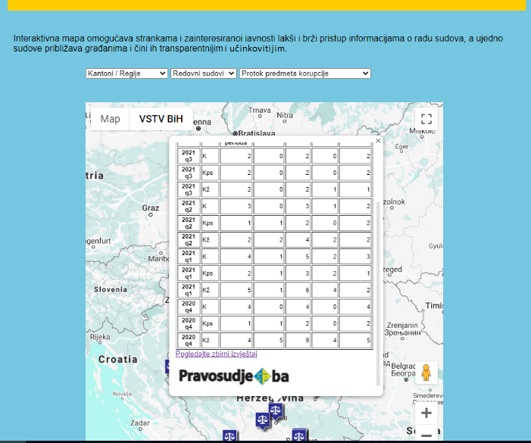

Image 4: Thematic meetings of key judicial institutions
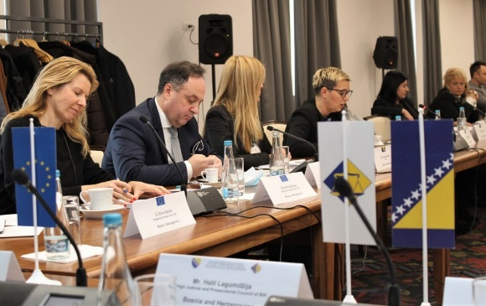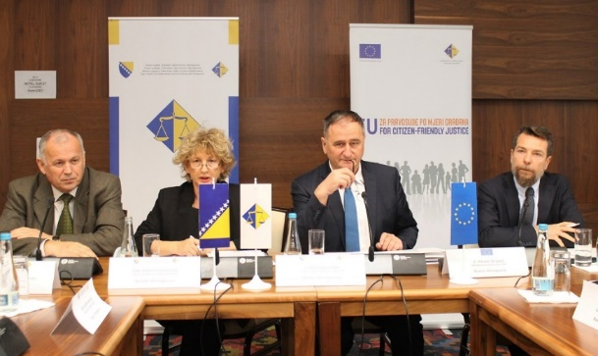

Improving enforcement procedures in BiH
Activities of the HJPC BiH with the aim of improving the enforcement procedure in BiH
Improving the enforcement procedure is one of the most important elements of the reform process being implemented in the BiH judiciary.
The problem of enforcement procedure was also recognised by the European Commission and it was clearly emphasised through the recommendations of the Subcommittee on Justice, Freedom and Security and the Expert Report on Rule of Law issues in Bosnia and Herzegovina that systematic measures are needed to resolve a large number of pending enforcement cases.
In accordance with the conclusions of the Subcommittee, the Working Group for the Improvement of Enforcement Procedure and Revision of the Law on Enforcement Procedure in BiH was formed, whose members are representatives of the competent ministries of justice, judicial community and HJPC BiH. The members of the Working Group defined short-term and long-term objectives, which were partially met in the past period. The short-term objectives are reflected in the launch of an initiative aimed at amending the existing laws on enforcement procedure in BiH, while the long-term objectives were comprehensive reform of the enforcement procedure in BiH, i.e. introducing a new model of enforcement procedure in BiH.
Through the activities of the Working Group for the Improvement of Enforcement Procedure in BiH, amendments to the existing laws on enforcement procedure in BiH have been defined. The short-term objectives have been met thanks to the significant efforts of the members of the Working Group who are representatives of the judiciary and representatives of the HJPC BiH. The proposed amendments to the law will have a positive impact on the efficiency of judicial institutions, and significantly reduce the length of enforcement proceedings. A greater number of enforced judgements will significantly affect the perception of the public, as well as restoring their confidence in the work of judicial institutions.
In that respect, thanks to the efforts of the Working Group, a legislative initiative was launched in the Federation of BiH and the Brčko District of BiH. Amendments have been adopted by the BD BiH Assembly, while the adoption of the amended FBiH Law is still pending. In 2021, the FBiH Ministry of Justice managed to initiate the legislative procedure for the adoption of amendments to the FBiH LEP. However, according to the representatives of the relevant ministry, after the first reading of the law in the parliamentary procedure, it was necessary to make additional amendments concerning the FBiH Ministry of Finance. Despite everything that was accomplished by the end of 2021, amendments to the law in the FBiH have not been adopted yet.
As for the amendments to the RS Law on Enforcement Procedure, members of the Working Group on behalf of the RS Ministry of Justice pointed out that amendments to the Law would not be adopted in the near future.
The second task, which refers to finding the optimal model of the reform of enforcement procedure in BiH, despite all the efforts of the representatives of the HJPC BiH and the Delegation of the EU has not been achieved. Despite all efforts to open a dialogue on the selection of an efficient and adequate model of enforcement procedure in BiH, an analysis of the model of introducing a system of private enforcement agents (with the advantages of this model), EU recommendations, analysis of enforcement models in EU and neighbouring countries, the ministries of justice did not take concrete actions in line with proposals given in relevant international reports, i.e. there was not enough interest in the dialogue regarding the introduction of a new model - professional enforcement agents.
Given the views of the executive power in BiH, the question arose for the representatives of the HJPC BiH if there would be a point in continuing the participation and activities in the Working Group. In this context, the competent ministries of justice were invited, as well as the competent entity governments, in accordance with their responsibilities, to present a further position on the reform of the enforcement procedure and the direction of reform, and set out clear measures, contribution to be provided by ministries and activities aiming at final reforms of the enforcement process, which will ultimately yield results. After they submit their positions, the HJPC BiH will reconsider its continuation of activities in the Working Group.
As no results have been achieved in the past period regarding the long-term reform of enforcement procedure, the HJPC BiH continued its activities aimed at improving the work of enforcement departments of courts by establishing cooperation with the Swedish Enforcement Authority, which is the state enforcement agency in Sweden. The purpose of this cooperation is to apply the good practices of the Swedish Enforcement Authority in BiH, in accordance with the existing legislative framework.
The HJPC BiH, in cooperation with partners, identified segments of enforcement procedure improvement of which can contribute to more efficient implementation of enforcement actions by court employees, and based on which a set of recommendations for courts was made. The set of recommendations for the improvement of enforcement procedure will be first implemented in five pilot courts, and then in all other courts in BiH.
Application of the SOKOP-Mal system for more efficient processing of utility cases
For a long time now, the so-called "utility cases” have taken the largest share of pending cases, which is why it was necessary to find the most effective ways to resolve this type of cases. The use of the system for electronic filing and processing of small value cases - so-called "utility cases” (SOKOP Mal) was recognised as one of the ways. Thanks to the application of the system, the increasing trend of pending cases of this type was stopped and it enabled the efficient dealing with cases by judges and legal associates up to the enforcement phase.
According to the decision of the HJPC BiH, the system is mandatory in all first instance courts in BiH and it is available to judgement creditors (public utility companies and "big" judgement creditors such as telecom operators, power companies, etc.) who send a letter to the HJPC BiH and express their interest in using the system and obtain a digital certificate. The system is used by 46 courts and 30 judgement creditors.
As the system proved to be effective, the goal was to further improve it by introducing new functionalities, primarily strengthening security and data protection systems, as well as improving its speed and application. With the support of the Government of the Kingdom of Norway, through the Improving Judicial Quality project, the development of the second generation of SOKOP-Mal system was funded, which is reflected in:
- Implementation of a new functionality of the system (the so-called Public Module) which implies that judgement debtor can access the court case through Internet using an access code. In this way, the debtors will be able to review the case and follow it;
- Launch of new SOKOP application servers, which will enable faster data processing;
- Testing of all system modules was performed in order to increase the security of system use.
- Introduction of new IT technologies that will enable overcoming of existing system deficiencies, introduction of new functionalities, increased security and data protection, as well as the speed of the system and its applications.
- Migration of data to new databases.

Image 5: Case review screen for judges
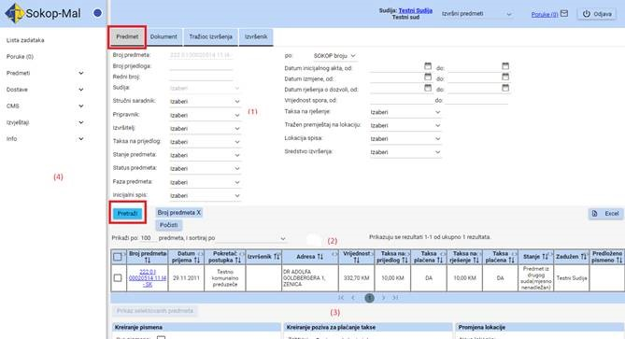

Improving business processes in courts, through reorganisation of work and human resources in courts
The work was reorganised and a system of more efficient use of human resources was established in eighteen target courts from the entire territory of BiH, which resulted in a shorter duration of court proceedings.
The changes are the result of joint work and cooperation between the HJPC BiH and the Swedish National Courts Administration under the project Improving Court Efficiency and Accountability of Judges and Prosecutors in BiH (ICEA).
This cooperation is based on the exchange of experiences, knowledge and application of good practice between the courts from Sweden and BiH. The main goal is to create working conditions that will relieve judges of administrative and technical tasks, which take up a significant part of their time, by assigning them to administrative staff and trainees while ensuring uniform administrative and technical procedures, and through the adoption of relevant procedural rules and tools.
That this is an important process is also shown by the great interest of the courts in the implementation of this activity.
The results achieved in 2021 showed that a different organisation of work enables more efficient and better use of non-judicial staff resources, including trainees, which is directly reflected in more efficient work of the judiciary and cost reduction.
By applying the innovated model of work in all courts, positive results were achieved in terms of organisation and development, depending on the stage of introduction of a new model of work. Changes in work include development of new, more modern tools for work, the application of which contributes to the rationalisation of the court work process, and the improvement of knowledge and competence of court staff. New tools include the application of a list of delegated tasks, a uniform list of actions and tasks, the so-called checklists, as well as a training plan for judicial trainees / volunteers.
Undertaking innovative organisational activities has also contributed to better management and use of human resources, along with cost rationalization. Using new tools, the court presidents organised the work processes through teamwork, using the full capacity of the expertise of each team member. At the same time, the usefulness of new ways of working is reflected in the creation of competent non-judicial staff, with clearly defined roles and status, which significantly increases the qualitative and quantitative performance of non-judicial staff.
In order to complete the process of reorganisation of work, at the same time we worked on improving the material and technical conditions for the court operations by providing a number of computers intended for trainees / volunteers, given that they are more active in performing their tasks.
In order to ensure the provision of continuous support to the courts regarding the implementation of the activity in question during 2021, a series of visits to the target courts were held, as well as an on-line meeting via the Webex platform. Continuous communication with the courts is a kind of control mechanism that seeks to maintain the quality of the results achieved as well as to eliminate certain dilemmas that the courts had during the application of new methods of work.
With the aim of implementing the above legislative activities, the HJPC BiH, through the activities of the Working Group, established cooperation with the relevant ministries of justice.
The work modality of the Working Group, formed by the HJPC BiH in 2021, through meetings and individual work of its members resulted in the adoption of working documents, which are a kind of guide for their own assessment of the fulfilment of commitments. Through the analysis of systematisation of both judicial and non-judicial staff positions and of current job descriptions for non-judicial staff and trainees/volunteers, the Working Group has identified legislative shortcomings and the need for a new category of staff. It implies a person with the status of a law graduate and at least one year of work experience. This person will provide professional assistance to the judge. In the forthcoming period, the Working Group will define the qualifications for the new position, and propose its introduction into the relevant bylaws, which will achieve the full effect of the new work model.
Improving the efficiency of bankruptcy proceedings
HJPC BiH, within the project Building an Effective and Citizen-friendly Judiciary (IPA - Instrument for Pre-Accession Assistance), has undertaken a number of activities to strengthen the capacity of bankruptcy judges to more effectively conduct bankruptcy proceedings, especially in terms of understanding its economic aspects.
The length of bankruptcy proceedings has a particularly negative impact not only on persons directly affiliated to bankruptcy debtors, but also on the wider business and social community. The problem of inefficiency in resolving bankruptcy proceedings has its roots both in certain legislative solutions and in bad practices which, as a rule, are not sanctioned, but concern the lack of timeliness regarding the opening of bankruptcy against insolvent bankruptcy debtors. However, part of the problem of inefficiency is related to the issue of conducting and managing bankruptcy proceedings by the competent court, while a special problem is the inadequate capacity of bankruptcy judges in terms of understanding the economic aspects of bankruptcy proceedings.
Therefore, through the engagement of financial advisers with relevant experience in this field, based on the analysis of a representative sample of archived bankruptcy cases, a Module for training of bankruptcy judges was developed, which included economic topics relevant to bankruptcy judges to better understand this aspect of bankruptcy proceedings, which is crucial for greater control and better management of bankruptcy proceedings.
Based on this Training Module, the HJPC BiH, in cooperation with the Entity judicial and prosecutorial training centres, conducted training for trainers on this specific topic. During 2021, as continuation of this activity, the HJPC BiH, in cooperation with the Entity judicial and prosecutorial training centres, organised special trainings for bankruptcy judges in Sarajevo and Trebinje, where economic topics relevant to bankruptcy proceedings were presented, starting with financial reports and their analysis, through inventory and assessment, to the audit of the bankruptcy proceedings.
Image 6: Training of bankruptcy judges on the topic of important economic aspects of bankruptcy proceedings
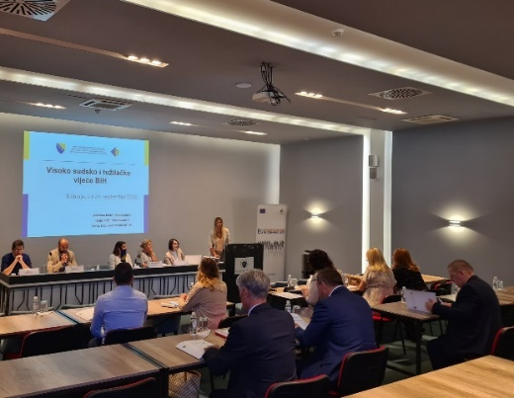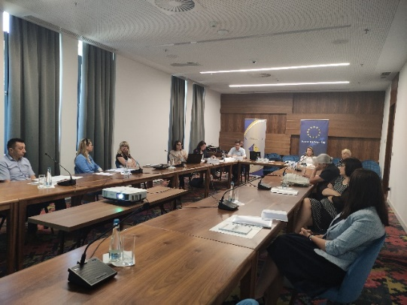

Draft Strategy for Alternative Dispute Resolution developed - faster and more economic dispute resolution
Although alternative dispute resolution has great potential for faster, more economic and often cheaper procedures, the essential alternative to court adjudicating in Bosnia and Herzegovina has not yet taken root to a significant extent. Citizens and businesses still rarely decide to entrust the resolution of their dispute to other entities.
Since substantial changes in this segment require synchronized and comprehensive action, the HJPC BiH, within the IPA 2017 Project, launched an initiative to develop a strategic framework for the development of alternative dispute resolution and formed the Working Group which, in addition to HJPC representatives, consists of representatives of line ministries of justice at the Entity and BiH level, the Judicial Commission of the Brcko District of BiH, the Foreign Trade Chamber of BiH, the Association of Mediators in BiH, the Ombudsman Institution for Consumer Protection, the Association Arbitri from Sarajevo and representatives of the judiciary. Through the work on defining the strategic framework in this segment, a draft Strategy for Alternative Dispute Resolution was developed, which included the segments of court settlement, mediation, arbitration and amicable settlement of consumer disputes.
Unfortunately, due to the political blockade of the BiH institutions, there was no engagement of representatives of the RS Ministry of Justice in the past year, and therefore it was not possible to consider the adoption of the draft Strategy.
In addition to working on the strategic improvement of this segment, presenting to the citizens and the business community the benefits of amicable and alternative dispute resolution in relation to judicial decision-making in regular proceedings, was one of the goals of the HJPC BiH in 2021.
The HJPC BiH organises Weekly Court Settlements in all first and second instance courts, during which the courts make particular efforts to resolve as many disputes as possible amicably, i.e. by concluding a court settlement.
During 2021, weeks of court settlements were organised on two occasions, and the HJPC BiH, among other things, provided promotional material for the courts and organised open days for the media in three courts in BiH, which informed the general public about this event and the concept of judicial settlement.
Image 7: Excerpts from media content on the topic of the Open Day for the promotion of the Court Settlement Week
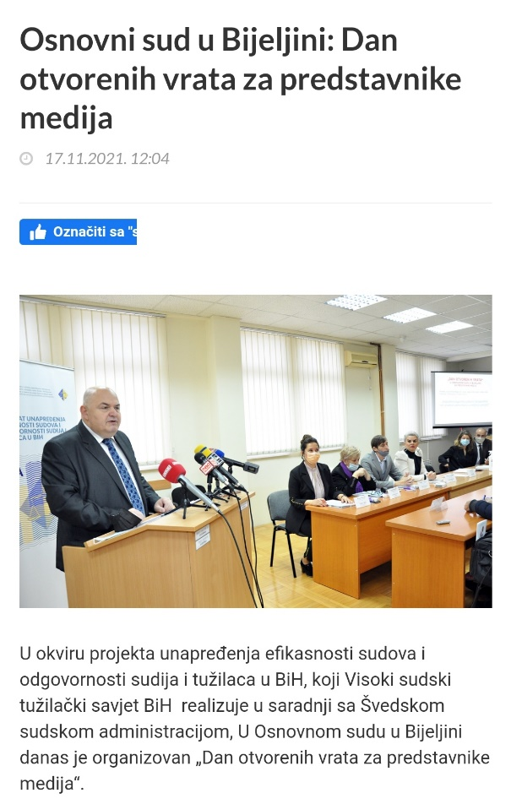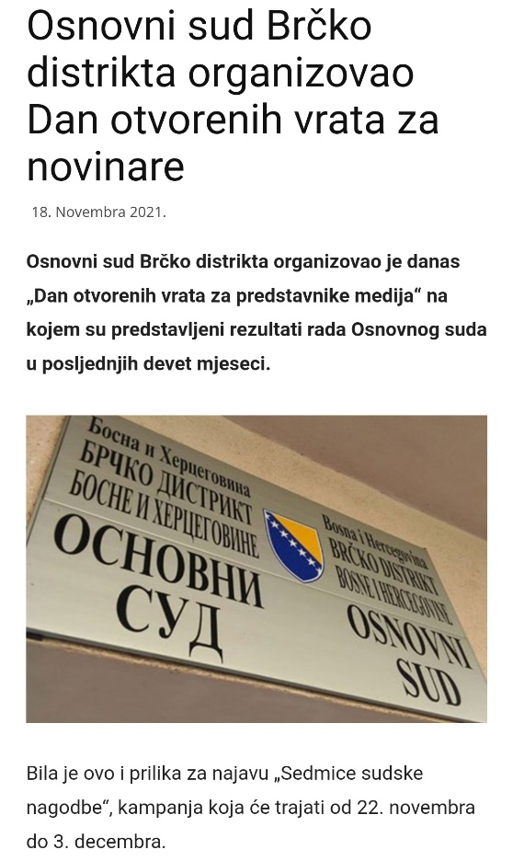

In addition to these activities, the HJPC BiH implemented an information campaign on the benefits of mediation and court settlement, within which video and radio jingles were broadcasted and information posted on social networks.
Image 8: Promotional animated film on large commercial displays
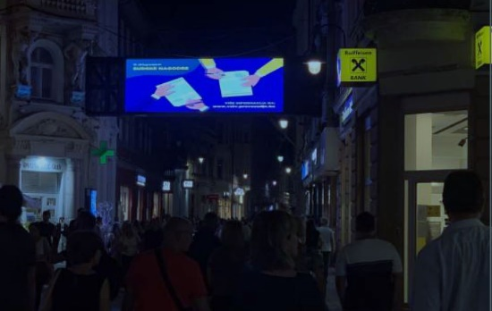

Special emphasis has been placed on the business community in popularizing alternative dispute resolution, including mediation, court settlement and arbitration, as faster and cheaper dispute resolution methods are becoming increasingly important.
In this regard, the HJPC BiH, in cooperation with the Foreign Trade Chamber of BiH, the Chamber of Commerce of Republika Srpska and the Chamber of Commerce of the Brcko District of BiH, organised four informative lectures for the business community, held in Sarajevo, Mostar, Banja Luka and Brcko District of BiH. At these workshops, economic operators had the opportunity to hear all the practical advantages of amicable and alternative ways of resolving disputes over dispute resolution in regular court proceedings, and received all the necessary information from lecturers in the field of court settlement, mediation and arbitration.

Image 9: Informative workshops on the benefits of alternative dispute resolution
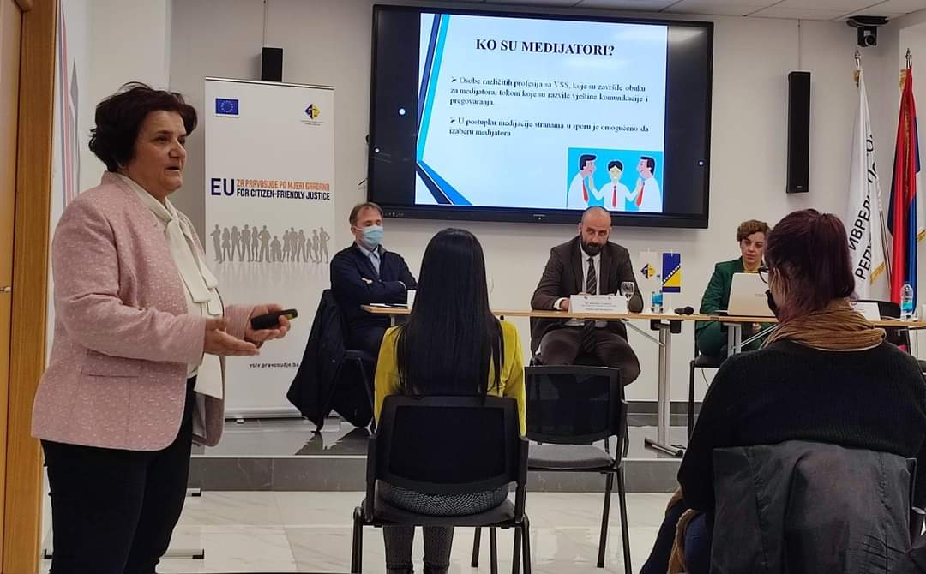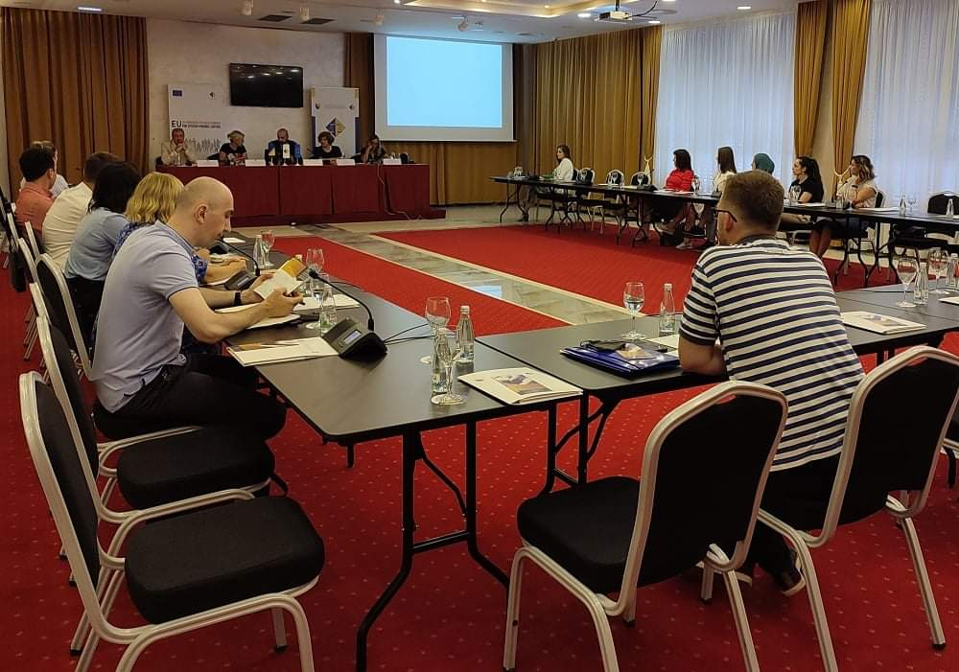

Improving efficiency and quality of civil procedure
Introducing quality standards in target courts and strengthening the capacity of civil / litigation departments
In 2021, the capacities of seven courts have been improved for the efficient and quality implementation of civil proceedings, which primarily refers to the improvement of the procedural discipline of litigation management, organisation and teamwork of civil / litigation departments of target courts. The Municipal Court in Mostar and the Cantonal Court in Mostar, the courts in the West Herzegovina Canton, the Basic Court in Trebinje and the District Court in Trebinje have been selected as judicial institutions in which changes will be introduced, which will be a model for all other institutions in BiH.
The introduction of a different approach in the work of civil / litigation departments began with the establishment of cooperation between civil judges from courts in BiH with judges from Norway and the Netherlands, partner countries with impressive experience in this field, and continued with the development of materials to improve current practices.
Guidelines and recommendations have been developed, as well as check-lists for examining the lawsuit and responding to the lawsuit, as well as a form for preparing and conducting civil proceedings. These are tools that significantly affect the efficiency of court proceedings and better preparation of judges.
The courts that are part of the first phase of improving the efficiency of litigation have worked intensively on the harmonisation of proceedings and case law using professional dialogue mechanisms, established through memoranda of cooperation, signed under the project Improving Judicial Quality, through which activities for the improvement in this field are implemented.

Image 10: Visit of the IJQ Project Expert Team to the District Court and Basic Court in Trebinje (September, 2021)
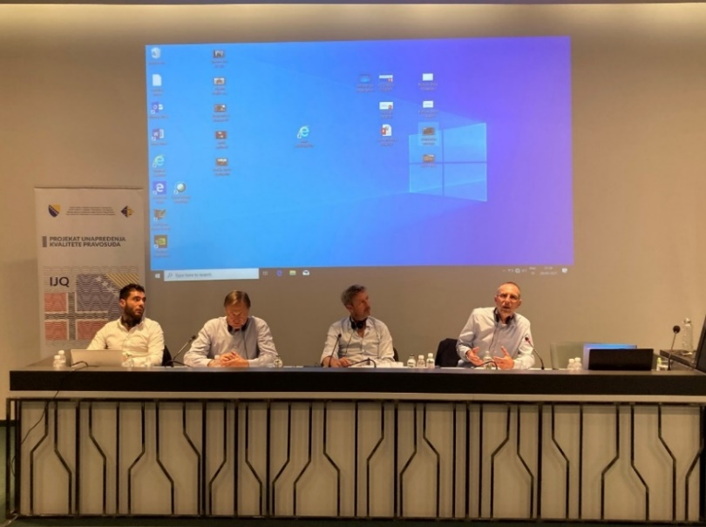

Image 11: Visit of the IJQ Project Expert Team to the Municipal Court and Cantonal Court in Mostar
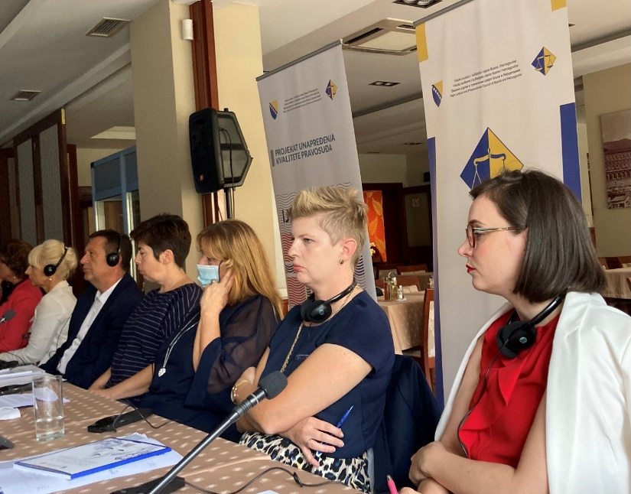

In order to present all the activities, results and experiences of the courts in the implementation of these activities, an updated edition of the publication "Blueprint - materials to improve the efficiency and quality of justice" was prepared. The publication contains a detailed description of all activities aimed at civil proceedings and management of civil departments, carried out in the period from 2015 to 2021, which will facilitate the application of positive practices in other courts.
Implementation of the Strategy for Improving Gender Equality in the Judiciary in BiH
The process of implementation of the Strategy for Improving Gender Equality in the Judiciary of BiH, adopted by the HJPC BiH at the end of October 2020, continued intensively in 2021 under the project Improving Court Efficiency and Accountability of Judges and Prosecutors in BiH - phase 3, funded by the Government of Sweden.
The Strategy contains all the most important steps that need to be taken in order to improve gender equality in the judiciary. At the same time, the Strategy is the basis for creating action plans for improving gender equality in all judicial institutions in BiH, which will be the very first strategic approach to this topic.
In four judicial institutions in BiH (the Cantonal Court in Sarajevo, the Basic Court in Bijeljina, the Prosecutor's Office of the Sarajevo Canton and the Prosecutor's Office of the Brčko District of BiH) a pilot phase was implemented to develop a model for the most effective implementation of the Strategy. In this phase, a document was developed within which good practices for the implementation of the Strategy were presented, which will be applied in other judicial institutions. The document is an integral part of the planned workshops that will be held in 2022, during which the representatives of all 102 judicial institutions in BiH will be presented with the starting point for the development of action plans for implementation of the Strategy.

Image 12: Title page of the publication created within the pilot phase of the Strategy implementation
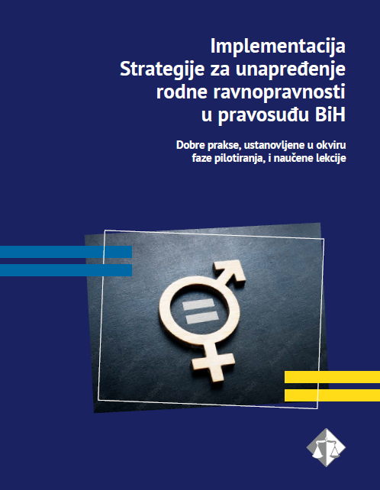

Image 13: Workshops held as part of the pilot phase of the Strategy implementation
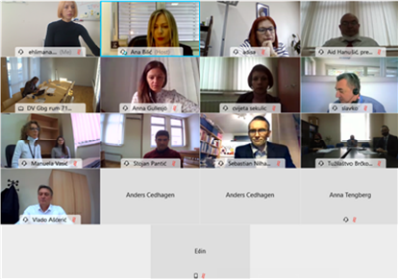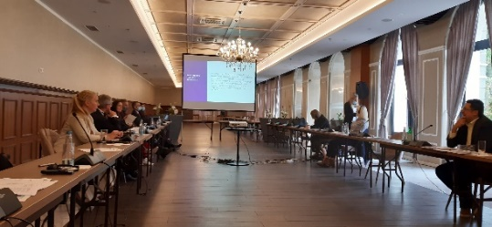

As part of the Strategy implementation efforts, the target judicial institutions have established working groups and appointed "ambassadors" of institutions - staff, who will support other judicial institutions in BiH in the process.
In order to determine the situation in the institution, as a basis for planning further activities, anonymous surveys on gender equality were conducted among the staff of target judicial institutions, but also users of court services and professional parties, appropriate training for employees of institutions was conducted, numerous analyses of processes and internal regulations and official documents were adopted by the heads of institutions, all with the aim of ensuring adequate implementation of the Strategy.
The judiciary and vulnerable groups
The HJPC BiH has been working intensively on the implementation of activities aimed at strengthening the rule of law, democracy, human rights and improving the position of vulnerable groups in contact with the courts in 2021, through several segments.
Efforts to improve the handling of discrimination cases, as one of the most important segments in the aspect of needs of vulnerable groups, continued with the creation of the Instruction on the use of the amended CMS codebook for Discrimination Cases, in cooperation with the OSCE Mission to BiH.

Image 14: Title page of Instruction on the Use of the Amended CMS Codebook for Discrimination Cases
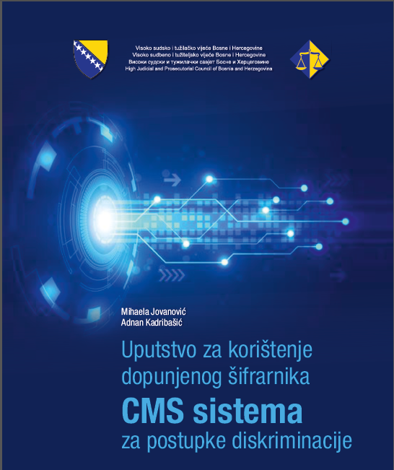

The purpose of this Instruction, which is intended for judges and registrars, is to offer additional information on the purpose and objective of the part of the CMS dealing with discrimination, clarify the entry of required elements in the CMS and ensure consistent data entry, so that data can be used for statistical reporting on discrimination cases.
Improving the position of members of vulnerable groups in contact with the judiciary is also aimed at conducting case analyses on hate crimes and incitement to hatred in the courts of BiH. This Analysis identified shortcomings, primarily in the collection of reliable data and statistics on these crimes, as prerequisites for creating effective policies to combat hate-motivated incidents, and created an action plan to improve the situation. The results of the 2022 Analysis will be considered first by the Standing Committee on the Efficiency and Quality of Courts, and then by the Council.
With regard to children and juveniles, the HJPC BiH continued to provide support to UNICEF BiH, in the context of equipping facilities in judicial institutions for hearing children in contact with the law, in accordance with the Minimum Standards for Equipping and Using Witness Child Examination Rooms, adopted by the HJPC BiH.
Faster resolution of enforcement proceedings, regarding the enforcement of adjudicated restitution claims in cases of war sexual violence, is another significant result, which was achieved in cooperation with TRIAL International. A technical solution was created and implemented, which included the addition of a new legal basis for enforcement in the CMS system and the introduction of an urgency mark for enforcements.
One of the segments that was improved through the project Improving Court Efficiency and Accountability of Judges and Prosecutors in BiH was the issue of gender-based violence.
Following a survey on the conduct of judicial office holders in cases of gender-based violence, the HJPC BiH has created an action plan aimed at improving the position of victims of violence in contact with the justice which will be implemented in cooperation with the OSCE Mission to BiH.
For the first time, within the training and professional development program of the Entity Judicial and Prosecutorial Training Centres (JPTCs), a seminar on Members of vulnerable groups as witnesses in the proceedings was realised in partnership with the AIRE Centre (Advice on Individual Rights in Europe).
The seminar participants had the opportunity to get acquainted with the basic communication skills and their application in investigative and court proceedings, basic communication techniques in the work of prosecutors and judges, and communication skills in situations of intense feelings.
In addition, they discussed ways of examining witnesses - members of vulnerable groups in the investigation and court proceedings, and ways to motivate these categories of witnesses to testify.
Image 15: Seminar Members of vulnerable groups as witnesses in the proceedings
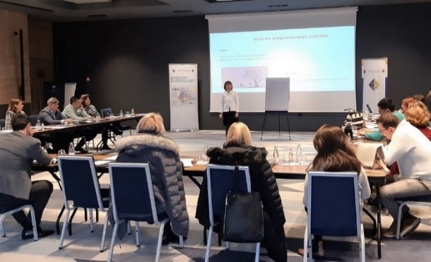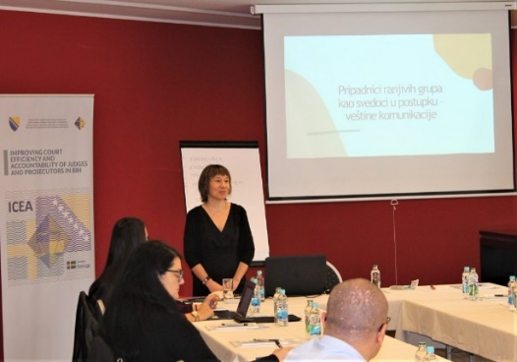

This year, the HJPC BiH joined the International Campaign 16 Days of Activism against Gender-Based Violence and, in cooperation with the Atlantic Initiative Association, organised advanced training for newly appointed advisers for the prevention of sexual and gender-based harassment in judicial institutions in BiH. At the suggestion of the HJPC BiH, the JPTCs have also included appropriate seminars/workshops on gender equality and the rights of vulnerable groups in their 2022 programmes for training and professional development.
Improving the quality of judgement in civil proceedings
In an effort to improve the quality of court decisions in BiH, the HJPC BiH has issued two important publications under the project Improving Judicial Quality: Manual and Guidelines for writing judgements in civil cases.

Image 16: Writing Manual for Civil Judgements
Image 17: Writing Guidelines for civil judgements

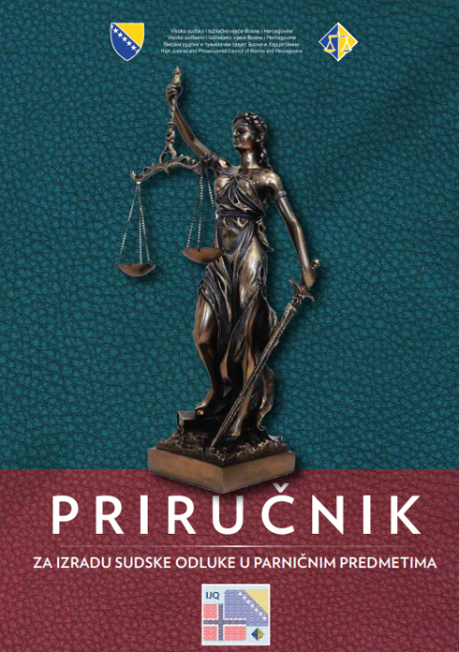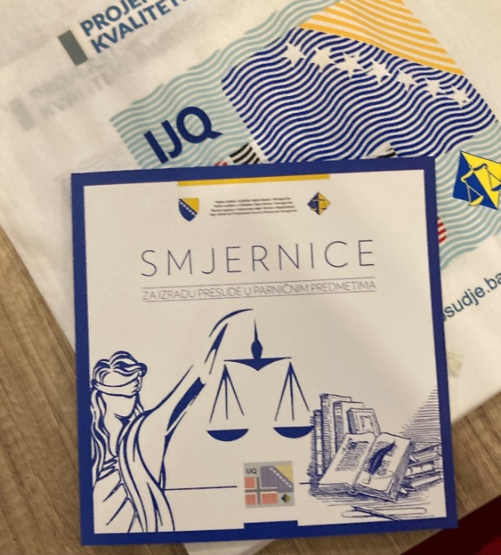
The publications are the result of a previous analysis of the quality of civil judgements, made by a panel of experts appointed by the HJPC BiH in 2019. Based on the findings of the analysis, i.e. identified specific shortcomings in the structure, language and legal reasoning of judgements in civil proceedings, experts began to develop materials that will help judges and court associates to avoid errors, i.e. improve judgement drafting techniques and training of judges and legal associates.
In cooperation with JPTCs, a total of six workshops were organised for judges and legal associates, focusing on the Manual and Guidelines, i.e. presenting the content and benefits of publications for courts in BiH. The professional / educational materials and training programmes developed under the project will serve JPTCs and courts for the continuous training of judicial office holders in order to improve the quality of court decisions.

Image 18: The Quality of Civil Judgement Drafting, workshop, Sarajevo, December 2021
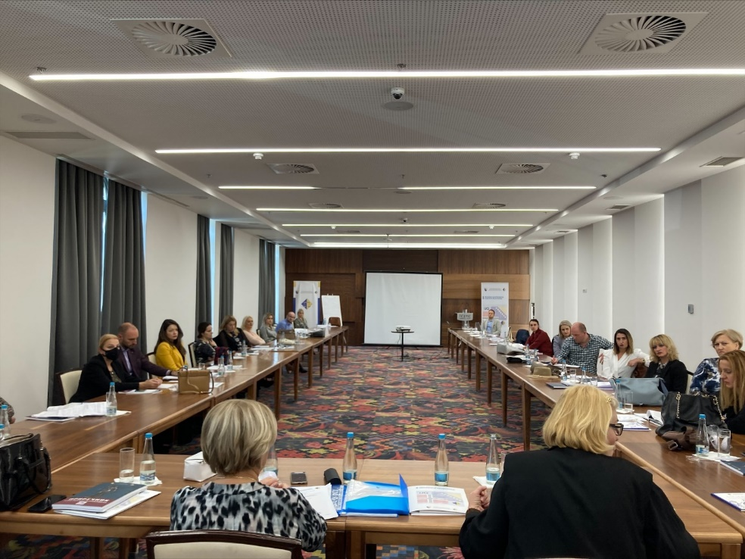
Initiating civil legislation reform
In 2021, the HJPC BiH, under the project Improving Court Efficiency and Accountability of Judges and Prosecutors in BiH, began considering the reform of the appeal procedure in civil litigation.
A detailed analysis of the state of appeal procedure before the courts in BiH was conducted, which indicated the specific needs for amendments to the applicable laws on civil procedure and other relevant regulations.
In the forthcoming period, an expert team consisting of representatives of the judiciary and academia, as well as experts in the field of civil law, will work on drafting a framework proposal for legislative amendments, as well as other measures affecting the number and duration of second instance civil proceedings.
Upon completion of the mandate of the expert team, the HJPC BiH will, in accordance with its legal competencies, forward an initiative for legislative amendments to the competent ministries.
Assessment of independence, accountability and quality of justice according to the ENCJ Indicators
In 2021, for the first time, the HJPC BiH participated in the assessment of the independence, accountability and quality of the judiciary by applying the criteria of the ENCJ, which means that the measurement was performed in accordance with all European standards.
The results and steps achieved by the HJPC BiH in the implementation of this activity are extremely important for the institution and the judiciary, given that the opportunity was used for the Council to apply the tools of the ENCJ (questionnaires and surveys), to make an objective assessment of independence, responsibility and quality according to the ENCJ measurements, and to set priorities for its own work and the work of judicial institutions, to define effective mechanisms for meeting the identified priorities, which will ultimately lead to the alignment of the domestic judiciary with the EU justice systems.
Image 19: Meeting with representatives of the National Courts Administration of Norway and the Council for the Judiciary of the Netherlands on the application of the ENCJ’s principles.
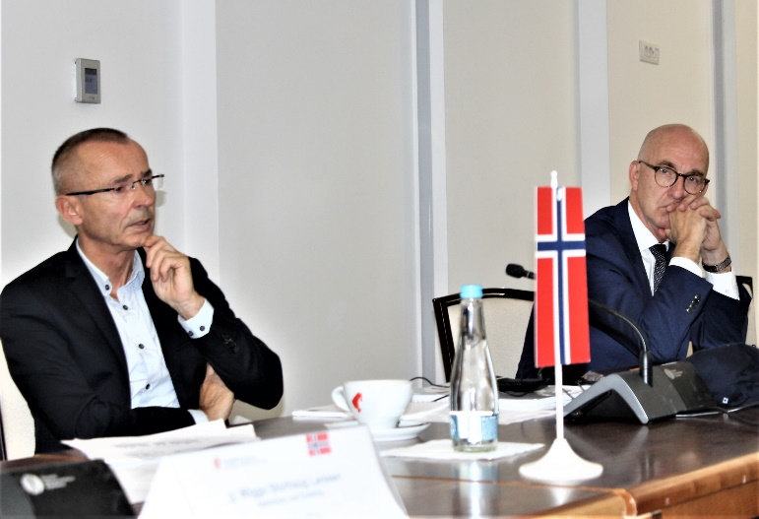

The Report provides an overview of the state of the BiH judiciary and identifies areas of work of the HJPC BiH and the judiciary that are not in line with European standards and that require improvement. As such, the Report is the basis for determining the further course of action of the HJPC BiH, defined and aligned with the highest European standards.
The key findings show that the HJPC BiH and the courts in BiH are working intensively to improve independence and accountability, and that the HJPC BiH is one of the few judicial councils in Europe to assess the quality of judgements.
The fact that the HJPC BiH, unlike other EU judicial councils, continuously conducts a survey of court users' satisfaction is also assessed as positive.
At the same time, the Report points out that further progress is needed, in particular in the field of asset declarations, appointment and promotion of judges, ethics and ethical conduct of judicial office holders. Shortcomings were also identified in the field of media relations and transparency, which led to a negative perception of the independence of the judiciary.
In view of the above, the Report proved to be a good corrective and preventive tool that encouraged thematic meetings between members of the Council and representatives of the Norwegian Courts Administration, the Council for the Judiciary of the Netherlands and representatives of the ENCJ, with the aim of reviewing the structural, legal and institutional problems of the BiH judiciary, and determining the further direction of the HJPC BiH. The meetings also resulted in determining the need to initiate dialogue meetings with other actors, which have a direct or indirect impact on the work of the judiciary, in order to provide quality and objective information on the functioning of the judicial system and ultimately get a more objective picture of the current BiH judiciary.
The collected views and opinions of the professional community were formalised through the Fact Finding Report which assesses the response of the judiciary to challenges that threaten, but also factors that improve the independence and accountability of the entire judiciary.
This diagnostic instrument, together with the Report prepared on the basis of the applied principles and tools of the ENCJ, will serve as a basis for determining priorities in the processes of reform and determining the direction in which these reforms should move.
The analysis was carried out under the project Improving Judicial Quality, and within the trilateral cooperation among the HJPC BiH and the Courts Administration of Norway and the Council for the Judiciary of the Netherlands.
Reconstruction and modernisation of selected judicial buildings
After the completion of the tender procedure for the selection of contractors and supervision of the construction works, the construction and renovation of buildings of five judicial institutions began in October 2021. The works were funded by EU under IPA 2017, and the completion of works was planned in 12 months.
The High Judicial and Prosecutorial Council of Bosnia and Herzegovina, with the financial support of the Government of Sweden, and under the project Improving Court Efficiency and Accountability of Judges and Prosecutors in BiH, provided project documentation for the construction of brand new buildings for District Public Prosecutor's Office in Bijeljina, Municipal Court in Žepče and part of the building of the Municipal Court in Zenica, while the buildings of the Basic Court in Prnjavor, the Basic Court in Mrkonjić-Grad and the ground floor of the existing building of the Municipal Court in Zenica will be renovated. The total value of the prepared project documentation, as well as all required studies (geomechanical reports, urban-technical conditions, studies on energy efficiency of buildings, review of project documentation), amounted to about BAM 160,000.
Infrastructural and technical solutions on the existing buildings of these judicial institutions could not meet the needs of a modern, efficient and citizen-friendly judiciary, which is why their adaptation and construction of new facilities is extremely important in establishing an efficient judicial system.

Image 20: Municipal Court in Žepče
Image 21: Condition of the archives of the Municipal Court in Žepče

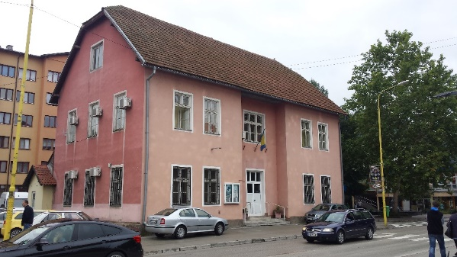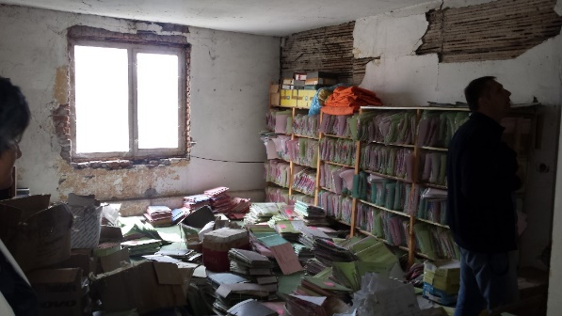

Image 22: Condition of the boiler house in Mrkonjić-Grad
Image 23: Appearance of the courtroom

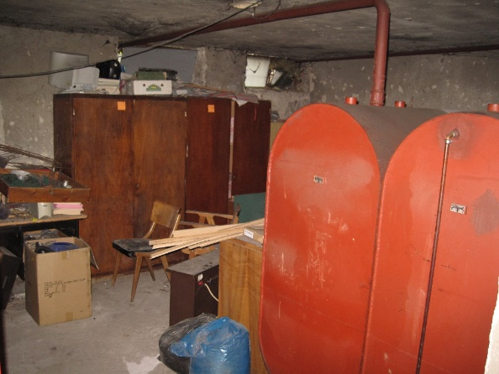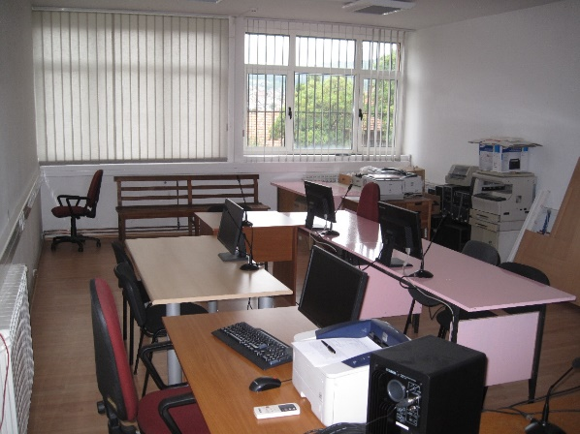

Image 24: Construction of a new part of the building of the Municipal Court in Zenica
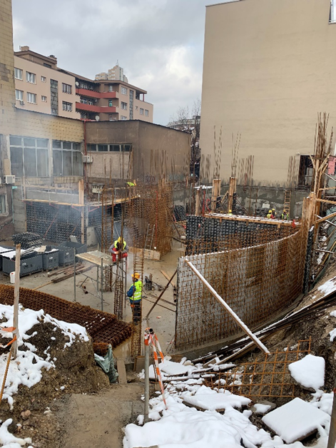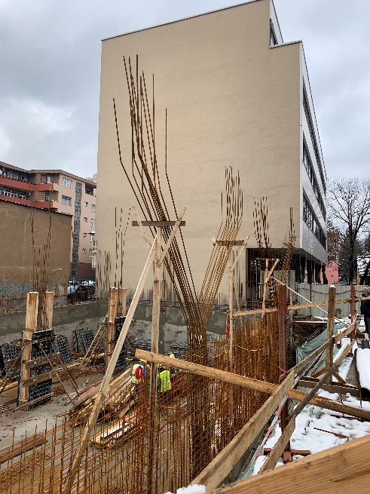

Image 25: Future appearance of the Basic Court in Mrkonjić-Grad
Image 26: Future appearance of the Basic Court in Žepče

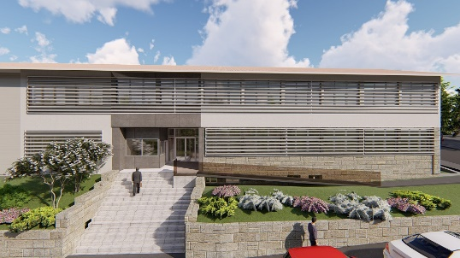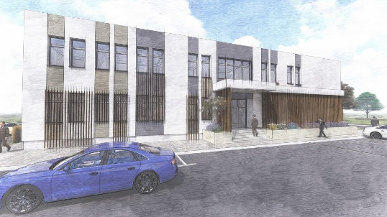

Conversion of the Miljacka Prison premises
In recent years, through the involvement of the HJPC BiH and with the help of international donors, a significant number of court and public prosecutor's buildings in Bosnia and Herzegovina have been completely renovated or built, and the practice has continued this year as well.
The building of the Palace of Justice in Sarajevo is positioned at the very top of the list of priorities in the renovation of the buildings of judicial institutions, because the building itself does not meet the requirements of modern times, and the lack of office space does not allow the efficient operation of two courts. Although adapted in 2009 with the help of donors and local authorities, the problem of lack of space is still present.
In order to solve the constant problem of the accommodation capacity of judicial institutions in Sarajevo, the HJPC BiH assumed a role in solving it and in 2014 proposed the construction of a new facility to house the Cantonal Prosecutor's Office in Sarajevo or the Cantonal Court in Sarajevo. As there were no available plots in the town centre and none of the institutions accepted this proposal, we resorted to finding another solution.
In 2017, the HJPC BiH submitted a proposal to the FBiH Ministry of Justice to find a solution to this problem, which consisted of moving the Miljacka Prison in Sarajevo to a new location, which would create more room for the Cantonal Court in Sarajevo and the Municipal Court in Sarajevo.
It is important to recall in this part that in the processes for programming EU pre-accession assistance under IPA 2017, due to significance of the issue, in order to support dislocation of Miljacka Prison, the HJPC BiH has changed the purpose of the 1,500,000 EUR grant that was initially intended for modernisation of the buildings of judicial institutions in the FBiH. The construction of the Miljacka Prison began in 2021, and it is funded by EU under IPA programme and the FBiH Government. Completion of the construction works is planned for the end of 2022, after which the conditions for the relocation of the prison will be met.
This is a prerequisite for beginning the expansion of the accommodation capacities of the Cantonal Court in Sarajevo and the Municipal Court in Sarajevo.
As in previous years, the Government of Norway proved to be a solid partner of the HJPC BiH in the process of improving the working conditions of judicial institutions in BiH, and under the project Improving Judicial Quality, in the part related to the modernisation and reconstruction of the buildings of judicial institutions, in 2021, it funded development of project documentation for the reconstruction of the semi-open prison Miljacka based in Sarajevo, in order to expand the room for Cantonal Court in Sarajevo and the Municipal Court in Sarajevo. The value of the project documentation was BAM 69,500.00. Review of the project documentation amounted to BAM 9,850.00 and it was also paid from these funds.
Given that this is a building that is under the protection of the Commission for the Preservation of National Monuments of BiH, the design and technical documentation was prepared in accordance with the relevant regulations of the FBiH Ministry of Spatial Planning and the Commission for the Preservation of National Monuments of BiH, on the basis of which it will be possible to obtain the necessary approvals and permits.
By renovating the premises of the Miljacka Prison, the Cantonal Court in Sarajevo and the Municipal Court in Sarajevo will have expanded accommodation capacities, which will meet the long-term needs of these institutions and enable filling out vacancies under the jobs systematisation. The planned construction works would improve the functional organisation, as well as working conditions, both for employees and the public. Furthermore, the construction works would improve both access for people with disabilities and energy efficiency.
With this project, in addition to the courts, the accommodation of the judicial police will be addressed as to have the adequate functioning of the courts within the Palace of Justice, especially with regard to the processing of criminal and minor offence cases. Taking into account the Guidelines for security standards and measures for judicial institutions and judicial office holders in Bosnia and Herzegovina, the judicial police will be provided with sufficient capacity of detention rooms and an adequate level of their security.
The future external and internal appearance of the existing building of the Miljacka Prison was presented at one of the meetings of all relevant actors involved in solving the problem of accommodation capacity of the Miljacka Prison and the courts.

Image 27: Future appearance of the Miljacka Prison
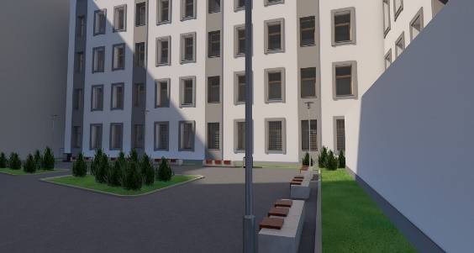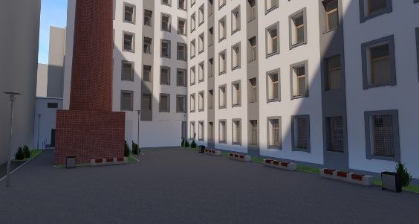

More proactive communication by the courts leads to greater transparency
New communication practices in judicial institutions in Bosnia and Herzegovina
Strengthening the transparency of the courts, primarily through the improvement of communication activities, was the focus of the work of the HJPC BiH throughout the year.
The result of intensive work was the adoption of the Communication Strategy of the HJPC BiH, developed guidelines for media reporting, a developed set of tools for effective court communication with the media, as well as new techniques for using communication tools and channels.
The Communication Strategy represents a kind of "umbrella" strategy for all judicial institutions, which will significantly contribute to the uniformity of communication practices, and which will directly reflect on the strengthening of the transparency of their work.
In addition, the Council drafted and printed the Guidelines for Reporting on Court Proceedings, the aim of which is to offer, in a simple and systematic manner, key recommendations to the courts in Bosnia and Herzegovina for up-to-date, complete, truthful and continuous reporting to the public on court proceedings that are of particular interest to the wider or special public, be it direct or media reporting.
The HJPC of BiH recognises the media as important partners in improving the work of judicial institutions, which is why particular attention is devoted to the establishment of a system for proactive communication of judicial institutions with the media and the public.
In order to recognise the key challenges in current communication practices, specialised events for media representatives were organised as one of the activities of the project Improving Court Efficiency and Accountability of Judges and Prosecutors in BiH, Phase 3, which the HJPC BiH is implementing with the support of the Government of Sweden and which is largely dedicated to strengthening this field.
Difficult access to information, the lack of proactivity of judicial institutions in communication with the media, insufficient use of the courts' website as a communication channel, and the lack of persons professionally engaged in public relations are identified as the biggest problems. Based on these parameters, activities were undertaken to improve key segments, primarily through cooperation with three courts (Municipal Court in Tuzla, Basic Court in Bijeljina and Basic Court of the Brčko District of BiH) which already use new methods of communication, and based on whose work and results current practices will be changed in other courts in Bosnia and Herzegovina.
In order to improve the communication of the courts with the media and the public, development of a set of tools for proactive communication and increased transparency is underway (checklists, forms and short guides for writing press releases, preparing for interviews, organising press conferences, as well as other events to increase the transparency of court operations, etc.).
Although it is a short period of time (one year) for the change of long-standing communication practices, certain developments have already been observed in the work of the courts in this segment, which primarily relate to better preparation of press releases and information for the media, but also including proactive communication with the media and the public in the annual plans of the courts.

Image 28: Media Open Days event
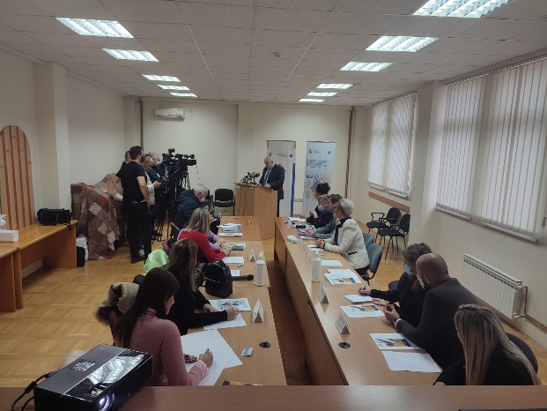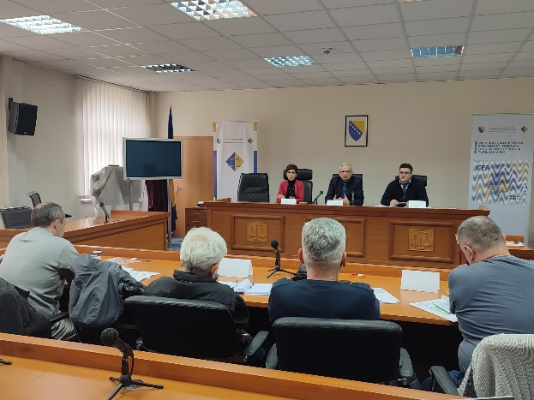

Changes were also observed in the part that refers to citizens' perception of the work of judicial institutions.
Public trust in the work of judicial institutions was strengthened through numerous activities and cooperation with international partners. The results of the final survey of the satisfaction of court users, which the HJPC BiH conducted in August 2021 as part of the project Building an Effective and Citizen-friendly Judiciary - IPA 2017, showed that in certain segments there was a slight improvement in the citizens’ perception of the judiciary in BiH.
The final survey was preceded by an initial survey that was conducted in 2019, and both surveys were carried out in order to gain insight into the level of public trust and to identify areas in which changes and improvements are necessary.
Improvements were noted in the following segments:
- opinion on the independence of the judiciary
- impartiality/objectivity
- different aspects of the work and approach of judges and court clerks.

Graph 9: One segment of the survey on court users' satisfaction
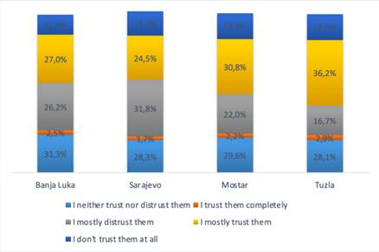
Based on the results of the research, a set of recommendations was created and submitted for future steps that the courts should take in order to make their work more effective, which relate to the improvement of internal processes within the units of the judicial system through the digitisation of certain services, the implementation of continuous and long-term information campaigns and a kind of education of citizens and bringing the judiciary closer to citizens.
The survey was conducted in the Municipal Courts in Mostar, Sarajevo, Tuzla and the Basic Court in Banja Luka, and it included the general population, that is, former, current and potential users of the said courts. The entire survey is available on the HJPC website.
Performance, quality and transparency of prosecutor’s offices
In line with its competence, the HJPC is relying on statistical indicators to regularly monitor the performance efficiency of all prosecutor's offices throughout Bosnia and Herzegovina.
Given the COVID-19 pandemic and Decision of the HJPC BiH on processing priority cases, the prosecutor’s offices had fewer working days due to being closed and staff being on sick leave, which significantly impacted the dynamic of processing all types of criminal offences.
According to the data from 2021, the prosecutor's offices in BiH received a total of 21,683 cases against known perpetrators, which is 2% less cases received compared to the number of cases received in 2020.
There were 15,213 pending cases as of 31 December 2021, which is 3% less compared to the number of unresolved cases on 31 December 2020 (15,608).

Graph 10: Backlog in prosecutor's offices in BiH per year

In 2021, the prosecutor's offices raised 11,041 indictments, which is 14% more than the number of indictments raised in 2020 i.e. 9,678.
Prosecution of corruption
In 2021, the prosecutor's offices raised 235 indictments for corruption offences, which is 87% more than the number of indictments raised for corruption offences in 2020 i.e. when the prosecutor’s offices raised 126 indictments.
In 2021, the prosecutor's offices issued 555 orders not to conduct investigations into corruption offences, which is 11% more than the number of orders issued not to conduct investigation in 2020, i.e. when the orders not to conduct investigations were issued in 499 cases.
In 2021, the prosecutor's offices issued 119 orders to discontinue investigation into corruption offences, which is 11% more than the number of orders to discontinue investigations into corruption offences issued in 2020 when investigations were discontinued in 107 cases.
Related to processing high-profile corruption cases, out of the total 328 ordered corruption investigations in 2021, 11 ordered investigations or 3% related to high-profile corruption cases.
Out of the total 235 raised indictments for corruption offences in 2021, the prosecutor's offices raised 6 indictments related to high-profile corruption or 3% of the total number of corruption indictments raised in 2021.
Prosecution of organised crime
In 2021, the prosecutor's offices raised 32 indictments for organised crime offences, which is 23% more than the 26 indictments raised in 2020.
In 2021, the prosecutor's offices issued 25 orders not to conduct investigations into organised crime offences, which is 4% more than the number of orders issued not to conduct investigation in 2020, i.e. when the orders not to conduct investigations were issued in 24 cases.
In 2021, the prosecutor's offices issued 13 orders to discontinue investigation into organised crime offences, which is 54 % less than the number of orders to discontinue investigations into organised crime offences issued in 2020 when investigations were discontinued in 28 cases.
Related to the processing of high-profile organised crime offences, of the total 55 ordered investigations in 2021, 2 ordered investigations or 4% related to high-level organised crime cases.
Out of the total 32 raised indictments for organised crime offences in 2021, the prosecutor's offices raised 2 indictments related to high-profile organised crime or 6% of the total number of organised crime indictments raised in 2021.
Supporting POs in processing cases involving economic crime, organised crime and corruption
The IPA 2017 Project, funded by the EU, provides significant support to the prosecutor’s offices processing cases involving economic crime, organised crime and corruption, by recruiting 11 financial advisers in 10 prosecutor’s offices in 24 months. Financial advisers are involved at the earliest phase of criminal procedure and the results of their engagement are reflected in shortened documentation collection time, not collecting unnecessary documentation, faster handling of current influx, more of better communication with expert witnesses and law enforcement agencies, assistance in drafting orders for expert witnessing, examination of witnesses and defendants. A significant contribution was reflected in recognising the need to initiate and conduct financial investigations, providing expert assistance in analysing cash flows and identifying illegally obtained income.
In their work so far, most of the cases involved complex economic and organised crime, corruption, tax evasion, abuse of position, fraud in obtaining loans, concluding harmful contracts, making false balance sheets, privatization, abuse on the capital market, money laundering and other crimes. In the period from May 2019 to January 2022, financial advisers made an analysis of 908 cases, of which the largest number of cases involved economic crime (516), corruption (140), organised crime (24), and financial investigations (14), and other cases (214). Of the total number of cases they were involved in, 23 cases of economic crime, corruption and organised crime had a court epilogue at the end of 2021, of which nineteen (19) verdicts were final and four (4) not final.
Situation analysis and backlog reduction measures for the prosecutor's offices
All prosecutor's offices that have old pending cases passed backlog reduction plans (pending cases, older than two years) at the beginning of 2021, as prescribed with the current Instruction for drafting backlog reduction plans in prosecutor's offices in BiH.
At the end of 2021, the overall Backlog reduction plan realisation rate of all the prosecutor's offices in BiH was 87%. In 2021, the prosecutor's offices in BiH completed 3,533 old cases the completion of which was planned in the 2021 Backlog reduction plans.
The total number of pending old cases in the prosecutors offices in BiH as of 31 December 2021 (5,486) was 67% less than the total number of pending old cases as of 31 December 2014 (16,611), and approximately the same as the total number of pending old cases as of 31 December 2020 (5.464).
In view of significant limitations and difficulties in work due to the COVID-19 pandemic, as a measure to help the prosecutor’s office in reducing the backlog of old cases, the Standing Committee on the Efficiency and Quality of POs decided to hire additional staff of 20 legal advisers and 10 associates in 9 prosecutor's offices to assist prosecutors in reducing the backlog of cases.

Graph 11: Backlog in prosecutor's offices

Activities of the Standing Committee on the Efficiency and Quality of Prosecutor's Offices
In 2021, the Standing Committee on the Efficiency and Quality of Prosecutor's Offices held 16 meetings at which current and issues of importance for the work of prosecutor's offices in Bosnia and Herzegovina were discussed.
Since the fight against corruption and organised crime is one of the priorities of the BiH judiciary, reflecting on the shortcomings in prosecution of corruption detected by the OSCE Mission in their Third Annual Report, the Standing Committee for Efficiency and Quality of Prosecutor's Offices made an action plan with an overview of necessary measures and activities directed at the implementation of measures recommended in the Report. The proposed measures and activities include the prioritisation of processing high-profile corruption cases, improved supervision by the chief prosecutor in the investigation stage and indictment drafting, but also the introduction of the obligation to develop investigation plans. The Action Plan was adopted by the High Judicial and Prosecutorial Council of Bosnia and Herzegovina, at its session on 24 and 25 March 2021, while the Standing Committee continues to monitor on a regular basis the extent of implementation of these measures and activities based on the reports submitted by the prosecutor’s offices. The implementation of the adopted activities seeks to improve the negative trend observed in processing corruption, but also to ensure the implementation of the recommendations from previous OSCE Mission Reports, for which the Mission established had no progress in the implementation.
Bearing in mind that the USAID (United States Agency for International Development) Judiciary Against Corruption in BiH Activity has published a Report on the application of the Definition for classification of high-profile corruption and organised crime cases, which presents the recommendations for a unified interpretation and improvement of the Definition, the Standing Committee has tasked the Strengthening Prosecutorial Capacities in the Criminal Justice System project to prepare together with the USAID representatives the Draft amendments to the Definition of high-profile corruption and organised crime, taking into consideration the recommendations given in the subject report.
On its session on 23 and 24 June 2021, the High Judicial and Prosecutorial Council of Bosnia and Herzegovina adopted a new Definition on high-profile corruption and organised crime. The new Definition specifies the existing criteria for the classification of high-profile corruption and organised crime cases and provides clear guidelines for the application of the criterion of the nature of the high-profile corruption offence perpetrator, the census criterion, the ratio between the two criteria and then the criteria of the nature of a high-profile organised crime, the international element and the damage or proceeds of crime.
The introduction of the new letter marking the high-profile corruption and organised crime cases required the adoption of the amendments to the Book of Rules on Performance Quotas for Prosecutors in the Prosecutor’s Offices in BiH that the Council adopted at the proposal of the Standing Committee. The Rules of Procedure for marking cases as high-profile corruption and organised crime were also adopted and they regulate the procedure of recording cases as high-profile corruption and organised crime, also at the proposal of the Standing Committee.
The Council also adopted the Guidelines for amendments to the Book of Rules on Internal Organisation and Systematisation of Prosecutor’s Offices or passing of a separate book of rules that regulates the relation between the chief prosecutor, deputy chief prosecutor and prosecutors, which regulates the procedure of the chief prosecutor issuing binding instructions to prosecutors in specific cases.
In 2021, supported by the Project, the Standing Committee started a comprehensive analysis of the impact of the Book of Rules on Performance Quotas for Prosecutors in Prosecutor's Offices in BiH on the performance and performance results and started drafting the proposed amendments.
Improving cooperation between prosecutor’s offices and law enforcement agencies
Meetings between the management of prosecutor’s offices and law enforcement agencies on strategic and operational level are being held on a regular basis.
Successful cooperation between the prosecutor's offices and law enforcement agencies is a key factor for the efficient operations of prosecutor's offices in BiH. In 2021, three meetings were held, of which one was a two-day meeting of the management of POs and law enforcement agencies on a strategic level (hereinafter: the Strategic forum). The attendees of these meetings are the Chief Prosecutor of the Prosecutor’s Office of BiH, Chief Prosecutor of the of FBiH Prosecutor's Office, Chief Prosecutor of the RS Public Prosecutor's Office and Chief Prosecutor of the Brcko District Prosecutor's Office, Director of the State Investigation and Protection Agency, Director of the FBiH Police Directorate, Director of the RS Police and Chief of the Brcko District Police.
In the said meetings, the Strategic Forum discussed the significant issues for efficient work and cooperation of the prosecutor’s offices and police. In 2021, among other things, there was a discussion and adoption of concrete conclusions on the capacity of law enforcement agencies to work on organised and economic crime and corruption cases, on the analysis of the work of the joint investigative teams between the prosecutors and authorised officials and proposals for improvement of cooperation, the check-list for quality indicators of the actions undertaken and reports of the law enforcement agencies, the implementation of the Revised National War Crimes Strategy - the issue of capacity, efficiency and quality of cooperation between prosecutor’s offices and police and other issues relevant for their joint work.
The Strategic Forum established a Working Group to amend the Instruction on the Cooperation of prosecutors and authorised officials while conducting evidentiary actions in investigations (hereinafter: the Instruction) that is functional and works on the proposal of amendments to the Instruction.
Improving specialisation of prosecutors and expanded categories of participants
Through the project Strengthening Prosecutorial Capacities in the Criminal Justice System that is supported by the Government of Switzerland, in cooperation with the entity judicial and prosecutorial training centres, the High Judicial and Prosecutorial Council of Bosnia and Herzegovina organised specialised training in the domain of corruption, cyber crime and economic and organised crime.
Specialised trainings went on in 2020 and 2021 and the trainers were the experts specialised in detecting and processing corruption, cyber crime, economic and organised crime cases.
The objective of the specialised training in detecting and processing cases of economic and organised crime was the professional development of prosecutors, judges and police officers for the purpose of even more efficient detecting and processing of criminal offences of economic and organised crime in the judiciary in Bosnia and Herzegovina. The implementation of the two-year professional development plan facilitated that at present we have a well trained and respectable team that can properly confront the perpetrators of criminal offences of economic and organised crime.
In 2021, two trainings were held on the topic of “Crime Intelligence Work in Support of Prosecutor’s Offices in Fighting Corruption in BiH” that was attended by the representatives of the prosecutor’s offices, the State Investigation and Protection Agency, the Federal Ministry of Internal Affairs of FBiH, the Ministry of Internal Affairs of the RS, the Security Intelligence Agency of BiH, the Indirect Taxation Authority of BiH, the Armed Forces of BiH, the Ministry of Interior of the Zenica-Doboj Canton, the Ministry of Interior of the Tuzla Canton, the Ministry of Interior of the Sarajevo Canton, the Police of the Brcko District and the Ministry of Interior of the Una-Sana Canton. The trainings were carried out through two teaching modules and the first one was a theoretical preparation and introduction into a joint exercise that was also the second teaching module.
Supporting the Coordinating Body of the chief prosecutors of the Prosecutor's Office of BiH, entity prosecutor’s offices and the Prosecutor’s Office of the Brcko District of BiH
The project Strengthening Prosecutorial Capacities in the Criminal Justice System initiated the establishment of the Coordinating Body of Chief Prosecutors from the Prosecutor's Office of Bosnia and Herzegovina, the RS Public Prosecutor's Office, the Prosecutor's Office of the FBiH and the BDBiH Prosecutor's Office, to consider the conflict of jurisdiction between the prosecutor's offices in situations when the law does not prescribe the manner of resolving the conflict of jurisdiction and when all previous methods of resolving the conflict of jurisdiction have been exhausted. Among the competence of the Coordinating Body is the exchange of information and coordination of conducted investigations, which are conducted in several prosecutor's offices that are signatories to the Agreement on the Establishment of the Coordinating Body, with the aim of improving legality and efficiency, but also cooperation and resolving other issues that fall within the competence of the prosecutor's offices in Bosnia and Herzegovina.
Throughout the year, the Coordinating Body decided on the matter of jurisdiction in six cases and regulated the procedure of proposals for resolving the conflict of jurisdiction in this body.
Strategic planning in prosecutor’s office
In 2021, the Strengthening Prosecutorial Capacities in the Criminal Justice System project in partnership with theUSAID Justice Against Corruption Project continued to provide support to the FBiH prosecutorial system, the RS prosecutorial system, the BDBiH Prosecutor's Office and the BiH Prosecutor's Office in the development of three-year strategic plans for the period 2021 through 2023, preparation of annual plans for 2021 and annual reports for 2020 for all individual POs, as well as holding regular collegiums of the chief prosecutors in the Federation of BiH and collegiums of chief prosecutors in Republika Srpska.
Aiming to have continued practice of mid-term strategic planning, to achieve independence in the strategic planning process and the preparation of annual work plans and annual reports on the implementation of the strategic framework of the prosecutorial system and achieved set targets, to hold collegiums of chief prosecutors and maintain the common course of action within the judicial system, the Strengthening Prosecutorial Capacities in the Criminal Justice System project continued in 2021 to raise the capacity and competencies of the employees in the prosecutor’s offices.

Support of the prosecutor’s offices in implementing the digitisation of archives
The Strengthening Prosecutorial Capacities in the Criminal Justice System project, in its third stage, continued supporting the systematisation and digitisation of archives in the prosecutor’s offices in Bosnia and Herzegovina through the activity of writing off registry materials, inventorying archive materials, scanning archive materials and other activities related to the archive digitisation.
In 2021, the archive digitisation started in eight district public and cantonal prosecutor's offices, where a total of 32 people are employed.
Transparency, public relations in the prosecutors offices and cooperation with the NGO sector
The Public Relations Monitoring and Evaluation Plan is based on a model of a complementary approach to the monitoring and evaluation process, through two groups of indicators, a group of quantitative indicators and a group of qualitative indicators and aims to create a model for systematic and continuous monitoring and evaluation of public relations performance on common grounds for all POs and it has been implemented since 2017. Evaluation for 2020 was made in 2021, and the overall score was 19.5, which is an increase of 4% compared to 2019.
The Strengthening Prosecutorial Capacities in the Criminal Justice System Project has continued implementing the activities to improve the quality and quantity of services, as well as the overall treatment of the persons coming in contact with the prosecutorial system. At the end of 2021, the prosecutor’s offices in BiH have had implemented 81% of the Strategy for Care of Persons who Come in Contact with Prosecutor's Offices in BiH, which is a 35% increase compared to 2018.
Given that one of the long-term objectives of the Strengthening Prosecutorial Capacities in the Criminal Justice System Project is to benefit the citizens through quality performance of activities within the competence of prosecutor’s offices and according to the Strategy for Care of Persons who Come in Contact with Prosecutor's Offices, in cooperation with the partner organisations the HJPC BiH has established cooperation with the non-governmental organisation which are active in the judicial sector, professional associations of the prosecutors in BiH, as well as the Association of Spokespersons of the Prosecutor’s Offices in BiH with financial support of the Embassy of Switzerland in BiH.
The involvement of non-governmental organisations that have concluded a Grant Agreement is focused on providing support to the prosecutor’s offices throughout BiH in establishing and maintaining interaction with the social community to suppress all types of crime. The involvement of NGOs will be aimed at establishing a platform for continuous cooperation between the civil society organizations and the judiciary, as well as development of a plan of activities to motivate citizens to contribute to the work of prosecutor's offices.
The activities implemented through the said involvement with the professional associations of prosecutors are focused on strengthening the capacities of associations of prosecutors to actively participate in the process of resolving key issues that matter for the work of prosecutors.
The Association of Spokespersons of the Prosecutor's Offices in BiH has implemented a project within which the basic principles and pubic relations standards have been defined and a training programme for public appearances for the chief prosecutors and prosecutors has been developed to be implemented in all the prosecutor's offices in BiH.
Performance evaluations for judicial office holders
Article 17, item 22) of the Law on the HJPC prescribes that the HJPC “determines the criteria for the performance evaluation of judges and prosecutors”. The performance evaluation of judges, prosecutors, court presidents and chief prosecutors is carried out annually, in line with HJPC criteria.
The performance evaluation for the last three years must be used to assess the competence of a candidate as part of the appointment procedure in accordance with the HJPC Rules of Procedure.
The HJPC BiH decided on its session on 22 and 23 October 2020 not to evaluate the performance of judicial office holders due to the circumstances caused by the COVID-19 pandemic that have diminished their performance. Apart from that, the new performance evaluation criteria were adopted on the HJPC BiH session on 29 October 2020 (Official Gazette of BiH, no. 01/21). The performance evaluation of all judicial office holders will be conducted by the court presidents and chief prosecutors according to the new criteria. In 2021, the HJPC BiH prepared the necessary materials to carry out the performance evaluation in courts and prosecutor’s offices. The deadline to carry out the performance evaluation for 2021 is 1 March 2022.
The adopted criteria contain the elements that are mostly of quantitative nature (performance target, statistical quality of decisions and the number of completed cases from the annual backlog reduction plan and timeliness). Therefore, these are common indicators that are based on different aspects of judicial office in prosecutor’s offices and the courts and which are used over a longer period of time to monitor the performance of judicial institutions and judicial office holders in Bosnia and Herzegovina.
The Criteria for performance evaluation of court presidents and Criteria for performance evaluation of chief prosecutors and department heads in the prosecutors offices prescribed the elements for the evaluation of their individual performance, as well as the elements for performance evaluation in management of court operations, prosecutor’s office and department/section in the prosecutor’s office.
The president of the immediately higher instance court evaluates the performance of the president of lower instance courts in his territory. The chief entity prosecutor evaluates the performance of the chief prosecutors in district public prosecutor’s offices and cantonal prosecutor’s offices.
As for the management of court operations, the performance of the court president is evaluated for the collective quota achieved by the court and for the organisation and management of the court operations, within which it is evaluated (i) whether and in which way the court president was fulfilling on a regular basis the obligations provided under the Book of Rules on Internal Court Operations and (ii) the percentage of the backlog reduction plan implementation on the court level.
The performance of chief prosecutors and heads of departments/sections in prosecutor’s offices is evaluated in terms of management for (i) collective quota achieved and collective quality of decisions of the prosecutor’s offices i.e. department or section of the prosecutor’s office and (ii) organisation and management of the operations of the prosecutor’s office and department/section in prosecutor’s office, the implementation of the backlog reduction plan of the prosecutor’s office departments/sections, etc.
The HJPC BiH shall evaluate the performance of the presidents of the Court of Bosnia and Herzegovina, the Supreme Court of the Federation of Bosnia and Herzegovina, the Supreme Court of Republika Srpska and the Appellate Court of the Brcko District of Bosnia and Herzegovina in accordance with the Criteria for performance evaluation of court presidents in Bosnia and Herzegovina.
The HJPC BiH shall also evaluate the performance of chief prosecutors in the Prosecutor’s Office of Bosnia and Herzegovina, the Federal Prosecutor’s Office, the Office of the Public Prosecutor of Republika Srpska and the Prosecutor’s Office of the Brcko District of Bosnia and Herzegovina under the Criteria for Performance Evaluation of the chief prosecutor of the Prosecutor’s Office of the Bosnia and Herzegovina, the chief prosecutor of the Federal Prosecutor’s Office of Bosnia and Herzegovina, the Office of the Public Prosecutor of Republika Srpska and the Prosecutor’s Office of Brcko District of Bosnia and Herzegovina.
The HJPC BiH shall ensure proper application of the Criteria for Performance Evaluation of judicial office holders in all courts and prosecutors offices by monitoring the implementation of the performance evaluation. An evaluated judicial office holder who does not agree with the performance evaluation may file an objection with the HJPC BiH.
Education of judicial office holders
In the domain of improving the education system of judges and prosecutors, improving the quality and transparency of the work of the judiciary of Bosnia and Herzegovina, the HJPC BiH carried out a number of activities in 2021 and achieved significant improvements.
As in all previous years, the HJPC BiH cooperated in 2021 with the Judicial and Prosecutorial Training Centre in Republika Srpska (RS JPTC) and the Judicial and Prosecutorial Training centre of the Federation of Bosnia and Herzegovina (FBiH JPTC) and the representatives of the steering boards of these public institutions and the Judicial Commission of the Brcko District of BiH (JC BDBiH). Apart from better coordination in drafting the 2022 education programme, the cooperation resulted in considering the improvement of the educators’ work. Thus, in a meeting of the HJPC BiH Standing Committee for Education and Court Documentation and the said institutions in charge of organising and conducting the education of judges and prosecutors on 7 December 2021, the HJPC BiH conclusions from 2018 were revisited for the purpose of improving the criteria for the selection of best trainers, all within the amendments to the Book of Rules on categories, selection, rights and obligations of trainers.
In 2021, in cooperation with the training centres and supported by the USAID Judiciary Against Corruption Project, separate multi-annual specialised trainings started for judges and prosecutors in target judicial institutions on the topic of organised crime and corruption, and the judges and prosecutors have been trained about the said topics continuously. It has been agreed with the training centres and the JC BDBiH that the conditions for obtaining the certificate for processing juvenile crime cases should be equalised for judges and prosecutors. In cooperation with the Council of Europe, the levels of training on the topic of human rights have been determined and a multi-annual curriculum for human rights studies has been developed and adjusted for the judicial office holders in BiH. The four modules from this curriculum adjusted for the basic level have been included in the mandatory initial training for newly appointed judges and prosecutors, that will be studied in 2022 within the training programme. The modules are partly adjusted to the on-line learning format and follow the methodology of the Council of Europe HELP platform, which inspires the use of the on-line learning methodology. Combined with the in vivo learning, this methodology is a good basis for a balanced training system for judges and prosecutors.
In the session on 24 and 25 March 2021, the HJPC BiH adopted the new Book of Rules on the Procedure for designation and modus operandi of consultative prosecutors with the newly appointed and other prosecutors, with the accompanying Guidelines for Consultative Prosecutors. In 2021, the application of the innovated Book of Rules was monitored on a regular basis and therefore it can be stated that in 2021 all newly appointed prosecutors worked with the help of the consultative prosecutors in the first year after their appointment. The reporting method of consultative prosecutors has also been improved and on the basis of proposals for improvement of the work of the newly appointed prosecutors the initial training has been expanded for the newly appointed prosecutors to be carried out in 2022 within the JPTCs.
With the participation of representatives of the entity judicial and prosecutorial training centres, steering boards and Judicial Commission of Brcko District BiH, on the session held on 29 and 30 September 2021, the 2020 reports on the work of the entity judicial and prosecutorial training centres were considered and approved with specific proposals for the improvement of ethics and integrity of judicial office holders, improvement of the initial training for newly appointed judges and prosecutors, the need to organise the training for certain categories of judicial management and other. The HJPC BiH actively worked in 2021 on the implementation of conclusions from the session on November 2019, when the topic of particular importance for the judiciary were identified. As per the Reform Agenda of the HJPC BiH, the Peer Review recommendations for training and GRECO recommendations, a new framework has been prepared, as well as the number and content of trainings on ethics and integrity. A number of activities have been initiated to enrich the 2022 training programme with the seminars where the judges and prosecutors will receive training based on their true needs. There is a new method of topic nomination and in cooperation with the highest instance courts in Bosnia and Herzegovina the most common mistakes in the work of lower instance courts have been identified per case type (criminal, civil and administrative). The compiled information and accompanying analyses have been delivered to the entity judicial and prosecutorial training centres and their steering boards, as well as the Judicial Commission of Brcko District BiH and the topics identified by the analyses have been included in the training curricula of judges and prosecutors in 2022, which facilitated the implementation of target training of lower instance courts judges.
In the HJPC BiH session on 15, 16 and 17 December 2021 the work programmes of the 2022 FBiH JPTC and RS JPTC steering boards were approved, which include common activities with the JC BDBiH. Regarding mandatory training, the HJPC BiH adopted a conclusion to continue applying in 2022 the Decision on Minimal Initial Training of judges and prosecutors in Bosnia and Herzegovina from 2018 and that:
- all judicial office holders are obligated to attend the training: On-line Module on Ethics, Integrity and Prevention of Conflict of Interest that will be recognised as one day of mandatory training;
- all managers of judicial institutions are obligated to attend the training: The role of the court president and chief prosecutor in preserving the integrity of judicial institutions;
- all new managers of judicial institutions are obligated to attend the training:
- Building leadership and managerial capacities in judicial institutions
- Proactive role of the court president
- Electronic tools for managers
- Contemporary communication with the public
- All new department heads are obligated to attend the Proactive role of department heads in managing departments training.
The HJPC BiH has also adopted the conclusion that in order to meet the conditions to obtain a certificate and according to the Law on Protection and Handling of Juveniles in Criminal Proceedings, the judicial office holders are obligated to attend all thematic units from a specialised training programme and that all open issues would be considered within the cooperation between the HJPC BiH Standing Committee for Education and Court Documentation and the Steering Board of the FBiH Judicial and Prosecutorial Training Centre, the Steering Board of the RS Judicial and Prosecutorial Training Centre and Judicial Commission of Brcko District of BiH.
According to the entity laws on judicial and prosecutorial training centres, in the period between July and December 2021 the HJPC BiH consulted the steering boards of the JPTCs regarding the election of the JPTC Director. Thus, in the session on 14 and 15 July 2021 the Council gave its opinion on the election of the Director of the RS Judicial and Prosecutorial Training Centre. Additionally, after having learned that the Steering Board of the FBiH Judicial and Prosecutorial Training Centre did not appoint the director of that public institution since December 2020 when the HJPC BiH gave its positive opinion for the proposed candidate, in the session on 22 October 2021 the HJPC BiH withdrew its positive opinion for the candidate. In the session held in Banja Luka, there was a discussion on the responsibility regarding the election meaning the lack of it and no election of a candidate for the post of the director of these public institutions and the nature of consultations in that process. The HJPC BiH considered the said situations again at its December session and concluded that regardless of the HJPC BiH opinion, the actions of the steering boards had to be addressed again, after obtaining additional information from the steering boards of the entity training centres. Given that no law or by-law has prescribed the consulting process and binding nature of the opinion the HJPC BIH gives, everything will be additionally considered in the upcoming period.
In the December session the HJPC BiH made a decision on temporary suspension of judge Jozo Andjic as a member of the Steering Board of the FBiH Judicial and Prosecutorial Training Centre due to the decision of an HJPC BiH disciplinary panel on temporary suspension of judge Andjic from the judicial post that is related to his function as a member of this steering board.
In the period from 13 to 20 September 2021 a three-day training for the members of the disciplinary panels on the topic of Disciplinary Procedures and Practice was held. The training was organised so the members of the first-instance and second-instance disciplinary panels, who have more practical experience, could convey their knowledge and experience to the new members of the panels. The training was assessed as very beneficial and well organised and generated a set of practical recommendations and conclusions to improve the disciplinary procedures on which the HJPC BiH will continue working in 2022.
Image 29: Training of the new members of the HJPC BiH disciplinary panels on the topic of Disciplinary Procedure and Practice
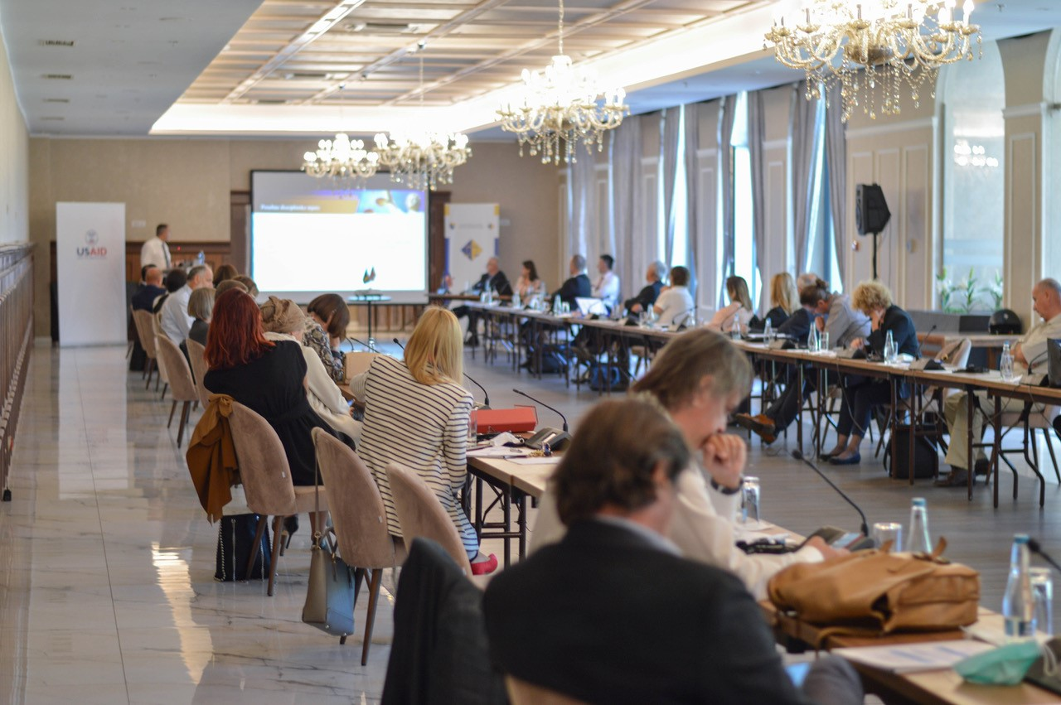
Coordination of the case law harmonisation process
As for the case law harmonisation, as in the previous years, the HJPC BiH nominated topics to be considered in the case law harmonisation panels. In April 2021, a civil law panel was held on the topic of: The right of banks to charge clients for expenses of loan processing. Legal opinions have not been harmonised since the Supreme Court of the Federation of BiH has not taken a position on this issue and the topic will be reconsidered once conditions for that are met. The other topics that the HJPC BiH nominated have not been accepted by the courts that have case law harmonisation panels (two topics from the civil law domain and one from the criminal law), due to the courts believing that there was no equal legal framework, meaning the lack of the contradicting case law in all jurisdictions in Bosnia and Herzegovina, as the preconditions to hold panel meetings.
The HJPC BiH has reached a consensus with both the domestic and international partners on the necessity to improve the legal framework for the work of case law harmonisation panels in Bosnia and Herzegovina and in the second half of 2021 started a dialogue with all the relevant actors on the modalities to achieve this objective. On 18 and 19 November 2021 the Fifth Annual Conference of the highest instance courts in Bosnia and Herzegovina was held on the topic: Case Law Harmonisation, when the need for the panels to start working again was stated, while a round table was held in cooperation with the OSCE Mission and Council of Europe to identify the topics to be considered in the panels...
In the second half of 2021 the HJPC BiH considered the proposals of the courts that have case law harmonisation panels about the validation of work for the judges who participate in the panels. The second half of 2021 saw the start of the compilation and review of replies from the judicial community in Bosnia and Herzegovina in the survey about the inconsistency of case law, which the HJPC BiH initiated in April 2021.
Within the implementation of the project - Building an Effective and Citizen-Friendly Judiciary - IPA 2017, the HJPC BiH ensured professional support for the judges assigned to case law departments/case law records in highest instance courts in Bosnia and Herzegovina. In cooperation with the European Union Delegation and AIRE Centre, the HJPC BiH Secretariat ensured the funds to create a software that will ensure archiving and search of court positions (E-sentence). Through the software the courts will be able to record the positions and sentences from the court decisions. In this way, the positions and accompanying decisions will be available to the judges while resolving new cases to familiarise themselves with the positions prior taken in factually same or similar situations, which is a step forward in the process of horizontal case law harmonisation.
During 2021 the HJPC BiH established cooperation with the Faculty of Law in Vitez in development of a specialised war crime case database. This cooperation resulted in signing of the Agreement on Mutual Cooperation in November 2021. The cooperation is focused on the information exchange on war crime cases with final decisions on the level of BiH judiciary and delivery of anonymised court decisions by the HJPC BiH to update the said database.
In 2021, within the implementation of the Agreement of the HJPC BiH on cooperation with the highest instance courts, a dialogue was held on the identification of topics for the preparation and development of a publication on a case law, which is significant for the work of the judiciary. As a result of the dialogue, five topics have been identified and the judges of the highest instance courts have been selected as the authors to develop the said publications. The work on the publications ended in December 2021. The publications highlight the issues that the BiH judiciary is facing and it is expected that further work on the publication promotion will help improve the training of judicial office holders, meaning that the case law harmonisation panels will start working on certain issues. The development of the publications about the current issues of the BiH judiciary will be continued through the IPA 2019.
The HJPC BiH coordinated the donors’ help and actively participated with the international partners. The activities in the case law harmonisation have been largely implemented with the use of funds from the EU pre-accession funds (IPA 2017). Other partners of the HJPC BiH were involved in some of these activities, primarily the Council of Europe, the OSCE Mission to BiH and the AIRE Centre from London, while the Justice Against Corruption Project of the USAID supported the HJPC BiH in organising initial training for the new members of the disciplinary panels of the HJPC BiH, as well as for those on the back-up lists. More about it is in the previous chapter Training of the Judicial Office Holders.

The increased transparency of the judicial system
In this domain the commitment of the HJPC BiH to raise the transparency of the judiciary in 2021 to a higher level is particularly significant. In that end, the HJPC BiH Court Decisions Database has been open to public since 5 February 2021 without any restrictions, which is a step forward compared to the previous practice, when the interested parties outside the judiciary had to pay a 100BAM annual fee to access the database with prior registration. In addition, the judgements are entered with more data in the database according to the Instruction for the Anonymisation of Court Decisions, adopted at the session of the HJPC on 14 April 2021. In this way, the HJPC BiH endeavoured to establish the balance between the private and public interest, because the judgements published in the database of court decisions are adjusted for reading not only by the judicial community, but the citizens of Bosnia and Herzegovina as well.
Within the 1.3.1. Component Strengthening the Case Law Department/Case Law Record in the Highest Instance Courts in Bosnia and Herzegovina of the project Building an Effective and Citizen-Friendly Judiciary, as funded by the European Union (IPA 2017), 2,913 court decisions were added to the database and thus 14,972 searchable decisions were available to the public on 31 December 2021. According to the new Instruction, the database is updated with all the final decisions in the cases of special public interest. Thus the database has been updated by final decisions from the cases of war crimes, discrimination, human trafficking, while currently decisions from areas of organised crime and corruption are being added.
Parallel to that, the War Crimes Map was updated in 2021 with 13 summaries of completed war crime cases with final judgements. The summaries are prepared in the languages of the constituent people in Bosnia and Herzegovina, as well as in English. This interactive Map is available through the HJPC BiH web site.
Apart from that, on 23 November 2021, an Agreement on Cooperation was signed between the High Judicial and Prosecutorial Council of Bosnia Herzegovina and the Faculty of Law of the Vitez University in the Project of Development of a Database of War Crime Cases with Final Decisions - The War Crimes Trials Database - WCTD, funded by the Government of Japan. The agreement is about the exchange of information from all final judgements in the war crime cases perpetrated on the territory of Bosnia and Herzegovina that the signatories to the Agreement have at their disposal. The database is available through the link: https://warcrimesdatabase.net/public/.
In mid 2021 the HJPC BiH surveyed the judicial community on the application methods of the Guidelines for the Publication of Court and Prosecutorial Decisions on the official web-sites of judicial institutions, adopted in September 2014. The HJPC BiH requested the judicial institutions to deliver in their 2021 annual performance reports the data on the number, method of publishing the decisions and their proposals for improvement. In this manner, there is an attempt to engage the judicial community to increase the transparency of its work, which in the end will be the topic for an expert body that will be tasked with the evaluation and review of the Guidelines from 2014 given the development of the social community, new technologies, innovated web-sites and public needs.
The work of the European Court of Human Rights (ECtHR) was monitored in 2021 as well. The summaries of the latest cases of that court were translated and 49 summaries were published in 2021 that were also being delivered to the case law departments on a regular basis for a faster and more effective familiarisation with the positions and standards taken in those cases. Weekly reviews of the ECtHR case law were also translated and additionally adapted with information that are in the focus of the BiH judiciary for the purpose of studying the court’s case law. Over 50 such news were published for the BiH judiciary and public in 2021. The publications contain a plethora of information and the links to the database of ECtHR decisions in the integral text. In the said project, 42 selected decisions of the European Court for Human Rights were translated from French to the languages of the constituent people in Bosnia and Herzegovina.
In 2021, under the category “Laws,” 134 pieces of information on newly adopted laws on the level of the Brcko District of BiH, entities and Bosnia and Herzegovina were published with the accompanying legislative texts. Compilations of opinions of consultative panels of European judges and prosecutors were published in the “Professional Publications” section, as well as the issues 13 and 14 of the Legal Chronicle magazine that the HJPC BiH develops and publishes together in cooperation with the AIRE Centre from London.
The activity that the HJPC BiH has been carrying out to improve judicial quality has been promoted on a regular basis. The trainings about the method of utilising the HJPC BiH Database of Court Decisions and other published contents have been carried out for the newly appointed judicial office holders on a regular basis within the entity judicial and prosecutorial training centres.
In 2021, three trainings were carried out for the students of the law faculties within the Building an Effective and Citizen-Friendly Judiciary Project (IPA 2017). The trainings included, among other things, a presentation of the information system of the HJPC BiH Secretariat Court Documentation and Training Department, the Database of Court Decisions primarily, but other content published through this information system as well. The trainings turned out to be very useful, because the Database of Court Decisions is a significant tool to help students in making research papers, while the web-site www.pravosudje.ba/csd is a significant source of information on the newly adopted laws and other professional publications and other materials. This web-site has been updated by other useful contents on a regular basis, while all information are official and updated and they are delivered to all users in the judiciary by an e-leaflet Case Law and Newly Adopted Laws. In 2021, 150,843 visitors searched the database of court decisions and other published contents 214,661 times.
The implementation of the Revised National War Crime Strategy and monitoring the work of courts and prosecutor’s office on war crimes cases
Defining a set of strategic objectives structured in individual measures, the Council of Ministers of BiH adopted a Revised National War Crimes Strategy (Revised National Strategy) on 24 September 2020. In the absence of the Supervisory Body, the HJPC BiH, meaning the Standing Committee for the Efficiency and Quality of the Prosecutor’s Offices and Courts has undertaken activities, measures and actions to improve the efficiency of processing war crime cases in the courts and prosecutor’s offices in BiH through the timely implementation of objectives and measures of the Revised National War Crimes Strategy. Specifically, following the methodology of strategic objectives and individual measures from the Revised National War Crimes Strategy, the HJPC BiH defined the measures to improve human and material resources in the courts and prosecutor’s offices, as well as those to improve the budget capacity. Furthermore, the areas of improvement of organisation, efficiency and quality of the prosecutor’s offices and efficiency of the court proceedings have been dealt with. Parallel to that, the assignment of war crime cases to different levels of the judiciary as per their complexity was coordinated and the legal framework for the prioritization of work on complex cases in the Prosecutor’s Office of BiH was adopted. Furthermore, the HJPC BiH issued an instruction for processing regional cases with persons with no access and organised regular and specialised training of judges and prosecutors, as well as for the defence attorneys in war crime cases. Apart from the aforesaid, a mechanism for regular communication with all witness support departments was established, as well as the one for identification specific problems in work. In the end, the HJPC focused on the issue of efficiency in the cooperation between the prosecutor’s offices and law enforcement agencies in the war crime cases. All the measures that the HJPC BiH undertook, according to the scope of HJPC BiH competences, are of organisational and strategic character. In relation to that, a complete and timely implementation of the Revised National Strategy depends on the efficiency of prosecutor’s offices and courts.
Timely activities of the HJPC BiH in chronological implementation of objectives and measures of the Revised National War Crimes Strategy resulted in the following:
- The HJPC BiH and Standing Committee for Efficiency and Quality of Courts and Prosecutor’s Offices coordinated and approved the implementation of the Enhancing the Processing of War Crimes Cases in BiH - IPA 2019, that tracks the processing of war crimes cases on a regular basis. Apart from that, the project supported 27 courts and prosecutor’s offices in the BiH judiciary by allocating significant funds and reinforced it by additional 106 posts of professional and administrative staff to work in this type of cases. Parallel to that, the needs of the courts and prosecutor’s offices for institutional capacities were fully evaluated for the purpose of a timely completion of the Revised National War Crimes Strategy. Analysing the budget proposals, the HJPC BiH called on the managers of courts and prosecutors offices to be proactive and defined the recommendations to include the highlighted needs in the budget proposals of courts and prosecutors offices for 2022 and 2023.
- The HJPC BiH, i.e. its Standing Committee for Efficiency and Quality of Prosecutor’s Offices, urgently issued mandatory instructions to the Prosecutor’s Office of BiH to update and integrate the data on the persons of the Hague “A” category. An order has also been sent to the Prosecutor’s Office of BiH to update its Centralised Database. The HJPC BiH is informing on a regular basis the public about the courts and prosecutor’s office processing war crimes cases and is informing the interested parties.
- The HJPC BiH adopted the Guidelines for the chief prosecutors for the Prosecutor’s Office of BiH, Prosecutor’s Office of FBiH, Prosecutor’s Office of RS and Prosecutor's Office of BD on Mandatory Compliance with the Revised National War Crimes Strategy and decisions, conclusions and recommendations. The HJPC BiH Guidelines define the Revised National War Crimes Strategy as binding, establish a comprehensive legal framework for efficient and quality work of the prosecutor’s offices that prioritise complex war crimes cases with recorded persons of the Hague “A” category and specify the disciplinary liability of the prosecutors.
- The new HJPC BiH instructions on development of plans for processing war crimes cases in the prosecutor’s offices established a mandatory framework for efficient planning and organisation of work of prosecutor’s offices, equal assignment of tasks only focusing on the war crimes cases. In addition, the same guidelines have been adopted for the courts as well.
- The coordination of activities and monitoring the implementation of the plan of the Court and Prosecutor’s Office of BiH contributed to the finalisation of an intensified process of ceding less complex KTRZ war crimes cases to the entity, i.e. the judiciary of the BD. Assignment of cases have made the preconditions for complete efficiency and the capacities of the Court of BiH and Prosecutor’s Office of BiH have been freed to process the most complex war crimes cases.
- The HJPC BiH has established a comprehensive reporting mechanism on everyday work, human and material resources, identified issues and overall functioning of the witness support department in courts and prosecutor’s offices. The courts and prosecutor’s offices of the entities/BD BiH deliver the relevant information to the Court of BiH and the Prosecutors Office of BiH on a regular basis, which the HJPC BiH then considers and makes relevant decisions in order to improve the procedural and financial status of the witnesses.
- The HJPC BiH adopted the Guidelines for the chief prosecutors for the Prosecutor’s Office of BiH, Prosecutor’s Office of FBiH, Prosecutor’s Office of RS and Prosecutor's Office of BD on the adoption of general and mandatory instructions on the mandatory framework of legal and ethical standards. In addition to specific definition of disciplinary responsibility, the guidelines enable the chief prosecutors to more efficiently monitor the legality of their work and establish a mandatory framework for responsible prosecution of the entire criminal event.
- In cooperation with the centres for judicial and prosecutorial training of FBiH/RS, the HJPC BiH continued holding on a regular basis multi-day general and specialised trainings for judges, prosecutors and attorneys working on the war crime cases. In 2021, two such trainings were held where over 50 judicial office holders participated.
- Within the regular monitoring, the HJPC BiH and the Standing Committee for the Efficiency and Quality of the Courts and Prosecutor’s Offices considered annual and semi-annual reports on the work of the BiH judiciary on war crime cases. In addition, the HJPC BiH Standing Committee for Efficiency and Quality of the Prosecutor’s Offices monitored on a regular basis the implementation of the Instruction for Development of Plans for processing war crimes cases by prosecutor’s offices and the implementation percentage of the plans to process this type of cases. In relation to that, a number of binding decisions were adopted that were forwarded to the courts and prosecutor’s offices for mandatory action with the aim of improving the dynamics of efficiency and quality of the war crime cases processing.
- Within the Strategic Forum of the chief prosecutors and heads of law enforcement agencies of BiH, RS, FBiH and BD BiH, with the support of the HJPC BiH, the issue of cooperation between the prosecutor's offices and law enforcement agencies was considered and a number of conclusions and recommendations were made regarding the key aspects of that cooperation.
Integrity
With a view to strengthening judicial integrity and accountability, in the light of obligations assumed and objectives set in the context of European integration of BiH as underlined in the Peer Review and GRECO recommendations, in 2021, the HJPC continued implementing the planned priority activities aimed at building the capacity to prevent and detect conflict of interest and corrupt conduct among judicial office holders in BiH. The implementation of integrity and accountability-related activities is one of the strategic objectives of the judicial reform and these activities are implemented by the HJPC working bodies with technical and professional support provided by the USAID's Judiciary Against Corruption Activity.
The Integrity Department, as a separate organisational unit, is responsible to ensure the implementation of and compliance with regulations governing asset declarations of judges and prosecutors, codes of judicial and prosecutorial ethics and conflict of interest prevention, the implementation of integrity plans in judicial institutions and in the HJPC and to provide support to the HJPC disciplinary panels. To identify and implement these activities, the HJPC has formed the Standing Committee for Ethics, Integrity and Accountability of Judges and Prosecutors, as a professional body of the HJPC responsible for consideration of all matters in this field. The recruitment process to fill the positions in the Integrity Department was carried out in 2021.
Asset declarations of judges and prosecutors
Following the adoption of the Book of Rules on Submission, Verification and Processing of Financial Statements of Judges and Prosecutors (hereinafter: the Book of Rules) by the HJPC in September 2018, along with the accompanying form, which regulates the submission, verification, keeping, processing and access to financial statements that contain information on assets of judges and prosecutors, their spouses and children with whom they live in the same household, in February 2019, in its decision upon the request of the Association of Judges in BiH, the Personal Data Protection Agency of BiH (hereinafter: the Agency) found that the HJPC BiH exceeded its authority under Article 86 of the Law on the HJPC BiH and prohibited the application of the Book of Rules. Acting on the basis of the Court of BiH judgement rendered in January 2020, which rejected the HJPC complaint against the Agency as ungrounded and fully upheld the decision of the Agency, in February 2020, the HJPC rendered the Book of Rules ineffective and decided that the financial statements of judges and prosecutors for 2019 were to be submitted to the HJPC using the old form.
According to the records, out of 1,431 judicial office holders in BiH, seven failed to submit their financial statement for 2020, of whom two were on long-term sick leave and five suspended. As for voluntary disclosure, 191 judicial office holders consented to disclosure of their 2020 financial statements, which have been subsequently published on the HJPC website.
In the total number of financial statements submitted in the reporting period by judges and prosecutors, 177 of them reported 276 additional activities. When it comes to permitted activities paid in the amount of up to 40% of annual judge’s or prosecutor’s income, two judicial office holders earned an amount exceeding the one permitted, and the Office of the Disciplinary Counsel (ODC) has been notified of that. The largest number of paid additional activities refers to training services, author's honorariums, membership in the bar exam panels, etc. In 2021, the HJPC issued 53 opinions, of which 44 were on compatibility of offices, seven on incompatibility of offices, one in which the Council declared itself incompetent to decide the request and one request was referred to the ODC.
Ethics, integrity and conflict of interest
To further strengthen professionalism and integrity of judges and prosecutors, the HJPC has taken additional steps to improve prevention, supervision and sanctioning policy aimed at implementing the documents it has adopted in this area.
At the same time, the monitoring of the application of and compliance with the codes of judicial and prosecutorial ethics, regulations on conflicts of interest in the judiciary, and integrity plans of the courts and prosecutor's offices with reference to the ethical conduct of judges and prosecutors and their integrity has continued. The activities involve ongoing collection and analysis of data submitted to the HJPC through the institutional mechanisms and records for implementation of the Guidelines for the Prevention of Conflict of Interest in the Judiciary that the HJPC adopted in September 2019.
As for the implementation of integrity plans in judicial institutions, which are preventive internal anti-corruption documents that contain an overview of identified and analysed integrity risks in the judiciary, the integrity plan implementation reports were collected from judicial institutions in 2020, and, based on them, the 2020 Annual Report was prepared. The report contains the recommendations to judicial institutions for further implementation of integrity plans, and the executive and legislative bodies at all levels of BiH were called upon to demonstrate their understanding of the matter and willingness to cooperate with judicial institutions in implementing the measures from integrity plans, as required.

ANNEX 1: RECOMMENDATIONS
Judicial efficiency
Recommendations pertaining to court efficiency
- The HJPC needs to exercise its regulatory role in its full capacity when it comes to policy making, coordination of judicial institutions and overseeing their work so as to increase the efficiency of courts and prosecutor's offices, especially in prosecuting organised crime and corruption, as one of strategic objectives of the judiciary;
- It is recommended that the BiH executive and legislature, within their respective remits and in accordance with the recommendations contained in the EU strategic documents, take appropriate steps to relocate the enforcement phase from the courts and transfer it from court bailiffs to professional enforcement agents;
- It is recommended that the executive branch take all necessary measures to improve the situation in enforcement departments of the courts, with a particular focus on adequate funding;
- It is recommended that the FBiH legislature adopt the proposed amendments to the Law on Enforcement Procedure as soon as possible, thereby contributing to greater efficiency in processing enforcement cases comprising the largest share of all cases in the BiH judiciary;
- Courts should intensify the use of best practices in their mutual cooperation, thus enabling professional dialogue, harmonisation of case law and resolution of current issues that arise in the work of courts;
- It is recommended that policy makers support the HJPC in implementing activities aimed at improving the efficiency and quality of justice, which will ultimately prevent violations of the parties' right to a trial within a reasonable time, restore public confidence in BiH judiciary and strengthen the rule of law;
- In coordination with the competent ministries in BiH, continue working on the strategic framework for alternative dispute resolution in BiH in order to utilise its full potentials and provide citizens and business in BiH with an effective alternative justice system;
- The continuous application of the ENCJ standards and principles is recommended with a focus on strengthening the regulatory role of the HJPC BiH and its strategic policy development, with the ultimate goal of strengthening the independence and accountability of the BiH judiciary;
- Continue the implementation of the Strategy for Improving Gender Equality in the Judiciary in BiH and gender awareness raising activities among judicial office holders including on specific needs of vulnerable groups in contact with the justice system so as to ensure equal access to justice for all without discrimination, and provide vulnerable groups with the necessary support in exercising their rights;
- The courts need to improve the quality of services they provide to citizens, which is primarily reflected in efficient court proceedings and well-reasoned, concise and reader-friendly decisions;
- The quality of induction training for newly appointed judicial office holders needs to be improved, with a focus on the implementation of a functional mentoring system as a form of on-the-job training;
- To ensure smooth functioning of the judiciary in line with the recommendations of the HJPC and thus achieve judicial economy and efficiency of court proceedings, the executive and legislative authorities are recommended to make available optimal budgets;
- Judicial institutions are recommended to plan their capital investments in a timely manner;
- It is recommended that the legislature, with the support of the HJPC and representatives of the judiciary, analyse and consider the options for civil procedure reform, with a focus on appeals, as well as the introduction of organisational and other measures that can contribute to more effective civil justice;
- Courts are advised to take all necessary actions to increase case disposition efficiency.
Recommendations pertaining to efficiency of prosecutor's offices
- In cooperation with police agencies, the prosecutor's offices need to identify priority areas in fighting corruption and organised crime, develop action plans for cooperation between prosecutor's offices and police agencies and ensure supervision over their implementation.
- All relevant institutions need to continue their coordinated efforts to implement the recommendations from peer review reports, the Report on the Rule of Law Issues in BiH, the OSCE Third Annual Report on the Judicial Response to Corruption and the USAID Judiciary Against Corruption Activity in BiH.
- The human resource capacity building of law enforcement agencies is required to effectively tackle economic crime and corruption.
- It is necessary to continue to actively use the established forms of cooperation between prosecutors and law enforcement officers at the strategic and operational level.
- It is necessary to insist on expending and improving the systematisation of posts in prosecutor's offices through the introduction of a new category of employees that would provide assistance to prosecutor's offices, such as financial advisers, in order to more effectively address corruption and commercial crime.
- Insist on capacity building of staff in prosecutor's offices to increase individual responsibility and improve internal communication within prosecutor's offices and the prosecution system, as well as to achieve self-reliance in strategic planning and preparation of annual work plans and annual reports on implementation of strategic framework of the prosecutorial system and set targets.
Recommendations for courts and prosecutor's offices in processing war crimes cases
- Consistent application of the HJPC Guidelines for Chief Prosecutors of the Prosecutor's Office of BiH, FBiH Prosecutor's Office, RS Public Prosecutor's Office and the Prosecutor's Office of BD BiH on Mandatory Compliance with the Supervisory Body's Decisions and Conclusions.
- Consistent application of the HJPC Instruction for the preparation of war crimes backlog reduction plans in prosecutor's offices;
- Prioritise complex war crime cases and improve quality control of prosecutorial decisions;
- Accelerate court proceedings and strengthen procedural discipline;
- Strong focus by prosecutor's offices on war crimes cases in which there is a procedural obstacle arising in connection with unavailability of a person;
- Intensify the practice of awarding restitution in criminal proceedings;
- Consistent revision and timely processing of KTNRZ and KTARZ cases.
- Continuous control of influx of new KTRZ cases and adequate distribution of cases across different jurisdictions;
- Improve the coordination of and communication with witness support units, raise the standard and quality of work with victims / witnesses, and ensure regular participation in the work of the Coordination Body for Witness Support coordinated by the OSCE Mission to BiH;
- Improve the transparency of courts and prosecutor's offices in line with the HJPC Guidelines for publishing prosecution and court decisions on official websites;
- Ensure full utilisation of the EU IPA 2019 support in processing war crime cases.
Recommendations pertaining to performance evaluation
- The HJPC BiH will prepare an analysis of the new criteria based on their application in the performance evaluation process for 2021 and will consider the need for their further improvement.
Recommendations pertaining to training and case law
- The JPTCs and the JCBD to consistently implement the decisions of the HJPC BiH made at the December session regarding the implementation and compulsory attendance of certain training events;
- All open issues should be discussed within the framework of cooperation of the Standing Committee for Training and Judicial Documentation of the HJPC BiH with the Steering Board of the JPTC FBiH, the Steering Board of the JPTC RS and the Judicial Commission of Brcko District BiH;
- The highest instance courts to actively cooperate with the HJPC BiH in exchanging judicial decisions and case law, and improving and formalising the work of the Panel for Harmonisation of Case Law under the project EU Support for Judicial Reforms in Bosnia and Herzegovina - IPA 2019;
- Intensify activities to improve the e-training system for newly appointed judicial office holders, as well as for all judges and prosecutors;
- Continue with joint trainings for judges, prosecutors and law enforcement officers.
Integrity and accountability
- Consistently implement all pending peer eeview recommendations on disciplinary proceedings in the judiciary of Bosnia and Herzegovina, in particular those concerning an increase in the number of ODC staff.
- The BiH Parliamentary Assembly is recommended to urgently adopt the proposed amendments to the Law on the High Judicial and Prosecutorial Council of BiH concerning disciplinary liability, conflict of interest and integrity of judicial office holders;
- Judicial institutions in BiH are recommended to continuously undertake activities to implement, monitor and improve the application of ethics rules and prevent conflict of interest in the judiciary, as well as of the integrity plans of courts and prosecutor's offices in terms of ethical conduct of their respective managers, judges, prosecutors and employees.

ANNEX 2: COURT PERFORMANCE STATISTICS
Analysis of court performance
This section of the report presents the work of regular courts in 2021 through the analysis of aggregated statistical data on the performance of regular courts in terms of: case flow, quantity and quality of court performance, statute of limitations in criminal and minor offence cases, as well as in enforcement of criminal sanctions. The 2021 data were compared with the 2020 data. Performance data for individual courts are available at vsts.pravosudje.ba.
Please note that statistics do not show data for the so-called "utility“ cases – debt collection for provided utility services and collection of subscription fees where the claimants are the public service broadcasters
Also, for complete information about the flow of cases in courts, please see the following statistical tables: pending cases, case influx and the number of completed cases.
Case flow – per court instance
Pending court cases
The total number of pending cases in 2021 increased by 3,805 cases or 1.3%, which is opposite to a declining trend in the number of pending cases in the courts between 2011-2019, but, still, the increase in the number of pending cases in 2021 was significantly less compared to 2020, when the number of pending cases increased by 14,942 cases or 5.2%.
An increase in the number of pending cases was observed in the RS Supreme Court, the High Commercial Court in Banja Luka, as well as in municipal and basic courts, and in the Basic Court of Brcko District of BiH. The largest absolute increase in the number of pending cases was observed in basic courts by 6,991 cases or 12.3% and in municipal courts by 3,793 cases or 2.1%, while the largest percentage increase of 117.9% was observed in the Appellate Court of Brcko District of BiH.
A decrease in the number of pending cases ranging from 2% to 31% was observed at other court instances. The largest absolute decrease in the number of pending cases of 4,475 cases or 11.9% was observed at the cantonal courts, while the largest percentage decrease in the number of pending cases was observed in the FBiH Supreme Court (31.4%).

Table 5: Pending cases
COURTS | Number of pending cases |  | Change in number of pending cases | Change in number of pending cases in percentages
COURTS | 01/01/2021 | 31/12/2021 | Change in number of pending cases | Change in number of pending cases in percentages
COURTS | I | II | III = II - I | IV = II / I
Court of Bosnia and Herzegovina | 3,307 | 2,723 | -584 | -17.7%
Supreme Court of the Federation of BiH | 4,839 | 3,320 | -1,519 | -31.4%
Supreme Court of Republika Srpska | 1,918 | 1,997 | 79 | 4.1%
The Appellate Court of the Brcko District BiH | 39 | 85 | 46 | 117.9%
Banja Luka High Commercial Court | 375 | 481 | 106 | 28.3%
Cantonal courts | 37,620 | 33,145 | -4,475 | -11.9%
District courts | 5,304 | 5,173 | -131 | -2.5%
District commercial courts | 4,283 | 3,480 | -803 | -18.7%
Municipal courts | 183,625 | 187,418 | 3,793 | 2.1%
Basic courts | 57,016 | 64,007 | 6,991 | 12.3%
The Basic Court of the Brcko District BiH | 4,730 | 5,032 | 302 | 6.4%
TOTAL | 303,056 | 306,861 | 3,805 | 1.3%

Courts' influx
Compared to 2020, the total influx in 2021 was increased by 48,005 cases or 14.2%. Such a large increase in influx was expected given that in 2020 the courts worked with reduced capacities (due to Covid-19 pandemic), and consequently the number of cases received was the lowest since 2005, which was the first reporting year for the HJPC. If we compare the 2021 influx with that in 2019 (before the pandemic-related restrictions in the courts), the number of cases received was also higher by 15,196 or 4%.
The increase in the number of received cases was recorded at all court instances, except in the Court of BiH and the FBiH Supreme Court. The increase of influx ranged from 5.7% to 28.0%. The largest absolute reduction in the number of pending cases was recorded in municipal courts by 28,274 or 15.0% and in basic courts by 17,342 cases or 21.3%, while the largest percentage increase of 28.0% was recorded in the High Commercial Court in Banja Luka.

Table 6: Courts' influx
COURTS | Number of received cases |  | Change in the number of received cases | Change in number of received cases in percentages
COURTS | 2020 | 2021 | Change in the number of received cases | Change in number of received cases in percentages
COURTS | I | II | III = II - I | IV = II / I
Court of Bosnia and Herzegovina | 7,631 | 5,143 | -2,488 | -32.6%
Supreme Court of the Federation of BiH | 4,963 | 4,396 | -567 | -11.4%
Supreme Court of Republika Srpska | 2,170 | 2,386 | 216 | 10.0%
The Appellate Court of the Brcko District BiH | 761 | 804 | 43 | 5.7%
Banja Luka High Commercial Court | 943 | 1,207 | 264 | 28.0%
Cantonal courts | 27,034 | 29,163 | 2,129 | 7.9%
District courts | 13,045 | 14,570 | 1,525 | 11.7%
District commercial courts | 6,118 | 6,501 | 383 | 6.3%
Municipal courts | 188,142 | 216,416 | 28,274 | 15.0%
Basic courts | 81,577 | 98,919 | 17,342 | 21.3%
The Basic Court of the Brcko District BiH | 6,287 | 7,171 | 884 | 14.1%
TOTAL | 338,671 | 386,676 | 48,005 | 14.2%

Change in the number of pending cases and change in influx
By comparing the changes in the number of pending cases (Table 1) and changes in the case influx (Table 2), it is possible to determine whether the change in the number of pending cases is resulting from a change in influx or from the activities of the courts. This comparison leads to the following conclusions:
- an extremely positive trend, a decrease in the number of pending cases, despite increase in influx, was observed in the cantonal and district courts, as well as in commercial courts.
- a positive trend, a decrease in the number of pending cases significantly higher than a decrease in influx, was observed in the Supreme Court of the Federation of BiH.
- A negative trend, a decrease in the number of pending cases, but still significantly less than the decrease in influx, was observed in the Court of Bosnia and Herzegovina, as well as in municipal and basic courts, the Basic Court of Brcko District of BiH and the RS Supreme Court, where the increase in the number of pending cases was significantly less than increase in influx.
- A positive trend, the increase in the number of pending cases significantly higher than a decrease in influx, was observed in the Appellate Court of the Brcko District of BiH.
- A change in the number of pending cases proportional to the change in influx, a rise in the number of pending cases proportional to a rise in influx, was observed in the High Commercial Court in Banja Luka.
Completed cases in courts
Compared to 2020, the total number of cases completed in 2021 was significantly higher, i.e. the courts completed 59,142 or 18.3% more cases. Given that the work of the courts during 2020 was limited (due to Covid-19), such a large increase in the number of completed cases in 2021 was expected. When comparing the number of cases completed in 2021 with the number of cases completed in the pre-pandemic year of 2019, it remained almost the same, with 600 or 0.2% more cases completed in 2021 than in 2019.
An increase in the number of completed cases was observed in the supreme courts, district and district commercial courts, as well as in municipal and basic courts, and the Basic Court of the Brcko District of BiH. The largest absolute increase in the number of completed cases by 41,315 and 14,578 was observed in municipal and basic courts respectively. At the same time, the municipal and the basic courts had a significant percentage increase in the number of completed cases by 24.1% and 18.8% respectively. The largest percentage increase of 26.3% in the number of completed cases was observed in the Basic Court of the Brcko District of BiH.
A decline in the number of completed cases by 1,099 or 16.1% was observed in the Court of Bosnia and Herzegovina, while in the High Commercial Court in Banja Luka, cantonal courts and the Appellate Court of the Brcko District of BiH there was a slight decrease (from 0.7% to 2.4%) in the number of completed cases.

Table 7: The number of cases completed by the courts
COURTS | Number of completed cases |  | Change in the number of completed cases | Change in the number of completed cases in percentages
COURTS | 2020 | 2021 | Change in the number of completed cases | Change in the number of completed cases in percentages
COURTS | I | II | III = II - I | IV = II / I
Court of Bosnia and Herzegovina | 6,826 | 5,727 | -1,099 | -16.1%
Supreme Court of the Federation of BiH | 5,606 | 5,915 | 309 | 5.5%
Supreme Court of Republika Srpska | 2,062 | 2,307 | 245 | 11.9%
The Appellate Court of the Brcko District BiH | 777 | 758 | -19 | -2.4%
Banja Luka High Commercial Court | 1,109 | 1,101 | -8 | -0.7%
Cantonal courts | 34,068 | 33,638 | -430 | -1.3%
District courts | 12,846 | 14,701 | 1,855 | 14.4%
District commercial courts | 6,339 | 7,304 | 965 | 15.2%
Municipal courts | 171,308 | 212,623 | 41,315 | 24.1%
Basic courts | 77,350 | 91,928 | 14,578 | 18.8%
The Basic Court of the Brcko District BiH | 5,438 | 6,869 | 1,431 | 26.3%
TOTAL | 323,729 | 382,871 | 59,142 | 18.3%

Flow of cases – per case type
Pending cases by type
An upward trend in the number of pending non-litigation and minor offence cases continued in 2021. So, a significant increase by 10,837 cases or 16.5% was observed in the number of pending non-litigation cases (of which the number of pending probate cases increased by 10,734) and pending minor offence cases by 3,611 or 8.0%, which is the main cause for rise of backlog in the municipal and basic courts. Out of a total of 76,398 pending non-litigation cases, as at 31 December 2021, 68,633 cases or 90% were probate cases pending before the municipal and basic courts, and the Basic Court of the Brčko District of Bosnia and Herzegovina. There was also an increase by 405 or 2.2% in the number of pending criminal cases.
Reduction of backlog was recorded in administrative (14.3%), commercial (9.7%), enforcement (6.2%) and civil cases (4.3%).

Table 8: Court backlog- by case type
CASE TYPE | Number of pending cases |  | Change in number of pending cases | Change in number of pending cases in percentages
CASE TYPE | 01/01/2021 | 31/12/2021 | Change in number of pending cases | Change in number of pending cases in percentages
CASE TYPE | I | II | III = II - I | IV = II / I
Civil cases | 82,738 | 79,174 | -3,564 | -4.3%
Enforcement cases | 59,767 | 56,080 | -3,687 | -6.2%
Criminal cases | 18,057 | 18,462 | 405 | 2.2%
Minor offence cases | 45,165 | 48,776 | 3,611 | 8.0%
Commercial cases | 16,497 | 14,889 | -1,608 | -9.7%
Administrative cases | 15,271 | 13,082 | -2,189 | -14.3%
Non-litigation cases | 65,561 | 76,398 | 10,837 | 16.5%
TOTAL | 303,056 | 306,861 | 3,805 | 1.3%

Influx by case type
In 2021, there was a rise in influx of all cases, except for administrative cases. So, in 2021, the influx of administrative cases increased by 1.661 cases or 12.5%, while in other types of cases the influx increased between 8.0% and 27.3%.
A significant increase by 18,110 or 27.3% cases was observed in the number of pending non-litigation cases and by 10,593 or 17.6% in the number of pending enforcement cases. Also, an increase in the 2021 influx compared to the previous year was observed in criminal cases by 6,925 or 12.1%, civil cases by 7,850 or 11.4%, commercial cases by 1,445 or 10.4% and minor offence cases by 4,743 or 8.0%.

Table 9: Case influx in courts- by case type
CASE TYPE | Number of received cases |  | Change in the number of received cases | Change in number of received cases in percentages
CASE TYPE | 2020 | 2021 | Change in the number of received cases | Change in number of received cases in percentages
CASE TYPE | II | II | III = II - I | IV = II / I
Civil cases | 68,671 | 76,521 | 7,850 | 11.4%
Enforcement cases | 60,064 | 70,657 | 10,593 | 17.6%
Criminal cases | 57,053 | 63,978 | 6,925 | 12.1%
Minor offence cases | 59,367 | 64,110 | 4,743 | 8.0%
Commercial cases | 13,867 | 15,312 | 1,445 | 10.4%
Administrative cases | 13,297 | 11,636 | -1,661 | -12.5%
Non-litigation cases | 66,352 | 84,462 | 18,110 | 27.3%
TOTAL | 338,671 | 386,676 | 48,005 | 14.2%

Completed cases by type
Compared to 2020, in 2021 the courts completed more cases of all types. A significant increase by 16,650 cases or 29.2% completed cases was observed in non-litigation cases, followed by 15,386 or 26.1% enforcement and 12,712 or 26.6% minor offence cases. The percentage increase in the number of completed other types of cases ranges from 7.5% to 11.8%.

Table 10: The number of completed cases- by case type
CASE TYPE | Number of completed cases |  | Change in the number of completed cases | Change in the number of completed cases in percentages
CASE TYPE | 2020 | 2021 | Change in the number of completed cases | Change in the number of completed cases in percentages
CASE TYPE | II | II | III = II - I | IV = II / I
Civil cases | 74,525 | 80,085 | 5,560 | 7.5%
Enforcement cases | 58,958 | 74,344 | 15,386 | 26.1%
Criminal cases | 57,561 | 63,573 | 6,012 | 10.4%
Minor offence cases | 47,787 | 60,499 | 12,712 | 26.6%
Commercial cases | 15,133 | 16,920 | 1,787 | 11.8%
Administrative cases | 12,790 | 13,825 | 1,035 | 8.1%
Non-litigation cases | 56,975 | 73,625 | 16,650 | 29.2%
TOTAL | 323,729 | 382,871 | 59,142 | 18.3%

Quality and quantity of justice
The quantity of court performance is expressed through the collective quota achieved in a calendar year, where the HJPC establishes the criteria for its calculation. The actual collective quota achieved by a court is calculated by dividing the sum percentage of the quota achieved by each judge, court president, and legal associates in the municipal courts with a number of judges and legal associates appointed to a specific court. Table 7 shows the achieved collective quota for all court instances for which the HJPC set the criteria based on which the courts calculate their performance results.
The average quality of judicial decisions in all regularly courts in BiH in 2021 was 89%, while in 2020 this figure stood at 88%. The average collective quota in 2021 was 109%, while in 2020 it amounted to 93%.

Table 11: Performance quality and quantity
Courts | Performance quality | Performance quantity- average collective quota achieved
Court of Bosnia and Herzegovina | 95% | 137%
Supreme Court of the Federation of BiH | - | 123%
Supreme Court of Republika Srpska | - | 125%
The Appellate Court of the Brcko District BiH | - | 135%
Banja Luka High Commercial Court | 89% | 96%
Cantonal courts | 89% | 103%
District courts | 93% | 101%
District commercial courts | 90% | 132%
Municipal Courts | 91% | 104%
Basic courts | 85% | 108%
The Basic Court of the Brcko District BiH | 90% | 146%
Statute of limitations
In 2021, there were 202 cases registered in the CMS that fell under the statute of limitations, as well as 55 cases in which the enforcement of criminal sanctions fell under the statute of limitations. The total number of cases that fell under the statute of limitations (after the indictment), including also the enforcement of criminal sanctions, increased by 19 cases or 8%, as in 2021, 257 cases were registered as completed by the courts as they fell under the statute of limitations, compared to 238 such cases in 2020.
As in the past, the courts often registered the cases as completed because of the statute of limitations running out due to the accused being unavailable (159 cases or 62%), while in a number of cases such decisions were rendered because the case arrived to a court after the statute of limitations ran out (13 cases or 5%).
In 2021, the courts registered 112 cases as completed in the CMS, after the statutory deadline to initiate or conduct minor offence proceedings was missed, which is 19 cases or 20% more than in 2020. The relative statute of limitations ran out in 38 minor offence cases, of which 33 were received after having fallen under the statute of limitations to initiate and conduct the minor offence proceedings. The absolute statute of limitations ran out in 74 minor offence cases, out of which 30 or 41% were received after having fallen under the statute of limitations to initiate and conduct the minor offence proceedings.

Table 12: Statute of limitations
Case type | Case type | Relative statute of limitations | Absolute statute of limitations | Total
Criminal | Iks | 0 | 55 | 55
Criminal | K | 3 | 87 | 90
Criminal | Kps | 1 | 55 | 56
Criminal | Kv | 1 | 47 | 48
Criminal | Kvlz | 0 | 1 | 1
Criminal | Kž | 0 | 5 | 5
Criminal | Kžk | 0 | 2 | 2
Total criminal cases |  | 5 | 252 | 257
Minor offence cases | Pr | 35 | 48 | 83
Minor offence cases | Prm | 0 | 2 | 2
Minor offence cases | Pžp | 3 | 24 | 27
Total minor offence cases |  | 38 | 74 | 112
TOTAL |  | 43 | 326 | 369

Decisions terminating prosecution or minor offence proceedings due to the statute of limitations are submitted to the Office of the Disciplinary Counsel to determine the potential liability of judges for such outcome in these cases.
In 2021, the functionality with special indicators for monitoring the statute of limitations has been introduced in the CMS in order to alert judges about the approaching statute of limitations in criminal and minor offence cases.
ANNEX 3: PROSECUTOR'S OFFICES PERFORMANCE STATISTICS
Analysis of performance of prosecutor’s offices
This chapter presents the work of prosecutor’s offices in 2021, through the aggregate reports on the work of prosecutor's offices including: criminal reports, investigations, indictments filed and judgements rendered in Kt cases, Kt cases that fell under the statute of limitations for criminal prosecution as well as the results achieved in terms of quality and quantity of work in accordance with general regulations of the HJPC BiH.
Performance data for individual prosecutor’s office is available at vsts.pravosudje.ba.
Crime reports
In 2021, there were 33,397 reports processed by the prosecutor's offices against 53,487 persons. Compared to 2020, the number of reports received increased by 945 or 4.6%. Compared to the beginning of 2019, the number of crimes reported increased by 2.099 or 21,8%, so the total number of reports or cases increased by 3,044 or 10.0%, or 5,267 or 10.9% more persons were reported. When comparing the 2021 and the 2019 influx (the year preceding the pandemic and limitations in the operations of prosecutor's offices associated with it), the number of reports received was slightly lower, that is by 182 or 0.8% observed by cases, or slightly higher, that is by 658 or 2.2% observed by persons.
Compared to 2020, the total number of reports processed in 2021 in terms of cases increased by 2.575 or 13,8%, meaning that there were more reports processed against 4,394 or 17.1% persons, while compared to 2019 the number of reports processed in 2021 was almost the same as in 2019. In 2021, fewer reports were processed than received, and there was an increase in the number of pending reports by 480 or 4.1% observed by cases, or by 833 or 3.7% observed by persons.
Out of the total number of reports, observed by cases, 63% were processed, which is 9% more than in 2020 with 37% of reports remaining pending.
In 2021, 21,172 reports against 30,042 persons were processed. From the table below showing the breakdown of processed reports it can be seen that most reports resulted in a decision to investigate, that is 68% of reports, observed by cases, against 62% reported persons. A significant number of reports resulted in an order not to investigate, that is 28% of reports, observed by cases, against 32% persons.

Table 13: Flow of reports and breakdown of resolved reports
Prosecutor's offices | Total number of reports in 2021 |  | Resolved reports in 2021 |  |  |  |  |  | Pending reports as at 31/12/2021
Prosecutor's offices |  |  | order not to investigate |  | order to investigate |  | other
Prosecutor's offices | cases | persons | cases | persons | cases | persons | cases | persons | cases | persons
BiH | 1,498 | 6,825 | 229 | 692 | 298 | 816 | 74 | 223 | 894 | 5,090
BiH | 1,498 | 6,825 | 38% | 40% | 50% | 47% | 12% | 13% | 894 | 5,090
FBiH | 20,538 | 31,213 | 4,216 | 6,754 | 8,726 | 11,256 | 394 | 786 | 7,179 | 12,386
FBiH | 20,538 | 31,213 | 32% | 36% | 65% | 60% | 3% | 4% | 7,179 | 12,386
RS | 11,102 | 15,116 | 1,474 | 2,150 | 5,164 | 6,366 | 338 | 666 | 4,117 | 5,920
RS | 11,102 | 15,116 | 21% | 23% | 74% | 69% | 5% | 7% | 4,117 | 5,920
Brcko District BiH | 259 | 333 | 1 | 4 | 248 | 311 | 10 | 18 | 0 | 0
Brcko District BiH | 259 | 333 | 0% | 1% | 96% | 93% | 4% | 5% | 0 | 0
TOTAL | 33,397 | 53,487 | 5,920 | 9,600 | 14,436 | 18,749 | 816 | 1,693 | 12,190 | 23,396
TOTAL | 33,397 | 53,487 | 28% | 32% | 68% | 62% | 4% | 6% | 12,190 | 23,396
Investigations
There were 18,296 cases i.e. 26,548 persons under investigation in 2021 in the prosecutor's offices. Compared to 2020, there were more orders to investigate issued, and the total number of investigations, observed by cases, was higher by 1,541 cases or 9.2%, that is by 2,797 persons or 11.8%. When comparing the number of orders to investigate in 2021 with that in 2019 (the year preceding the pandemic and limitations in the operations of prosecutor's offices associated with it), the number of investigations ordered in 2021 was lower by 780 or 5.1%, observed by cases, that is by 837 or 4.3%, observed by persons.
Compared to 2020, the total number of completed investigations in 2021 was higher by 1,701 cases or 13.2%, that is the number of persons investigated was higher by 2.710 persons or 16.9%. However, compared to 2019, there were 858 or 5.5% less investigations completed, observed by cases, or 1,293 or 6.5%, observed by persons. In 2021, 175 investigations were completed or 1.2% more than ordered, and the number of pending investigations decreased by 5% at the end of the year.
Unlike the previous year, when 77% of the total number of investigations observed by cases were completed, in 2021, 80% of investigations were completed, meaning that 20% of investigations remained pending.
In 2021, a total of 14,611 investigations against 18,733 persons were completed. The breakdown of investigations completed, presented in the table below, shows that most investigations resulted in an indictment, that is 75% of investigations or cases against 70% of persons. A significant number of investigations resulted in an order to discontinue investigation, that is 23% of investigated cases against 26% investigated persons.

Table 14: Flow of investigations and breakdown of completed investigations
Prosecutor's offices | Total number of investigations in 2021 |  | Completed investigations in 2021 |  |  |  |  |  | Pending investigations as at 31/12/2021
Prosecutor's offices |  |  | order to discontinue investigation |  | indictment |  | other
Prosecutor's offices | cases | persons | cases | persons | cases | persons | cases | persons | cases | persons
BiH | 635 | 2,639 | 142 | 379 | 160 | 335 | 14 | 84 | 319 | 1,841
BiH | 635 | 2,639 | 45% | 47% | 51% | 42% | 4% | 11% | 319 | 1,841
FBiH | 10,705 | 14,913 | 1,343 | 2,184 | 7,494 | 8,767 | 136 | 460 | 1,731 | 3,500
FBiH | 10,705 | 14,913 | 15% | 19% | 84% | 77% | 2% | 4% | 1,731 | 3,500
RS | 6,619 | 8,559 | 1,802 | 2,258 | 3,196 | 3,767 | 77 | 192 | 1,542 | 2,339
RS | 6,619 | 8,559 | 36% | 36% | 63% | 61% | 2% | 3% | 1,542 | 2,339
BD BiH | 337 | 437 | 44 | 64 | 191 | 224 | 12 | 19 | 90 | 130
BD BiH | 337 | 437 | 18% | 21% | 77% | 73% | 5% | 6% | 90 | 130
TOTAL | 18,296 | 26,548 | 3,331 | 4,885 | 11,041 | 13,093 | 239 | 755 | 3,682 | 7,810
TOTAL | 18,296 | 26,548 | 24% | 27% | 75% | 70% | 1% | 3% | 3,682 | 7,810
Indictments
During 2021, the prosecutor’s offices filed 11,041 indictments against 13,093 persons. Compared to 2020, the total number of indictments increased by 1,363 or 14%, the number of persons indicted increased by 1,880 or 18%. An increase in the number of indictments was observed at all levels, except in the Prosecutor's Office of BiH, where there was a slight decrease in the number of indictments. However, if the data on indictments are compared to 2019, the number of indictments filed in 2021 was lower by 444 or 3.9%, observed by cases, or 518 or 3.8%, observed by persons.

Table 15: Indictments
Prosecutor's offices | Indictments filed in 2020 |  | Indictments filed in 2021 |  | Change in the number of filed indictments
Prosecutor's offices | Cases | Persons | Cases | Persons | Cases |  | Persons
BiH | 167 | 286 | 160 | 335 | -7 | -4% | 49 | 17%
FBiH: | 6,309 | 7,292 | 7,494 | 8,767 | 1,185 | 19% | 1,475 | 20%
RS | 3,022 | 3,422 | 3,196 | 3,767 | 174 | 6% | 345 | 10%
Brcko District BiH | 180 | 213 | 191 | 224 | 11 | 6% | 11 | 5%
TOTAL | 9,678 | 11,213 | 11,041 | 13,093 | 1,363 | 14% | 1,880 | 17%
Judgments
In 2021, 10,421 judgements were rendered, which was 629 or 6% more than in 2020. The number of convictions in 2021 compared to 2020 was higher by 540 or 6%, and the number of acquittals was higher by 82 or 14%, as well as the number of judgments dismissing charges by 7 or 5%. However, if the data on the total number of judgments rendered in 2021 are compared with that in 2019, the number of judgments rendered in 2021 was lower by 1,889 or 15%, observed by cases, or 2,537 or 17%, observed by persons.
Acting upon indictments, in 2021 the courts rendered 9,591 or 92% judgements of conviction, finding 11,198 persons guilty. In 688 cases or 7%, 930 persons were acquitted. Judgments dismissing charges were rendered in 142 or 1% of cases.

Table 16: Judgements
Prosecutor's offices | Convictions |  | Acquittals |  |  | Judgments dismissing charges |  |  | TOTAL
Prosecutor's offices | Cases | Persons | Cases | Persons | Cases |  | Persons | Cases |  | Persons
BiH | 147 | 253 | 16 | 35 | 2 |  | 9 | 165 |  | 297
FBiH: | 6,772 | 7,872 | 424 | 592 | 60 |  | 83 | 7,256 |  | 8,547
RS | 2,482 | 2,855 | 236 | 283 | 80 |  | 94 | 2,798 |  | 3,232
BD BiH | 190 | 218 | 12 | 20 | 0 |  | 0 | 202 |  | 238
TOTAL | 9,591 | 11,198 | 688 | 930 | 142 |  | 186 | 10,421 |  | 12,314

Compared to 2020, the number of convictions increased across all prosecution instances, except in the district prosecutor's offices in Republika Srpska, where the number of convictions in 2021 saw a drop by 24 or 1%. The largest absolute increase in the number of convictions of 518 or 8% was observed in the cantonal prosecutor's offices. The Prosecutor's Office of BiH and the Prosecutor's Office of the Brcko District of BiH saw a rise in the number of convictions by 30 or 26%, and 16 or 9%, respectively.

Table 17: Convictions
Prosecutor’s offices | Convictions in 2020 |  | Convictions in 2021 |  | Change in the number of convictions
Prosecutor’s offices | Cases | Persons | Cases | Persons | Cases |  | Persons
BiH | 117 | 187 | 147 | 253 | 30 | 26% | 66 | 35%
FBiH: | 6,254 | 7,277 | 6,772 | 7,872 | 518 | 8% | 595 | 8%
RS | 2,506 | 2,872 | 2,482 | 2,855 | -24 | -1% | -17 | -1%
Brcko District BiH | 174 | 202 | 190 | 218 | 16 | 9% | 16 | 8%
TOTAL | 9,051 | 10,538 | 9,591 | 11,198 | 540 | 6% | 660 | 6%

In 2021, 64% of convictions were suspended sentences, 24% imprisonments and 12% fines. Compared to 2020, in the structure of convictions, the suspended sentence rate remained the same, while the imprisonment rate increased by 2%. At the same time, the fine rate was down by 2% compared to the previous year.

Table 18: Breakdown of criminal sanctions imposed
Prosecutor's offices | Prison sentences |  | Fines |  | Suspended sentences
Prosecutor's offices | Cases | Persons | Cases | Persons | Cases | Persons
BiH | 56 | 114 | 2 | 10 | 89 | 129
FBiH: | 1,722 | 2,079 | 331 | 391 | 4,664 | 5,336
RS | 398 | 493 | 837 | 965 | 1,243 | 1,393
BD BiH | 94 | 108 | 19 | 24 | 77 | 86
TOTAL | 2,270 | 2,794 | 1,189 | 1,390 | 6,073 | 6,944

The analysis of suspended sentences shows that 83% of suspended sentences were imposed for the following criminal offences: possession, sale and enabling enjoyment of narcotic drugs (21%), theft and aggravated theft (12%), endangering public transport (9%), inflicting bodily injuries (8%), domestic violence (8%), damaging someone else's property (4%), forgery of documents security(4%), endangering security (4%), illegal possession, manufacturing and trade of weapons or explosives (3%), forest theft (3%), violent behaviour (3%), as well as evasion and fraud (2% each). For other crimes, the percentage of the imposed suspended sentences, per offence, is less than 1% of total suspended sentences imposed.

Backlog
In 2021, the total number of pending Kt cases (pending reports and investigations) against known persons suspected of committing a crime increased by 290 cases or 2%, and the number of suspects in pending cases increased by 928 persons or 3%. An increase in the number of pending cases of 481 cases or 9% was observed at the level of district prosecutor's offices, while a slight decrease by 41 cases or 3% of pending cases was observed in the Prosecutor's Office of BiH and in the cantonal prosecutor's office by 151 cases or 2%. The number of pending cases in the Prosecutor's Office of the Brcko District of BiH remained at 2020 level.

Table 19: Backlog
Prosecutor's offices | Number of pending cases as at 31/12/2021 |  | Change in the number of pending cases compared to 31/12/2020
Prosecutor's offices | Cases | Persons | Cases |  | Persons
BiH | 1,213 | 6,931 | -41 | -3% | -78 | -1%
FBiH: | 8,911 | 15,887 | -151 | -2% | 234 | 1%
RS | 5,659 | 8,259 | 481 | 9% | 768 | 10%
Brcko District BiH | 90 | 130 | 1 | 1% | 4 | 3%
TOTAL | 15,873 | 31,207 | 290 | 2% | 928 | 3%
The statute of limitations on criminal prosecution
In 2021, there were 148 cases against 230 persons registered in the TCMS in which decisions to discontinue investigation were rendered as they fell under the statute of limitations on criminal prosecution before the indictment was filed. In 2020, the prosecutor’s office’s rendered such decisions in 113 cases. This means that in 2021 the number of prosecutorial decisions to terminate the prosecution as it became time barred increased by 35 cases or 31%. As in the previous period, prosecutorial decisions on the expiry statute of limitations were made in the report phase (decision not to conduct investigation in 105 cases or 71%) and in the investigation phase (decisions to discontinue investigation in 43 cases or 29%).
Prosecutorial decisions to discontinue investigation due to the expiry of statute of limitations on criminal prosecution are submitted to the Office of Disciplinary Counsel to determine possible liability of prosecutors for such outcome in these cases.

Table 20: Statute of limitations prior to indictment
Prosecutor's offices | Relative statute of limitations |  | Absolute statute of limitations |  | TOTAL
Prosecutor's offices | Cases | Persons | Cases | Persons | Cases | Persons
BiH | 0 | 0 | 1 | 1 | 1 | 1
FBiH: | 56 | 99 | 26 | 37 | 82 | 136
RS | 36 | 58 | 28 | 34 | 64 | 92
BD BiH | 1 | 1 | 0 | 0 | 1 | 1
TOTAL | 93 | 158 | 55 | 72 | 148 | 230

In 2021, the functionality with special indicators for monitoring the statute of limitations has been introduced in the TCMS in order to alert prosecutors about the approaching statute of limitations in criminal cases.
Breakdown of crimes
The following table presents data on the number of indictments by chapters of the BiH Criminal Code, since the crimes under these chapters account for most indictments filed in 2021. As in 2020, the crimes listed in the table account for 80% of the total number of indictments filed in 2021.
Complete data on the breakdown of crimes and data on all chapters and articles of criminal codes are available at vsts.pravosudje.ba.

Table 21: Breakdown of crimes
Law | Chapter | Description | Indictments filed in 2020 |  | Indictments filed in 2021
Law | Chapter | Description | Cases | Persons | Cases | Persons
Criminal Code of BiH | CC BiH Chapter XVIII | Criminal offences against economy and market integrity and criminal offences in the area of customs | 72 | 86 | 98 | 131
Criminal Code of BiH | CC BiH Chapter XVII | Criminal offences against humanity and values protected under international law | 60 | 106 | 40 | 96
Criminal Code of the FBiH | CC FBiH CHAPTER XXV | Criminal offences against human health | 1,841 | 1,964 | 1,866 | 1,982
Criminal Code of the FBiH | CC FBiH CHAPTER XXV | Criminal offences against property | 1,436 | 1,798 | 1,770 | 2,159
Criminal Code of the FBiH | CC FBiH CHAPTER xxxxx | Criminal offences against public order and legal transaction | 641 | 775 | 862 | 1,076
Criminal Code of the FBiH | CC FBiH CHAPTER XXVIII | Criminal offences against public traffic safety | 457 | 462 | 574 | 577
Criminal Code of the FBiH | CC FBiH CHAPTER XVI | Criminal offences against life and limb | 475 | 589 | 612 | 754
Criminal Code of the FBiH | CC FBiH CHAPTER XX | Criminal offences against marriage, family and youth | 507 | 522 | 588 | 612
Criminal Code of the RS | CC RS CHAPTER XX | Criminal offences against property | 927 | 1,081 | 917 | 1,089
Criminal Code of the RS | CC RS CHAPTER XII | Criminal offences against life and limb | 375 | 453 | 366 | 480
Criminal Code of the RS | CC RS CHAPTER XII | Criminal offences against marriage and family | 317 | 327 | 386 | 401
Criminal Code of the RS | CC RS CHAPTER XII | Criminal offences against freedom and rights of citizens | 207 | 220 | 193 | 208
Criminal Code of the RS | CC RS CHAPTER XXXI | Criminal offences against public traffic safety | 211 | 212 | 194 | 204
Criminal Code of the RS | CC RS CHAPTER XXVII | Criminal offences against legal transactions | 136 | 152 | 209 | 226
Criminal Code of BD BiH | CC BDBiH XXV | Criminal offences against property | 55 | 67 | 53 | 60
Criminal Code of BD BiH | CC BDBiH CHAPTER XVI | Criminal offences against life and limb | 15 | 19 | 29 | 40
Criminal Code of BD BiH | CC BDBiH CHAPTER XX | Criminal offences against marriage, family and youth | 14 | 14 | 18 | 19
Criminal Code of BD BiH | CC BDBiH CHAPTER XXVIII | Criminal offences against public traffic safety | 16 | 16 | 17 | 17
Criminal Code of BD BiH | CC BDBiH XXI | Criminal offences against human health | 31 | 37 | 11 | 14
TOTAL FOR THE ABOVE CHAPTERS OF CRIMINAL CODES |  |  | 7,827 | 8,955 | 8,803 | 10,145
TOTAL FOR ALL CHAPTERS OF CRIMINAL CODES |  |  | 9,678 | 11,213 | 11,041 | 13,093
Quality and quantity of justice
In 2021, prosecutor’s offices, on average, achieved their collective quotas at 105%, which is 11% higher than in 2020. In accordance with the criteria for evaluating the work of prosecutors and chief prosecutors, the quality of prosecutorial decisions is expressed through two elements: quality of indictments and quality of orders not to investigate and orders to discontinue investigation. In 2021, the average quality of indictments was 96%, which is a 2% increase compared to 2020. In 2021, the average result the prosecutor's offices in terms of quality of orders not to investigate and to discontinue investigation was 99.3%, which is a decrease of 0.3% compared to the previous year.
Table 22: Performance quality and quantity
Prosecutor’s offices | Performance quality |  | Performance quantity- average collective quota achieved
Prosecutor’s offices | Indictment quality | Quality of orders not to conduct and orders to discontinue investigation | Performance quantity- average collective quota achieved
Prosecutor's Office of BiH | 93% | 100% | 129%
Cantonal Prosecutor's Offices | 96% | 99% | 96%
District Prosecutor's Offices | 97% | 99% | 120%
Special Department of the RS Public Prosecutor's Office | 87% | 100% | 111%
The Prosecutors Office of the Brcko District BiH | 95% | 100% | 75%

Official Gazette of BiH, no 46/20
Official Gazette of BiH, no. 25/04, 93/05, 48/07 & 15/08
Published in the Official Gazette of BiH, no. 12/21
Published in the Official Gazette of BiH, no. 12/21 & 64/21
(JHA IND/EXP 62880, 12-16. September 2016, Maria Giuliana Civinini);
On 9 November 2021 the Curriculum was presented to the HJPC BiH Standing Committee for Education and Court Documentation, representatives of the steering boards of the entity judicial and prosecutorial training centres and Judicial Commission of Brcko District BiH
The new Book of Rules on the procedure for designation and modus operandi of consultative prosecutors with the newly appointed and other prosecutors is published in the Official Gazette of BiH (no: 30/21).
The laws on entity training centres prescribe in Article 8 the consultations between the HJPC BiH and steering boards for the purpose of selecting the best candidate for the post of the manager of these public institutions.
In 2022, the HJPC BiH will organise advanced training on the topic of: Disciplinary Procedure and Practice
Within the IPA 2019, under the auspices of the EU, meetings of the representatives of highest instance courts in Bosnia and Herzegovina and the HJPC BIH will be held to find the best solutions to formalise and improve the work of panels, as well as the panel meetings about the identified topics.
The initiative for standardisation will be the subject of further consideration at the beginning of 2022, when the relevant HJPC BiH are expected to be passed.
The database of court positions was officially presented in November 2021 in Mostar, in the Fifth Annual Conference of the highest instance courts in BiH, when it was announced that it would be open for the public on 1 February 2022.
With appropriate address, the HJPC BiH representatives participated in the official promotion of the database, that was held in the Culture House in Travnik with the participation of the Ambassador of Japan in Bosnia and Herzegovina, as well as representatives of the residual mechanism for international crime courts and other partners on the project.
The decision of the Council of Ministers of Bosnia and Herzegovina of 29 January 2021 abolished the annual access fee.
The HJPC BiH Instruction for the Anonymisation of Court Decisions published in the Official Gazette of BiH (no: 30/21 of 21 May 2021)
The decisions in the database can be searched by the court name, number and date of the decision, the applied legal regulation and concept and by the decision text.
Final decisions in cases of war crimes, organised crime and corruption, human trafficking, discrimination, hate crime, terrorism and similar.
The HJPC BiH took over the War Crimes Map from the OSCE Mission to Bosnia and Herzegovina in December 2019.
The information about the relevant article of the Convention, date and number of case in the ECtHR, the panel composition, development of case law, established violation and similar.
In the upcoming period the translations will be published on the web-site www.pravosudje.ba/csd and delivered to the European Court for Human Rights to fill up the database of official translations of that court’s decisions.
Also, the data in this section of the report do not include data on the following cases: court administration, registration of business entities, preparation phase in administrative disputes, enforcement of minor offence sanctions, expunging of sanctions and safeguard measures in various criminal cases, detention and the arrest in minor offence cases, as well as data on minor offence cases involving substitution of unpaid fines with imprisonment.
Change in the number of pending cases can be caused either by change in influx or by change in the number of cases completed by the courts or by combination of these two factors. For example, a 10% increase in influx may result in a 10% increase in backlog, which leads to the conclusion that increased backlog is caused by increased influx. If the courts make an extra effort to dispose a part of the increased case influx, the increase in the number of pending cases will then be smaller than the increase in influx. For example, the influx of cases may increase by 10%, and the number of pending cases by 5%, which could be defined as a positive result. Contrary to the above, the increase in the backlog may be higher than the increase in influx. For example, the influx of cases may increase by 10%, and the number of pending cases by 15%, which could be then be defined as a negative result.
The KT cases are the cases which the prosecutor's offices initiated against known perpetrators upon grounds for suspicion of them having perpetrated a criminal offence. The "KT" designation for the purposes of this report includes all types of cases against known perpetrators: KT, KTRZ, KTK, KTPO, KTT, etc.
Data on judgments includes all judgments regardless of whether they become final in the reporting period.
In addition to pending Kt cases against known perpetrators shown in table 7 as at 31/12/2021, the prosecutor's offices had 250 pending Ktm cases against 342 minors.
At its session held on 29 December 2020, the HJPC BiH determined the Criteria for Performance Evaluation of Prosecutors in BiH, the Criteria for Performance Evaluation of Chief Prosecutors, Deputy Chief Prosecutors and Heads of Departments in BiH and the Criteria for Performance Evaluation of Chief Prosecutors of the Prosecutor's Office of BiH, the FBiH Prosecutor's Office, the RS Prosecutor's Office and the Prosecutor's Office of the Brcko District of BiH.
All or some prosecutors in a number of cantonal and district prosecutor's offices and the Prosecutor's Office of Brcko District BiH were not able to meet 100% of their respective quotas due to the insufficient number of cases. The insufficient number of cases is the result of insufficient case influx.

